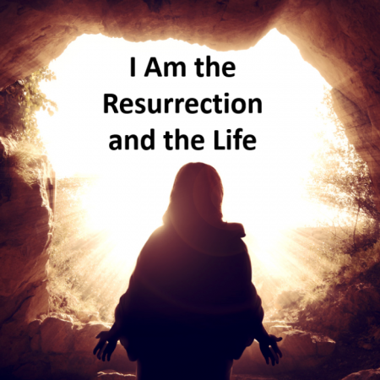

VALLEY PARK UNITED METHODIST CHURCH
436 Valley School Drive, Valley Park, MO 63088

Pastor: Jewell Brodie
Church Phone: 636-225-0057
Cell Phone: 314-401-7672
Church website: Valleypark-umc.org (BETA test version)
Church e-mail address: vpumc88@sbcglobal.net
A CELEBRATION OF THE GOSPEL
Proclamation: Every believer-Every day in God’s Word
Mission Statement: We are a Bible-believing Christian community inviting all people on a spiritual journey, forming companions in faith, and sending disciples of Jesus Christ into the world. “Which means we are called to “Carry on the Work of Christ”). Vision and Mission: We Exist to Worship; We Depart to Serve;
Connect: Christ Likeness—Inside Out
Fifth Sunday in Lent
Liturgical Color: Purple

Our Theme: “Illumine—Be The Light, Yet Even Now”
“With God All Things Are Possible”
March 22, 2026

Praise and Worship Music 9:00—9:30 A.M.

PRELUDE

GREETING As we begin our service:
“LET US KEEP OUR EYES ON THE MASTER”

MUSIC/WORSHIP

WORDS OF REPENTANCE:
Let us repent as a people, as a church, as a community and as a nation.

PSALM 130--A song for those journeying to worship. (The VOICE)

1 From the depths of disaster I appeal to You, O Eternal One:
2 Lord, hear my cry!
Attune Your ears to my humble prayer!
3 If You, Eternal One, recorded each offense,
Lord, who on earth could stand innocent?
4 But with You forgiveness exists;
that’s why true respect of You might flow.
5 So I wait for the Eternal—my soul awaits rescue—
and I put my hope in His transforming word.
6 My soul waits for the Lord to break into the world
more than night watchmen expect the break of day,
even more than night watchmen expect the break of day.
7 O Israel, ground your hope in the Eternal.
For in the Eternal lives the most loyal love,
and with Him comes the most abundant redemption.
8 He will ransom Israel
from all the sinful acts that stole you away.

OPENING PRAYER

WORDS OF ASSURANCE

OUR FAITH DECLARATION (for the congregation):

“Lord, even when we can’t see it, we believe You are working. When what’s left looks few, less, or little, remind us that you are still with us.
We will keep building, keep believing, and keep holding on—because Your glory is coming.”

THE FIRST COMMANDMENT: Mark 12:30

The first of all the commandments is: You shall love the Lord your God with all your heart and with all your soul and with all your mind and with all your strength. And the second, like it, is this: ‘You shall love your neighbor as yourself.’

Exodus 19:8: All that you say, Lord, we will do.

*HYMN “How Firm A Foundation” (vs 1,5) UMH #529
“Jesus Is All The World To Me” (vs 1,3) UMH #469
“Trust And Obey” (vs 1,3) UMH #467

*CALL TO WORSHIP

Leader: Jesus had confidence in life after death. That confidence can be
ours.
People: The grief felt at Lazarus’ death was overcome by the
reassurance of Jesus.

Leader: He said, “I am the resurrection and the life.”
People: In raising Lazarus, Jesus demonstrated that death is not
beyond the hope found in resurrection.

Leader: We are strengthened in our faith by the mighty acts of Jesus.
People: We are given courage and confidence by the power of God
to overcome our worst fears. AMEN.

*HYMN “Lord Be Glorified” FWS #2150

*SCRIPTURE READING John 11:1-45 (NIV)

The Death of Lazarus

11 Now a man named Lazarus was sick. He was from Bethany, the village of Mary and her sister Martha. 2 (This Mary, whose brother Lazarus now lay sick, was the same one who poured perfume on the Lord and wiped his feet with her hair.) 3 So the sisters sent word to Jesus, “Lord, the one you love is sick.”

4 When he heard this, Jesus said, “This sickness will not end in death. No, it is for God’s glory so that God’s Son may be glorified through it.” 5 Now Jesus loved Martha and her sister and Lazarus. 6 So when he heard that Lazarus was sick, he stayed where he was two more days, 7 and then he said to his disciples, “Let us go back to Judea.”

8 “But Rabbi,” they said, “a short while ago the Jews there tried to stone you, and yet you are going back?”

9 Jesus answered, “Are there not twelve hours of daylight? Anyone who walks in the daytime will not stumble, for they see by this world’s light. 10 It is when a person walks at night that they stumble, for they have no light.”
11 After he had said this, he went on to tell them, “Our friend Lazarus has fallen asleep; but I am going there to wake him up.”

12 His disciples replied, “Lord, if he sleeps, he will get better.” 13 Jesus had been speaking of his death, but his disciples thought he meant natural sleep.

14 So then he told them plainly, “Lazarus is dead, 15 and for your sake I am glad I was not there, so that you may believe. But let us go to him.”

16 Then Thomas (also known as Didymus) said to the rest of the disciples, “Let us also go, that we may die with him.”

Jesus Comforts the Sisters of Lazarus

17 On his arrival, Jesus found that Lazarus had already been in the tomb for four days. 18 Now Bethany was less than two miles from Jerusalem, 19 and many Jews had come to Martha and Mary to comfort them in the loss of their brother. 20 When Martha heard that Jesus was coming, she went out to meet him, but Mary stayed at home.

21 “Lord,” Martha said to Jesus, “if you had been here, my brother would not have died. 22 But I know that even now God will give you whatever you ask.”

23 Jesus said to her, “Your brother will rise again.”

24 Martha answered, “I know he will rise again in the resurrection at the last day.”

25 Jesus said to her, “I am the resurrection and the life. The one who believes in me will live, even though they die; 26 and whoever lives by believing in me will never die. Do you believe this?”

27 “Yes, Lord,” she replied, “I believe that you are the Messiah, the Son of God, who is to come into the world.”

28 After she had said this, she went back and called her sister Mary aside. “The Teacher is here,” she said, “and is asking for you.” 29 When Mary heard this, she got up quickly and went to him. 30 Now Jesus had not yet entered the village, but was still at the place where Martha had met him. 31 When the Jews who had been with Mary in the house, comforting her, noticed how quickly she got up and went out, they followed her, supposing she was going to the tomb to mourn there.

32 When Mary reached the place where Jesus was and saw him, she fell at his feet and said, “Lord, if you had been here, my brother would not have died.”

33 When Jesus saw her weeping, and the Jews who had come along with her also weeping, he was deeply moved in spirit and troubled. 34 “Where have you laid him?” he asked.

“Come and see, Lord,” they replied.

35 Jesus wept.

36 Then the Jews said, “See how he loved him!”

37 But some of them said, “Could not he who opened the eyes of the blind man have kept this man from dying?”

Jesus Raises Lazarus From the Dead

38 Jesus, once more deeply moved, came to the tomb. It was a cave with a stone laid across the entrance. 39 “Take away the stone,” he said.
“But, Lord,” said Martha, the sister of the dead man, “by this time there is a bad odor, for he has been there four days.”

40 Then Jesus said, “Did I not tell you that if you believe, you will see the glory of God?”

41 So they took away the stone. Then Jesus looked up and said, “Father, I thank you that you have heard me. 42 I knew that you always hear me, but I said this for the benefit of the people standing here, that they may believe that you sent me.”

43 When he had said this, Jesus called in a loud voice, “Lazarus, come out!” 44 The dead man came out, his hands and feet wrapped with strips of linen, and a cloth around his face.

Jesus said to them, “Take off the grave clothes and let him go.”

The Plot to Kill Jesus

45 Therefore many of the Jews who had come to visit Mary, and had seen what Jesus did, believed in him.

Leader: This is the Gospel of Jesus Christ.
People: Thanks be to God for Jesus Christ. Amen.

SPECIAL MUSIC

THE MESSAGE “From Dry Bones To Living Hope” Pastor Jewell Brodie

DOXOLOGY UMH #95
Praise God from whom all blessings flow
Praise Him all creatures here below
Praise Him above ye heavenly host
Praise Father, Son and Holy Ghost. Amen.

“HEAR O ISRAEL”

OUR PRAYER AND TIME OF REFLECTION

PASTORAL PRAYER (including prayers for the people, silent prayers of the people.

THE LORD'S PRAYER
And now, with the confidence of children of God, let us pray:

Our Father who art in heaven, hallowed be thy name, thy kingdom come, thy will be done, on earth as it is in heaven. Give us this day our daily bread and forgive us our trespasses as we forgive those who trespass against us. And lead us not into temptation, but deliver us from evil. For thine is the kingdom, and the power, and the glory forever. Amen.

RESPONSE “Amen” UMH #898
“Amen, Amen, Amen”

ANNOUNCEMENTS

TITHES AND OFFERINGS—Please leave your tithes and offerings in one of the collection boxes either on your way in or on your way out of the sanctuary.

*HYMN OF CELEBRATION “Sweet Hour Of Prayer” UMH #496

SPECIAL MUSIC

BENEDICTION

Lord, unbind us from our fears and doubts. As we go from this place of worship, be with us in our witness to the power and love of Jesus Christ. AMEN.

*SHALOM

Shalom to you now, shalom, my friends. May God’s full mercies be yours my friends. In all your living and through your loving, Christ be your shalom, Christ be your shalom.

*POSTLUDE

THIS WEEK’S LECTIONARY READINGS: NEXT WEEK’S LECTIONARY READINGS:
Ezekiel 37:1-14 Psalm 118:1-2, 19-29
Psalm 130 Matthew 21:1-11
Romans 8:6-11 Isaiah 50:4-9a
John 11:1-45 Psalm 31:9-16
Philippians 2:9-11
Matthew 26:14-27:66

CIRCLE OF CONCERN—current needs: Dinner Helpers; Pasta Sauce; Canned Fruit; Condiments; Snacks (8-12 servings/package); Size 5 and 6 Diapers; Baby wipes
View our Amazon Wish List, Walmart List or Target List for more items to fill our pantry.

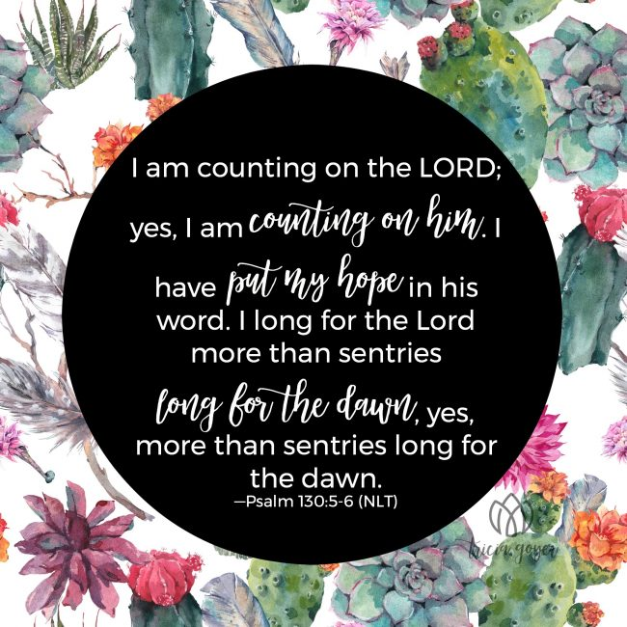

MARCH, 2026

3-29 9:32 A.M. Sunday Worship on Zoom
AND IN SANCTUARY!!

Mondays, Wednesdays: 9:30-11:30 A.M. Quilting
There will be no quilting if Rockwood schools are closed

3-29 Palm/Passion Sunday

3-29—4-5 Holy Week

Monday: Matthew 21:12-19 (Jesus cleanses the temple)
Tuesday: Matthew 21:23-46 (Jesus rebukes the Pharisees)
Wednesday: Matthew 24:1-36 (Signs of things to come)
Thursday: Matthew 26:20-75 (The Significance of the Last
Supper)
Friday: Matthew 27:1-61 (Jesus’ crucifixion)
Saturday: Matthew 27:57-61 (Responding to the Cross)
Sunday: Matthew 28:1-20 (Startling Implications of the
Resurrection)

APRIL, 2026

4-5,12,19,26 9:32 A.M. Sunday Worship on Zoom
AND IN SANCTUARY!!

Mondays, Wednesdays: 9:30-11:30 A.M. Quilting

4-5 Easter Day
4-12 Ad Board/Finance/Trustees meeting after Worship
4-19 Native American Ministries Sunday
4-22 Earth Day
Administrative Professionals Day
4-24 National Arbor Day

The 30-Day Church Challenge

Whether in the Sanctuary or on Zoom:
Family, we want to hear from you!

What would make you want to come to church—
or Zoom in—more often?
If you already join us from time to time, what would help you stay more connected and consistent in worship and fellowship?
Would it be a special project that excites your heart?
A mission that reaches others in need?
A ministry that helps you grow deeper in faith or serve in new ways?
This invitation is for everyone—our in-person family and our Zoom family alike.
We believe God can use your ideas—big or small, simple or bold—to strengthen our community and renew our dedication to Him.

Here’s How It Works:

1. Pray for 30 days – Ask God to reveal His vision for our church.
2. Write down your ideas – No idea is too small, too large, or too “trivial.”
3. Submit your thoughts – We’ll collect and compile them for prayerful review.
4. On Trinity Sunday, May 31, 2026, we’ll begin to implement what God reveals through this time of reflection and renewal.

“Unless the Lord builds the house, those who build it labor in vain.” — Psalm 127:1

• Let’s dream together.
• Let’s pray together.
• Let’s grow together.

And let’s watch what God will do when His people are faithful in the meantime and united in purpose.

PRAYER REQUESTS

Your prayer concerns are important to us. If you have a prayer need, joy or concern, if you need someone to just pray with you during this week, or if you are looking to connect with a church that loves people and you are interested in doing ministry and mission is this new way, please call Pastor Jewell at (314) 401-7672 or the church (636) 225-0057. We will walk with you no matter where you are on your journey. Check on someone you’ve not heard from this week.

MEMBERS, FRIENDS AND RELATIVES

Janet and Pasquale Parenti Jim Sieberg
June Bouck and her children Randy Statler
Glenda Hamilton and family Nancy and David Limback
Brinda Armstead Ashford
Alex, Alexis, Aubrey and Aden Mitchell Robison (Todd and Penny)
Captain Irma Hamilton and Dorothy Hamilton
Lilly Mulligan (Kolander) Mark Rudoff (Carol Hamilton)
Nick and Erin Rasch (Limback) Cynthia and Kenny Gooch
Doris “Bonnie” Watson; Sandy Nathan
Sara Laun (Nancy Limback’s mother) Andrea Limback
Cathy Becker, Chris Ewalt, Abigail Ewalt (Welsh)
Michael Schmidt (Haubrich) Sybil Young (Grant’s wife)
Mary Ellen Pagliughi (Dodson) Michelle Morton
Joe and Penny Moskus Frances “Cookie” Whitfield
Yvonne McClain Letha and Jim Buckley Michelle Parker
Laurie and Jeff Knight Chris Sides Kimmy Limback
Betty Slunaker (Welsh) Gary Laun (Limback)
Stean Pack (Brodie) Freddie Freeman
Mary Cosmo (Rev. Jespersen’s daughter-in-law)
Susan Jespersen
Wayne Chinn, Brandon Williams (G. Hamilton)
Theresa Hamilton, Walker Friedmeyer, Jen Kurowski (G. Hamilton)
Jean Hopper (Dodson) Becky Halker
Mike Hendrickson (Dodson) Mary Crawford
Joan Ranson
Bishop Bob Farr Rev. Adrienne Denson Ewell

DAILY PRAYER TIME: 1:11 P.M. Stop and say a few prayers for ourselves, our families, friends, neighbors and our prayer list.

Based on John 11:1-45, these prayers focus on trusting God during delayed answers, finding comfort in Jesus’ shared grief, and believing in His power as the "Resurrection and the Life." Key themes include asking for glory in suffering, seeking hope in despair, and trusting God to call loved ones out of "graves" of despair.

Prayers for Ourselves:

Trust in Delayed Answers: "Lord, when I am in pain and You seem slow to act, help me to believe that this delay is for Your glory and not for my destruction (John 11:4). Give me patience to trust Your timing over my own."

Surrender in Grief: "Jesus, You wept at the tomb of Lazarus (John 11:35). Thank You for understanding my deepest sorrows. I bring my brokenness to You, knowing You are not distant, but present in my tears."

Hope in Darkness: "Lord Jesus, I declare that You are the resurrection and the life (John 11:25). In my hopeless situations, help me to believe in Your power to bring life out of death."

Removing Obstacles: "Lord, give me the faith to take away the stone (John 11:39) of doubt and unbelief, trusting that You will bring forth a miracle in my life."

Prayers for Others

For the Suffering/Sick: "Lord, [Name] is ill/suffering, the one whom You love (John 11:3). I pray for Your healing touch and that this situation will not end in death, but bring glory to Your name."

For Those in Despair: "Father, I pray for [Name] who feels buried by grief or circumstance. Call them out of their tomb (John 11:43) and into Your light."

For Spiritual Renewal: "Lord, I pray for those bound by fear or sin. As You instructed the disciples to unbind Lazarus (John 11:44), please remove the grave clothes from [Name] and set them free to walk in new life."

For Faith to See Glory: "I pray that those struggling to believe, like Martha, will trust Your promise: 'If you believe, you will see the glory of God' (John 11:40)."

A Prayer of Thanksgiving

"Father, I thank You that You always hear me (John 11:42). I thank You that even when I feel dead inside, You are the Resurrection. Amen."

Thomas (also known as Didymus)

Thomas, also known as Didymus ("the Twin"), was one of the twelve apostles of Jesus, known for his initial skepticism regarding Jesus' resurrection—earning him the nickname "Doubting Thomas"—followed by his profound confession, "My Lord and my God". He was a devoted follower, believed to have brought Christianity to India, where he was martyred.

Key Aspects of Thomas Didymus:

Name Meaning: "Thomas" is derived from the Aramaic Tʾōmā and "Didymus" from Greek Δίδυμος; both translate to "the twin".

Role and Character: While known for needing physical proof of the resurrection, he was also courageous, having previously encouraged the disciples to follow Jesus to Judea, saying, "Let us also go, that we may die with him" (John 11:16).
The Resurrection Event: Absent during Jesus' first appearance to the disciples after his resurrection, he declared he would not believe without touching Jesus' wounds. A week later, Jesus allowed him to do so, leading to his belief.

Missionary Work: Tradition holds that he traveled to India to preach, building churches in Kerala and establishing a strong Christian foundation there before his martyrdom (traditionally stabbed with a spear) around 72 AD.

Mentioned in Scripture: He appears frequently in the Gospel of John, including the scene of Lazarus's raising and the Last Supper discussions.

Some early traditions, such as the Acts of Thomas, suggest his full name was Judas Thomas.

