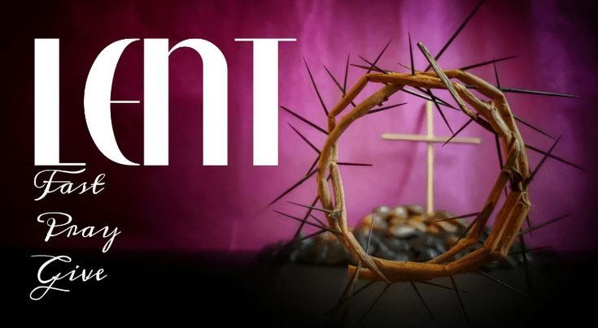

VALLEY PARK UNITED METHODIST CHURCH
436 Valley School Drive, Valley Park, MO 63088

Pastor: Jewell Brodie
Church Phone: 636-225-0057
Cell Phone: 314-401-7672
Church website: Valleypark-umc.org (BETA test version)
Church e-mail address: vpumc88@sbcglobal.net
A CELEBRATION OF THE GOSPEL
Proclamation: Every believer-Every day in God’s Word
Mission Statement: We are a Bible-believing Christian community inviting all people on a spiritual journey, forming companions in faith, and sending disciples of Jesus Christ into the world. “Which means we are called to “Carry on the Work of Christ”). Vision and Mission: We Exist to Worship; We Depart to Serve;
Connect: Christ Likeness—Inside Out
Fourth Sunday in Lent
Liturgical Color: Purple

Our Theme: “Illumine—Be The Light, Yet Even Now”
“With God All Things Are Possible”
March 15, 2026

Praise and Worship Music 9:00—9:30 A.M.

PRELUDE

GREETING As we begin our service:
“LET US KEEP OUR EYES ON THE MASTER”

MUSIC/WORSHIP

WORDS OF REPENTANCE:
Let us repent as a people, as a church, as a community and as a nation.

PSALM 23--A song of David. (The VOICE)

1 The Eternal is my shepherd, He cares for me always.

2 He provides me rest in rich, green fields
beside streams of refreshing water.
He soothes my fears;

3 He makes me whole again,
steering me off worn, hard paths
to roads where truth and righteousness echo His name.
4 Even in the unending shadows of death’s darkness,
I am not overcome by fear.
Because You are with me in those dark moments,
near with Your protection and guidance,
I am comforted.

5 You spread out a table before me,
provisions in the midst of attack from my enemies;
You care for all my needs, anointing my head with soothing, fragrant oil,
filling my cup again and again with Your grace.

6 Certainly Your faithful protection and loving provision will pursue me
where I go, always, everywhere.
I will always be with the Eternal,
in Your house forever.

OPENING PRAYER

WORDS OF ASSURANCE

OUR FAITH DECLARATION (for the congregation):

“Lord, even when we can’t see it, we believe You are working. When what’s left looks few, less, or little, remind us that you are still with us.
We will keep building, keep believing, and keep holding on—because Your glory is coming.”

THE FIRST COMMANDMENT: Mark 12:30

The first of all the commandments is: You shall love the Lord your God with all your heart and with all your soul and with all your mind and with all your strength. And the second, like it, is this: ‘You shall love your neighbor as yourself.’

Exodus 19:8: All that you say, Lord, we will do.

*HYMN “Grace Greater Than Our Sin” (vs 1,4) UMH #365
“Great Is Thy Faithfulness” (vs 1,3) UMH #140
“Open My Eyes, That I May See” (vs 1,2) UMH #454

*CALL TO WORSHIP

Leader: As Jesus passed by, He saw a man blind from birth.
People: He saw what others overlooked, and He brings light into
our darkness.

Leader: Jesus said, "I am the light of the world."
People: Open our eyes, Lord, that we may see Your glory.

Leader: We were blind, but now we see.
People: Lord, we believe, and we worship You!

*HYMN “Open Our Eyes” FWS #2086

*SCRIPTURE READING Matthew 17:1-9 (NIV)

17 After six days Jesus took with him Peter, James and John the brother of James, and led them up a high mountain by themselves. 2 There he was transfigured before them. His face shone like the sun, and his clothes became as white as the light. 3 Just then there appeared before them Moses and Elijah, talking with Jesus.

4 Peter said to Jesus, “Lord, it is good for us to be here. If you wish, I will put up three shelters—one for you, one for Moses and one for Elijah.”

5 While he was still speaking, a bright cloud covered them, and a voice from the cloud said, “This is my Son, whom I love; with him I am well pleased. Listen to him!”

6 When the disciples heard this, they fell facedown to the ground, terrified. 7 But Jesus came and touched them. “Get up,” he said. “Don’t be afraid.” 8 When they looked up, they saw no one except Jesus.
9 As they were coming down the mountain, Jesus instructed them, “Don’t tell anyone what you have seen, until the Son of Man has been raised from the dead.”

Leader: This is the Gospel of Jesus Christ.
People: Thanks be to God for Jesus Christ. Amen.

SPECIAL MUSIC

THE MESSAGE “Listen To Him” Pastor Jewell Brodie

DOXOLOGY UMH #95
Praise God from whom all blessings flow
Praise Him all creatures here below
Praise Him above ye heavenly host
Praise Father, Son and Holy Ghost. Amen.

“HEAR O ISRAEL”

OUR PRAYER AND TIME OF REFLECTION

PASTORAL PRAYER (including prayers for the people, silent prayers of the people.

THE LORD'S PRAYER
And now, with the confidence of children of God, let us pray:

Our Father who art in heaven, hallowed be thy name, thy kingdom come, thy will be done, on earth as it is in heaven. Give us this day our daily bread and forgive us our trespasses as we forgive those who trespass against us. And lead us not into temptation, but deliver us from evil. For thine is the kingdom, and the power, and the glory forever. Amen.

RESPONSE “Amen” UMH #898
“Amen, Amen, Amen”

ANNOUNCEMENTS

TITHES AND OFFERINGS—Please leave your tithes and offerings in one of the collection boxes either on your way in or on your way out of the sanctuary.

*HYMN OF CELEBRATION “Lord, Dismiss Us with Thy Blessing”
UMH #671

SPECIAL MUSIC

BENEDICTION

May God, who comes to us in the things of this world, bless your eyes and be in your seeing.

May Christ, who looks upon you with deepest love, bless your eyes and widen your gaze.

May the Spirit, who perceives what is and what may yet be, bless your eyes and sharpen your vision.

May the Sacred Three bless your eyes and cause you to see.

*SHALOM

Shalom to you now, shalom, my friends. May God’s full mercies be yours my friends. In all your living and through your loving, Christ be your shalom, Christ be your shalom.

*POSTLUDE

THIS WEEK’S LECTIONARY READINGS: NEXT WEEK’S LECTIONARY READINGS:
Samuel 16:1-13 Ezekiel 37:1-14
Psalm 23 Psalm 130
Ephesians 5:8-14 Romans 8:6-11
John 9:1-41 John 11:1-45
CIRCLE OF CONCERN—current needs: Dinner Helpers; Pasta Sauce; Canned Fruit; Condiments; Snacks (8-12 servings/package); Size 5 and 6 Diapers; Baby wipes
View our Amazon Wish List, Walmart List or Target List for more items to fill our pantry.

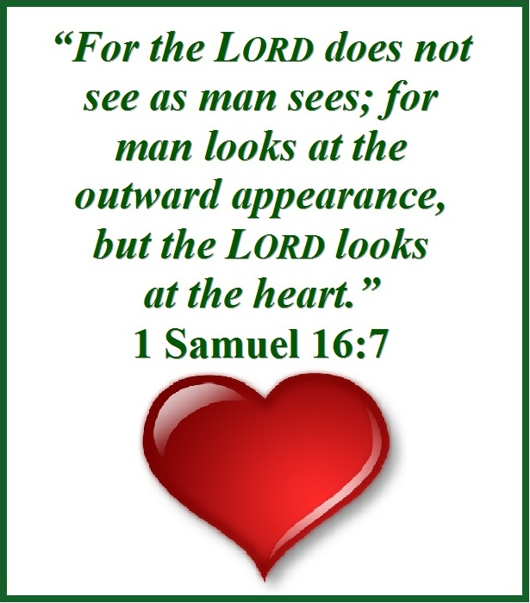

MARCH, 2026

3-22,29 9:32 A.M. Sunday Worship on Zoom
AND IN SANCTUARY!!

Mondays, Wednesdays: 9:30-11:30 A.M. Quilting
There will be no quilting if Rockwood schools are closed

TODAY UMCOR Sunday

3-17 St. Patrick’s Day

3-20 First Day of Spring

3-29 Palm/Passion Sunday

3-29—4-5 Holy Week

Monday: Matthew 21:12-19 (Jesus cleanses the temple)

Tuesday: Matthew 21:23-46 (Jesus rebukes the Pharisees)

Wednesday: Matthew 24:1-36 (Signs of things to come)

Thursday: Matthew 26:20-75 (The Significance of the Last
Supper)

Friday: Matthew 27:1-61 (Jesus’ crucifixion)

Saturday: Matthew 27:57-61 (Responding to the Cross)

Sunday: Matthew 28:1-20 (Startling Implications of the
Resurrection)

APRIL, 2026

4-5,12,19,26 9:32 A.M. Sunday Worship on Zoom
AND IN SANCTUARY!!

Mondays, Wednesdays: 9:30-11:30 A.M. Quilting

4-5 Easter Day

4-12 Ad Board/Finance/Trustees meeting after Worship

4-19 Native American Ministries Sunday

4-22 Earth Day

Administrative Professionals Day

4-24 National Arbor Day

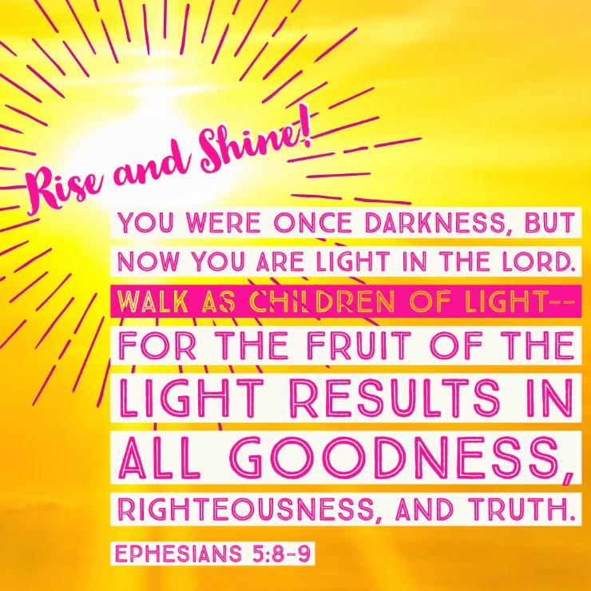
The 30-Day Church Challenge

Whether in the Sanctuary or on Zoom:
Family, we want to hear from you!

What would make you want to come to church—
or Zoom in—more often?
If you already join us from time to time, what would help you stay more connected and consistent in worship and fellowship?
Would it be a special project that excites your heart?
A mission that reaches others in need?
A ministry that helps you grow deeper in faith or serve in new ways?
This invitation is for everyone—our in-person family and our Zoom family alike.
We believe God can use your ideas—big or small, simple or bold—to strengthen our community and renew our dedication to Him.

Here’s How It Works:

1. Pray for 30 days – Ask God to reveal His vision for our church.
2. Write down your ideas – No idea is too small, too large, or too “trivial.”
3. Submit your thoughts – We’ll collect and compile them for prayerful review.
4. On Trinity Sunday, May 31, 2026, we’ll begin to implement what God reveals through this time of reflection and renewal.

“Unless the Lord builds the house, those who build it labor in vain.” — Psalm 127:1

• Let’s dream together.
• Let’s pray together.
• Let’s grow together.

And let’s watch what God will do when His people are faithful in the meantime and united in purpose.

PRAYER REQUESTS

Your prayer concerns are important to us. If you have a prayer need, joy or concern, if you need someone to just pray with you during this week, or if you are looking to connect with a church that loves people and you are interested in doing ministry and mission is this new way, please call Pastor Jewell at (314) 401-7672 or the church (636) 225-0057. We will walk with you no matter where you are on your journey. Check on someone you’ve not heard from this week.

MEMBERS, FRIENDS AND RELATIVES

Janet and Pasquale Parenti Jim Sieberg
June Bouck and her children Randy Statler
Glenda Hamilton and family Nancy and David Limback
Brinda Armstead Ashford
Alex, Alexis, Aubrey and Aden Mitchell Robison (Todd and Penny)
Captain Irma Hamilton and Dorothy Hamilton
Lilly Mulligan (Kolander) Mark Rudoff (Carol Hamilton)
Nick and Erin Rasch (Limback) Cynthia and Kenny Gooch
Doris “Bonnie” Watson; Sandy Nathan
Sara Laun (Nancy Limback’s mother)
Cathy Becker, Chris Ewalt, Abigail Ewalt (Welsh)
Michael Schmidt (Haubrich) Sybil Young (Grant’s wife)
Mary Ellen Pagliughi (Dodson) Michelle Morton
Joe and Penny Moskus Frances “Cookie” Whitfield
Yvonne McClain Letha and Jim Buckley Michelle Parker
Laurie and Jeff Knight Chris Sides Kimmy Limback
Betty Slunaker (Welsh) Gary Laun (Limback)
Stean Pack (Brodie) Freddie Freeman
Mary Cosmo (Rev. Jespersen’s daughter-in-law)
Susan Jespersen
Kathy Wuestling, Wayne Chinn, Brandon Williams (G. Hamilton)
Theresa Hamilton, Walker Friedmeyer, Jen Kurowski (G. Hamilton)
Jean Hopper (Dodson) Becky Halker
Mike Hendrickson (Dodson) Mary Crawford
Joan Ranson
Bishop Bob Farr Rev. Adrienne Denson Ewell

DAILY PRAYER TIME: 1:11 P.M. Stop and say a few prayers for ourselves, our families, friends, neighbors and our prayer list.

Based on John 9:1-41, these prayers focus on asking Jesus, the Light of the World, to heal spiritual blindness, remove pride, and reveal God’s works in suffering. They encourage surrendering to His light for clarity and the boldness to witness, transforming trials into opportunities for divine glory and renewed faith.

Prayers for Ourselves:

For Spiritual Sight: "Lord Jesus, heal my spiritual blindness. Remove the scales of pride and self-righteousness, that I may see my own faults and recognize You as the true Light in my life".

For Trust in Trials: "Father, when I face difficult times, help me not to seek blame, but to believe that You can manifest Your glory through my circumstances, just as You did for the man born blind".

For Obedience: "Lord, give me the faith of the blind man who obeyed Your command to wash in the pool of Siloam. May I trust Your word and act on it, even when I do not fully understand the process".

For Courage to Witness: "Lord, grant me the boldness of the man healed of blindness to stand for the truth, confessing what You have done for me, despite pressure from the world".

Prayers for Others :

For Those in Spiritual Darkness: "Father, I pray for those blinded by unbelief or worldly pride. Please open their eyes to Your truth and grant them repentance, so they may see Jesus as their Savior".

For Those Suffering: "Lord, look with mercy upon those facing deep afflictions. Comfort them with Your presence and let their suffering become a canvas for Your works to be displayed".

For Discernment in the Church: "Lord, keep us from the mindset of the Pharisees, who were blind to Your works. Help us to see others through the lens of grace, not judgment".

For Sharing the Light: "Lord, help us as a community to be 'sent' (Siloam) into the world, sharing the healing, enlightening love of Jesus with those trapped in darkness".

A Closing Prayer:

"Lord Jesus, You are the Light of the World. As I wash in the pool of Your grace, open my eyes to see myself, others, and You more clearly. Turn my blindness into sight, my fear into faith, and my life into a testament to Your glory. Amen"

Psalm 23 is the best known and most beloved psalm in the collection.

Surprisingly, it casts humanity as sheep—stupid, helpless sheep. But the long-lasting appeal of Psalm 23 is a direct result of that casting because the imagery is both soothing and accessible.

When he was a boy, King David was a shepherd watching his father’s flocks in the hills around Bethlehem. In those days, too, it was common to refer to kings in the Near East as shepherds; but not all shepherd-kings cared for their sheep. Though David tried to shepherd his people well, he knew the truth: the Eternal is the true Shepherd.

In John 10:11 Jesus makes a bold claim. He declares that He is the good shepherd. Immediately His disciples detected the resonance of Psalm 23 in His words. Those of us who follow Jesus today come to know Him as that gentle but strong shepherd who guides us through life if we will follow Him.

