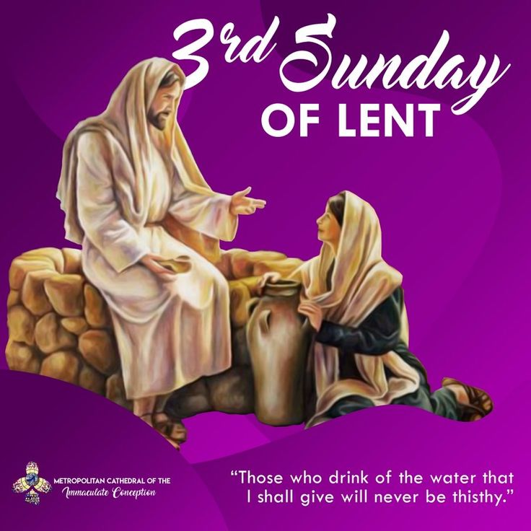

VALLEY PARK UNITED METHODIST CHURCH
436 Valley School Drive, Valley Park, MO 63088

Pastor: Jewell Brodie
Church Phone: 636-225-0057
Cell Phone: 314-401-7672
Church website: Valleypark-umc.org (BETA test version)
Church e-mail address: vpumc88@sbcglobal.net
A CELEBRATION OF THE GOSPEL
Proclamation: Every believer-Every day in God’s Word
Mission Statement: We are a Bible-believing Christian community inviting all people on a spiritual journey, forming companions in faith, and sending disciples of Jesus Christ into the world. “Which means we are called to “Carry on the Work of Christ”). Vision and Mission: We Exist to Worship; We Depart to Serve;
Connect: Christ Likeness—Inside Out
Third Sunday in Lent
Liturgical Color: Purple

Our Theme: “Illumine—Be The Light, Yet Even Now”
“With God All Things Are Possible”
March 8, 2026

Praise and Worship Music 9:00—9:30 A.M.

PRELUDE

GREETING As we begin our service:
“LET US KEEP OUR EYES ON THE MASTER”

MUSIC/WORSHIP

WORDS OF REPENTANCE:
Let us repent as a people, as a church, as a community and as a nation.

PSALM 95 (NIV)

1 Come, let us sing for joy to the Lord;
let us shout aloud to the Rock of our salvation.
2 Let us come before him with thanksgiving
and extol him with music and song.

3 For the Lord is the great God,
the great King above all gods.
4 In his hand are the depths of the earth,
and the mountain peaks belong to him.
5 The sea is his, for he made it,
and his hands formed the dry land.

6 Come, let us bow down in worship,
let us kneel before the Lord our Maker;
7 for he is our God
and we are the people of his pasture,
the flock under his care.

Today, if only you would hear his voice,
8 “Do not harden your hearts as you did at Meribah,
as you did that day at Massah in the wilderness,
9 where your ancestors tested me;
they tried me, though they had seen what I did.
10 For forty years I was angry with that generation;
I said, ‘They are a people whose hearts go astray,
and they have not known my ways.’
11 So I declared on oath in my anger,
‘They shall never enter my rest.’”

OPENING PRAYER

WORDS OF ASSURANCE

OUR FAITH DECLARATION (for the congregation):

“Lord, even when we can’t see it, we believe You are working. When what’s left looks few, less, or little, remind us that you are still with us.
We will keep building, keep believing, and keep holding on—because Your glory is coming.”

THE FIRST COMMANDMENT: Mark 12:30

The first of all the commandments is: You shall love the Lord your God with all your heart and with all your soul and with all your mind and with all your strength. And the second, like it, is this: ‘You shall love your neighbor as yourself.’
Exodus 19:8: All that you say, Lord, we will do.

*HYMN “He Leadeth Me, O Blessed Thought” (vs 1,3) UMH #128
“Dear Jesus, In Whose Life I See” UMH #468
“Rejoice The Lord Is King” (vs 1,4) UMH #715

*CALL TO WORSHIP

Leader: Come, all who are thirsty, says Jesus, our Lord.
People: We come to drink from the well that never runs dry.

Leader: Come, all who are searching, for the Messiah is here.
People: We come to worship in Spirit and in truth.

Leader: Come and see the one who knows us completely and loves us
unconditionally.
People: Let us worship Jesus, the Savior of the world!

*HYMN “Jesus, Name Above All Names” FWS #2071

*SCRIPTURE READING John 4:5-42 (NIV)

5 So he came to a town in Samaria called Sychar, near the plot of ground Jacob had given to his son Joseph. 6 Jacob’s well was there, and Jesus, tired as he was from the journey, sat down by the well. It was about noon.

7 When a Samaritan woman came to draw water, Jesus said to her, “Will you give me a drink?” 8 (His disciples had gone into the town to buy food.)

9 The Samaritan woman said to him, “You are a Jew and I am a Samaritan woman. How can you ask me for a drink?” (For Jews do not associate with Samaritans.)

10 Jesus answered her, “If you knew the gift of God and who it is that asks you for a drink, you would have asked him and he would have given you living water.”

11 “Sir,” the woman said, “you have nothing to draw with and the well is deep. Where can you get this living water? 12 Are you greater than our father Jacob, who gave us the well and drank from it himself, as did also his sons and his livestock?”

13 Jesus answered, “Everyone who drinks this water will be thirsty again, 14 but whoever drinks the water I give them will never thirst. Indeed, the water I give them will become in them a spring of water welling up to eternal life.”

15 The woman said to him, “Sir, give me this water so that I won’t get thirsty and have to keep coming here to draw water.”

16 He told her, “Go, call your husband and come back.”

17 “I have no husband,” she replied.

Jesus said to her, “You are right when you say you have no husband. 18 The fact is, you have had five husbands, and the man you now have is not your husband. What you have just said is quite true.”

19 “Sir,” the woman said, “I can see that you are a prophet. 20 Our ancestors worshiped on this mountain, but you Jews claim that the place where we must worship is in Jerusalem.”

21 “Woman,” Jesus replied, “believe me, a time is coming when you will worship the Father neither on this mountain nor in Jerusalem. 22 You Samaritans worship what you do not know; we worship what we do know, for salvation is from the Jews. 23 Yet a time is coming and has now come when the true worshipers will worship the Father in the Spirit and in truth, for they are the kind of worshipers the Father seeks. 24 God is spirit, and his worshipers must worship in the Spirit and in truth.”

25 The woman said, “I know that Messiah” (called Christ) “is coming. When he comes, he will explain everything to us.”

26 Then Jesus declared, “I, the one speaking to you—I am he.”

The Disciples Rejoin Jesus

27 Just then his disciples returned and were surprised to find him talking with a woman. But no one asked, “What do you want?” or “Why are you talking with her?”

28 Then, leaving her water jar, the woman went back to the town and said to the people, 29 “Come, see a man who told me everything I ever did. Could this be the Messiah?” 30 They came out of the town and made their way toward him.

31 Meanwhile his disciples urged him, “Rabbi, eat something.”

32 But he said to them, “I have food to eat that you know nothing about.”

33 Then his disciples said to each other, “Could someone have brought him food?”

34 “My food,” said Jesus, “is to do the will of him who sent me and to finish his work. 35 Don’t you have a saying, ‘It’s still four months until harvest’? I tell you, open your eyes and look at the fields! They are ripe for harvest. 36 Even now the one who reaps draws a wage and harvests a crop for eternal life, so that the sower and the reaper may be glad together. 37 Thus the saying ‘One sows and another reaps’ is true. 38 I sent you to reap what you have not worked for. Others have done the hard work, and you have reaped the benefits of their labor.”

Many Samaritans Believe

39 Many of the Samaritans from that town believed in him because of the woman’s testimony, “He told me everything I ever did.” 40 So when the Samaritans came to him, they urged him to stay with them, and he stayed two days. 41 And because of his words many more became believers.

42 They said to the woman, “We no longer believe just because of what you said; now we have heard for ourselves, and we know that this man really is the Savior of the world.”

Leader: This is the Gospel of Jesus Christ.
People: Thanks be to God for Jesus Christ. Amen.

SPECIAL MUSIC

THE MESSAGE “Companion For The Journey” Pastor Jewell Brodie

DOXOLOGY UMH #95
Praise God from whom all blessings flow
Praise Him all creatures here below
Praise Him above ye heavenly host
Praise Father, Son and Holy Ghost. Amen.

“HEAR O ISRAEL”

OUR PRAYER AND TIME OF REFLECTION

PASTORAL PRAYER (including prayers for the people, silent prayers of the people.

THE LORD'S PRAYER
And now, with the confidence of children of God, let us pray:

Our Father who art in heaven, hallowed be thy name, thy kingdom come, thy will be done, on earth as it is in heaven. Give us this day our daily bread and forgive us our trespasses as we forgive those who trespass against us. And lead us not into temptation, but deliver us from evil. For thine is the kingdom, and the power, and the glory forever. Amen.
RESPONSE “Amen” UMH #898
“Amen, Amen, Amen”

ANNOUNCEMENTS

TITHES AND OFFERINGS—Please leave your tithes and offerings in one of the collection boxes either on your way in or on your way out of the sanctuary.

*HYMN OF CELEBRATION “Joyful, Joyful, We Adore Thee” UMH #89

SPECIAL MUSIC

BENEDICTION

Go now, having drunk from the living water that quenches your deepest thirst, and fear not to leave behind the empty jars of your past. May the grace of Jesus Christ, who knows you fully and loves you still, empower you to bear witness to your community. Go forth to worship in spirit and truth, as a spring of living water welling up to eternal life. Amen.

*SHALOM

Shalom to you now, shalom, my friends. May God’s full mercies be yours my friends. In all your living and through your loving, Christ be your shalom, Christ be your shalom.

*POSTLUDE

THIS WEEK’S LECTIONARY READINGS: NEXT WEEK’S LECTIONARY READINGS:
Exodus 17:1-7 1 Samuel 16:1-13
Psalm 95 Psalm 23
Romans 5:1-11 Ephesians 5:8-14
John 4:5-42 John 9:1-41

CIRCLE OF CONCERN—current needs: Dinner Helpers; Pasta Sauce; Canned Fruit; Condiments; Snacks (8-12 servings/package); Size 5 and 6 Diapers; Baby wipes
View our Amazon Wish List, Walmart List or Target List for more items to fill our pantry.

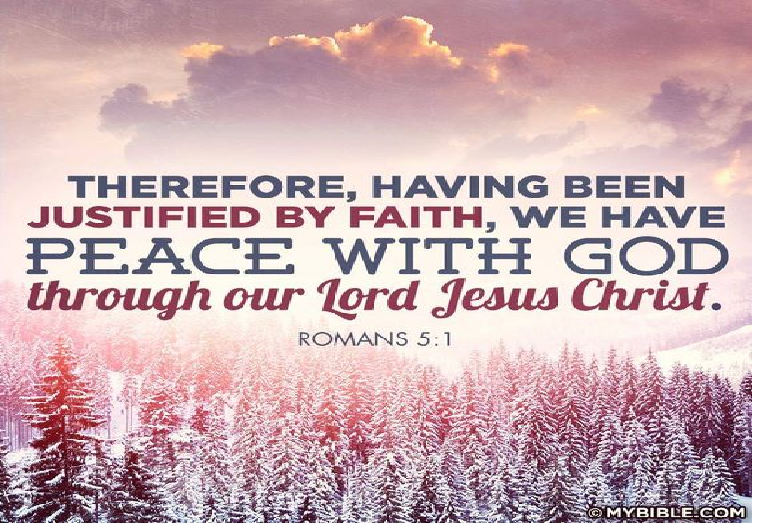

MARCH, 2026

3-15, 22,29 9:32 A.M. Sunday Worship on Zoom
AND IN SANCTUARY!!

Mondays, Wednesdays: 9:30-11:30 A.M. Quilting
There will be no quilting if Rockwood schools are closed

TODAY Ad Board/Finance/Trustees meeting after Worship
Scouting Sunday
Daylight Savings Time Begins
3-15 UMCOR Sunday
3-17 St. Patrick’s Day
3-20 First Day of Spring
3-29 Palm/Passion Sunday

3-29—4-5 Holy Week

Monday: Matthew 21:12-19 (Jesus cleanses the temple)
Tuesday: Matthew 21:23-46 (Jesus rebukes the Pharisees)
Wednesday: Matthew 24:1-36 (Signs of things to come)
Thursday: Matthew 26:20-75 (The Significance of the Last
Supper)
Friday: Matthew 27:1-61 (Jesus’ crucifixion)
Saturday: Matthew 27:57-61 (Responding to the Cross)
Sunday: Matthew 28:1-20 (Startling Implications of the
Resurrection)

APRIL, 2026

4-5,12,19,26 9:32 A.M. Sunday Worship on Zoom
AND IN SANCTUARY!!

Mondays, Wednesdays: 9:30-11:30 A.M. Quilting
There will be no quilting if Rockwood schools are closed

4-5 Easter Day

4-12 Ad Board/Finance/Trustees meeting after Worship

4-19 Native American Ministries Sunday

4-22 Earth Day
Administrative Professionals Day

4-24 National Arbor Day

The 30-Day Church Challenge

Whether in the Sanctuary or on Zoom:
Family, we want to hear from you!

What would make you want to come to church—
or Zoom in—more often?
If you already join us from time to time, what would help you stay more connected and consistent in worship and fellowship?
Would it be a special project that excites your heart?
A mission that reaches others in need?
A ministry that helps you grow deeper in faith or serve in new ways?
This invitation is for everyone—our in-person family and our Zoom family alike.
We believe God can use your ideas—big or small, simple or bold—to strengthen our community and renew our dedication to Him.

Here’s How It Works:
1. Pray for 30 days – Ask God to reveal His vision for our church.
2. Write down your ideas – No idea is too small, too large, or too “trivial.”
3. Submit your thoughts – We’ll collect and compile them for prayerful review.
4. On Trinity Sunday, May 31, 2026, we’ll begin to implement what God reveals through this time of reflection and renewal.

“Unless the Lord builds the house, those who build it labor in vain.” — Psalm 127:1
• Let’s dream together.
• Let’s pray together.
• Let’s grow together.

And let’s watch what God will do when His people are faithful in the meantime and united in purpose.

PRAYER REQUESTS

Your prayer concerns are important to us. If you have a prayer need, joy or concern, if you need someone to just pray with you during this week, or if you are looking to connect with a church that loves people and you are interested in doing ministry and mission is this new way, please call Pastor Jewell at (314) 401-7672 or the church (636) 225-0057. We will walk with you no matter where you are on your journey. Check on someone you’ve not heard from this week.

MEMBERS, FRIENDS AND RELATIVES

Janet and Pasquale Parenti Jim Sieberg
June Bouck and her children Randy Statler
Glenda Hamilton and family Nancy and David Limback
Brinda Armstead Ashford
Alex, Alexis, Aubrey and Aden Mitchell Robison (Todd and Penny)
Captain Irma Hamilton and Dorothy Hamilton
Lilly Mulligan (Kolander) Mark Rudoff (Carol Hamilton)
Nick and Erin Rasch (Limback) Cynthia and Kenny Gooch
Doris “Bonnie” Watson; Sandy Nathan
Sara Laun (Nancy Limback’s mother)
Cathy Becker, Chris Ewalt, Abigail Ewalt (Welsh)
Michael Schmidt (Haubrich) Sybil Young (Grant’s wife)
Mary Ellen Pagliughi (Dodson) Michelle Morton
Joe and Penny Moskus Frances “Cookie” Whitfield
Yvonne McClain Letha and Jim Buckley Michelle Parker
Laurie and Jeff Knight Chris Sides Kimmy Limback
Betty Slunaker (Welsh) Gary Laun (Limback)
Stean Pack (Brodie) Freddie Freeman
Mary Cosmo (Rev. Jespersen’s daughter-in-law)
Susan Jespersen
Kathy Wuestling, Wayne Chinn, Brandon Williams (G. Hamilton)
Theresa Hamilton, Walker Friedmeyer, Jen Kurowski (G. Hamilton)
Jean Hopper (Dodson) Becky Halker
Mike Hendrickson (Dodson) Mary Crawford
Joan Ranson
Bishop Bob Farr Rev. Adrienne Denson Ewell

DAILY PRAYER TIME: 1:11 P.M. Stop and say a few prayers for ourselves, our families, friends, neighbors and our prayer list.

Based on John 4:5-42, these prayers focus on seeking "living water" to quench spiritual thirst, embracing true worship in spirit and truth, and having the courage to witness to others about Jesus's transformative love, regardless of social barriers. These prayers invite believers to see their lives as opportunities for evangelism.

Prayers for Ourselves (Based on the Samaritan Woman/Jesus at the well)

For Spiritual Satisfaction: Lord Jesus, I confess that I often drink from things other than You—seeking satisfaction in worldly things. I come thirsty to Your well. Quench my deep spiritual thirst with Your living water, that I may never thirst again.

For True Worship: Father, teach me to worship You in Spirit and in truth, not just by outward rituals. Free me from the constraints of my past and the shame that binds me, that I may encounter You with a pure heart.

For Courage to Witness: Lord, like the woman at the well, help me to overcome fear and share my testimony of how You have transformed my life. Let my life be a witness to Your grace, even if I feel unqualified.

Prayers for Others (Based on the Samaritan Townspeople)

For Open Eyes to the Harvest: Lord, open our eyes to the fields that are ripe for harvest around us—the people in our communities, workplaces, and families who need to know Your love.

For Reaching the Marginalized: Father, give us Your heart for the overlooked, the rejected, and the social outcasts, just as Jesus sought out the Samaritan woman. Help us to break down barriers to share Your truth.
For Transformation and Belief: We pray for our neighbors and cities to come to know Jesus as the Savior of the world. May they, like the Samaritans, hear Your word and believe, experiencing the joy of salvation.

For Unity in Ministry: Lord, help us to work together with other believers in a spirit of unity to spread the Gospel, knowing that it is not about our own wisdom, but about Your power to save.

A Closing Prayer of Thanksgiving

Lord Jesus, thank You that You are the Savior of the world, who does not condemn but offers life-giving, transforming grace. Help us to live as living stones, built up by Your spirit, and to share this Good News with everyone we meet. Amen.



