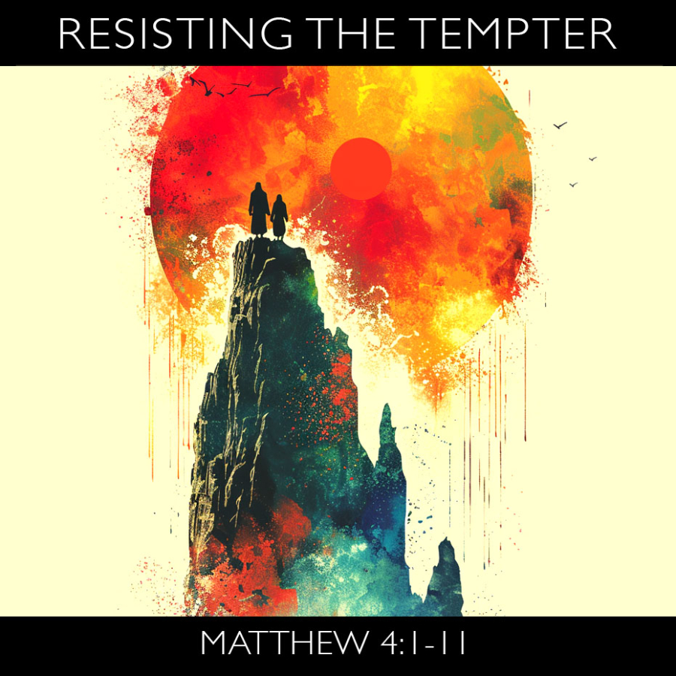

VALLEY PARK UNITED METHODIST CHURCH
436 Valley School Drive, Valley Park, MO 63088

Pastor: Jewell Brodie
Church Phone: 636-225-0057
Cell Phone: 314-401-7672
Church website: Valleypark-umc.org (BETA test version)
Church e-mail address: vpumc88@sbcglobal.net
A CELEBRATION OF THE GOSPEL
Proclamation: Every believer-Every day in God’s Word
Mission Statement: We are a Bible-believing Christian community inviting all people on a spiritual journey, forming companions in faith, and sending disciples of Jesus Christ into the world. “Which means we are called to “Carry on the Work of Christ”). Vision and Mission: We Exist to Worship; We Depart to Serve;
Connect: Christ Likeness—Inside Out

First Sunday in Lent
Liturgical Color: Purple

Our Theme: “Illumine—Be The Light, Yet Even Now”
“With God All Things Are Possible”
February 22, 2026

Praise and Worship Music 9:00—9:30 A.M.

PRELUDE

GREETING As we begin our service:
“LET US KEEP OUR EYES ON THE MASTER”

MUSIC/WORSHIP

WORDS OF REPENTANCE:
Let us repent as a people, as a church, as a community and as a nation.

PSALM 32--Of David. A maskil. (NIV)

1 Blessed is the one whose transgressions are forgiven,
whose sins are covered.
2 Blessed is the one whose sin the Lord does not count against them
and in whose spirit is no deceit.

3 When I kept silent, my bones wasted away
through my groaning all day long.

4 For day and night your hand was heavy on me;
my strength was sapped as in the heat of summer.

5 Then I acknowledged my sin to you and did not cover up my iniquity.
I said, “I will confess my transgressions to the Lord.”
And you forgave the guilt of my sin.

6 Therefore let all the faithful pray to you while you may be found;
surely the rising of the mighty waters will not reach them.
7 You are my hiding place; you will protect me from trouble
and surround me with songs of deliverance.

8 I will instruct you and teach you in the way you should go;
I will counsel you with my loving eye on you.
9 Do not be like the horse or the mule, which have no understanding
but must be controlled by bit and bridle or they will not come to you.
10 Many are the woes of the wicked, but the Lord’s unfailing love
surrounds the one who trusts in him.

11 Rejoice in the Lord and be glad, you righteous; sing, all you who are upright in heart!

OPENING PRAYER

WORDS OF ASSURANCE

OUR FAITH DECLARATION (for the congregation):

“Lord, even when we can’t see it, we believe You are working. When what’s left looks few, less, or little, remind us that you are still with us.
We will keep building, keep believing, and keep holding on—because Your glory is coming.”

THE FIRST COMMANDMENT: Mark 12:30

The first of all the commandments is: You shall love the Lord your God with all your heart and with all your soul and with all your mind and with all your strength. And the second, like it, is this: ‘You shall love your neighbor as yourself.’

Exodus 19:8: All that you say, Lord, we will do.

*HYMN “Dear Jesus, in Whose Life I See” UMH #468
“Take Time to Be Holy” (vs. 1,4) UMH #395
“Come, Thou Fount of Every Blessing” (vs 1,3) UMH #400

*CALL TO WORSHIP

Leader: Today the journey begins. Are you ready?

People: There is so much I still have to do. I am not sure I’ll ever be
ready.

Leader: Let go of those things that chain you to despair.

People: Lord, help me look and see the ways in which I have
abandoned you.

Leader: Come, let us worship and feel the power of freedom in God.

People: Open our hearts today to receive your freeing love, O Lord.
AMEN.

*HYMN “You Are My Hiding Place” FWS #2055

*SCRIPTURE READING Matthew 4:1-11 (NIV)

Jesus Is Tested in the Wilderness

4 Then Jesus was led by the Spirit into the wilderness to be tempted by the devil. 2 After fasting forty days and forty nights, he was hungry. 3 The tempter came to him and said, “If you are the Son of God, tell these stones to become bread.”

4 Jesus answered, “It is written: ‘Man shall not live on bread alone, but on every word that comes from the mouth of God.’”

5 Then the devil took him to the holy city and had him stand on the highest point of the temple. 6 “If you are the Son of God,” he said, “throw yourself down. For it is written:

“‘He will command his angels concerning you,
and they will lift you up in their hands,
so that you will not strike your foot against a stone.’”

7 Jesus answered him, “It is also written: ‘Do not put the Lord your God to the test.’”

8 Again, the devil took him to a very high mountain and showed him all the kingdoms of the world and their splendor. 9 “All this I will give you,” he said, “if you will bow down and worship me.”

10 Jesus said to him, “Away from me, Satan! For it is written: ‘Worship the Lord your God, and serve him only.’”

11 Then the devil left him, and angels came and attended him.

Leader: This is the Gospel of Jesus Christ.
People: Thanks be to God for Jesus Christ. Amen.

SPECIAL MUSIC

THE MESSAGE “Garden vs. Wilderness: Humanity’s Struggle”
Pastor Jewell Brodie

DOXOLOGY UMH #95
Praise God from whom all blessings flow
Praise Him all creatures here below
Praise Him above ye heavenly host
Praise Father, Son and Holy Ghost. Amen.

“HEAR O ISRAEL”

OUR PRAYER AND TIME OF REFLECTION

PASTORAL PRAYER (including prayers for the people, silent prayers of the people.

THE LORD'S PRAYER
And now, with the confidence of children of God, let us pray:

Our Father who art in heaven, hallowed be thy name, thy kingdom come, thy will be done, on earth as it is in heaven. Give us this day our daily bread and forgive us our trespasses as we forgive those who trespass against us. And lead us not into temptation, but deliver us from evil. For thine is the kingdom, and the power, and the glory forever. Amen.

RESPONSE “Amen” UMH #898
“Amen, Amen, Amen”

ANNOUNCEMENTS

TITHES AND OFFERINGS—Please leave your tithes and offerings in one of the collection boxes either on your way in or on your way out of the sanctuary.

*HYMN OF CELEBRATION “Be Still My Soul” UMH #534

SPECIAL MUSIC

*BENEDICTION

The Lord spoke to Moses: Tell Aaron and his sons how you are to bless the Israelites. Say to them: May Yahweh bless you and protect you; may Yahweh make his face to shine on you and be gracious to you; may Yahweh look with favor on you and give you peace.
In this way they will pronounce my name over the Israelites, and I will bless them. (Numbers 6:22-27, HCSB)

Go now, strengthened by the Spirit to face the wilderness, living not by bread alone but by every word of God. Trust in Christ’s victory over temptation and walk in faithful obedience. May God’s tender love enfold you, and may you go in peace to serve the Lord. In the name of Christ. Amen.

*SHALOM

Shalom to you now, shalom, my friends. May God’s full mercies be yours my friends. In all your living and through your loving, Christ be your shalom, Christ be your shalom.

*POSTLUDE

THIS WEEK’S LECTIONARY READINGS: NEXT WEEK’S LECTIONARY READINGS:
Genesis 2:15-17; 3:1-7 Genesis 12:1-4
Psalm 32 Psalm 121
Romans 5:12-19 Romans 4:1-5, 13-17
Matthew 4:1-11 John 3:1-17

CIRCLE OF CONCERN—current needs: Dinner Helpers; Pasta Sauce; Canned Fruit; Condiments; Snacks (8-12 servings/package); Size 5 and 6 Diapers; Baby wipes
View our Amazon Wish List, Walmart List or Target List for more items to fill our pantry.

FEBRUARY, 2026

TODAY 9:32 A.M. Sunday Worship on Zoom
AND IN SANCTUARY!!

Mondays, Wednesdays: 9:30-11:30 A.M. Quilting
There will be no quilting if Rockwood schools are closed
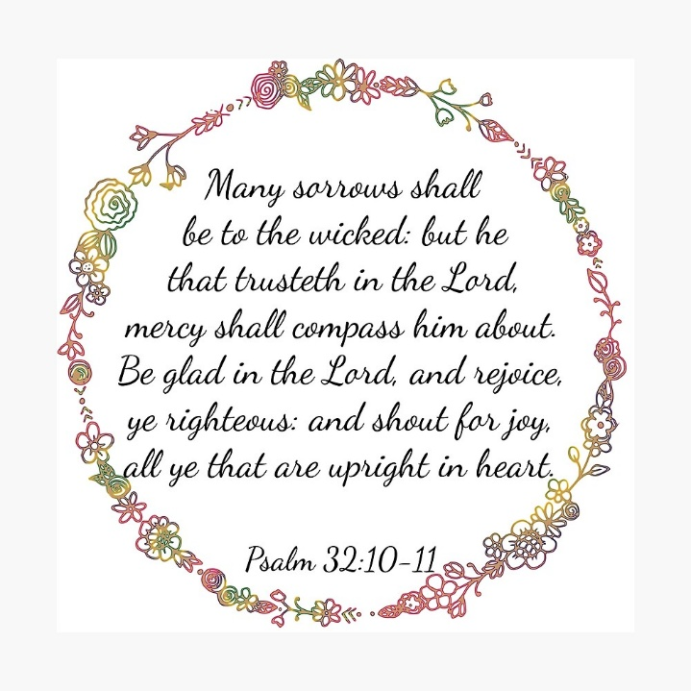

MARCH, 2026

3-1, 8, 15, 22,29 9:32 A.M. Sunday Worship on Zoom
AND IN SANCTUARY!!

Mondays, Wednesdays: 9:30-11:30 A.M. Quilting
There will be no quilting if Rockwood schools are closed

3-1 Communion Sunday (Love Feast) with
crackers and juice if you do not have the
communion elements.

3-6 World Day of Prayer

3-8 Ad Board/Finance/Trustees meeting after Worship
Scouting Sunday

3-8 Daylight Savings Time Begins



3-15 UMCOR Sunday

3-17 St. Patrick’s Day

3-20 First Day of Spring

3-29 Palm/Passion Sunday

3-29—4-5 Holy Week

Monday: Matthew 21:12-19 (Jesus cleanses the temple)

Tuesday: Matthew 21:23-46 (Jesus rebukes the Pharisees)

Wednesday: Matthew 24:1-36 (Signs of things to come)

Thursday: Matthew 26:20-75 (The Significance of the Last
Supper)

Friday: Matthew 27:1-61 (Jesus’ crucifixion)

Saturday: Matthew 27:57-61 (Responding to the Cross)

Sunday: Matthew 28:1-20 (Startling Implications of the
Resurrection)
The 30-Day Church Challenge

Whether in the Sanctuary or on Zoom:
Family, we want to hear from you!

What would make you want to come to church—
or Zoom in—more often?
If you already join us from time to time, what would help you stay more connected and consistent in worship and fellowship?
Would it be a special project that excites your heart?
A mission that reaches others in need?
A ministry that helps you grow deeper in faith or serve in new ways?
This invitation is for everyone—our in-person family and our Zoom family alike.
We believe God can use your ideas—big or small, simple or bold—to strengthen our community and renew our dedication to Him.

Here’s How It Works:
1. Pray for 30 days – Ask God to reveal His vision for our church.
2. Write down your ideas – No idea is too small, too large, or too “trivial.”
3. Submit your thoughts – We’ll collect and compile them for prayerful review.
4. On Trinity Sunday, May 31, 2026, we’ll begin to implement what God reveals through this time of reflection and renewal.

“Unless the Lord builds the house, those who build it labor in vain.” — Psalm 127:1
• Let’s dream together.
• Let’s pray together.
• Let’s grow together.

And let’s watch what God will do when His people are faithful in the meantime and united in purpose.

PRAYER REQUESTS

Your prayer concerns are important to us. If you have a prayer need, joy or concern, if you need someone to just pray with you during this week, or if you are looking to connect with a church that loves people and you are interested in doing ministry and mission is this new way, please call Pastor Jewell at (314) 401-7672 or the church (636) 225-0057. We will walk with you no matter where you are on your journey. Check on someone you’ve not heard from this week.

MEMBERS, FRIENDS AND RELATIVES

Janet and Pasquale Parenti Jim Sieberg
June Bouck and her children Randy Statler
Glenda Hamilton and family Nancy and David Limback
Brinda Armstead Ashford
Alex, Alexis, Aubrey and Aden Mitchell Robison (Todd and Penny)
Captain Irma Hamilton and Dorothy Hamilton
Lilly Mulligan (Kolander) Mark Rudoff (Carol Hamilton)
Nick and Erin Rasch (Limback) Cynthia and Kenny Gooch
Doris “Bonnie” Watson; Sandy Nathan
Sara Laun (Nancy Limback’s mother)
Cathy Becker, Chris Ewalt, Abigail Ewalt (Welsh)
Michael Schmidt (Haubrich) Sybil Young (Grant’s wife)
Mary Ellen Pagliughi (Dodson) Michelle Morton
Joe and Penny Moskus Frances “Cookie” Whitfield
Yvonne McClain Letha and Jim Buckley Michelle Parker
Laurie and Jeff Knight Chris Sides Kimmy Limback
Betty Slunaker (Welsh) Gary Laun (Limback)
Stean Pack (Brodie) Freddie Freeman
Mary Cosmo (Rev. Jespersen’s daughter-in-law)
Susan Jespersen
Kathy Wuestling, Wayne Chinn, Brandon Williams (G. Hamilton)
Theresa Hamilton, Walker Friedmeyer, Jen Kurowski (G. Hamilton)
Jean Hopper (Dodson) Becky Halker
Mike Hendrickson (Dodson) Mary Crawford
Joan Ranson

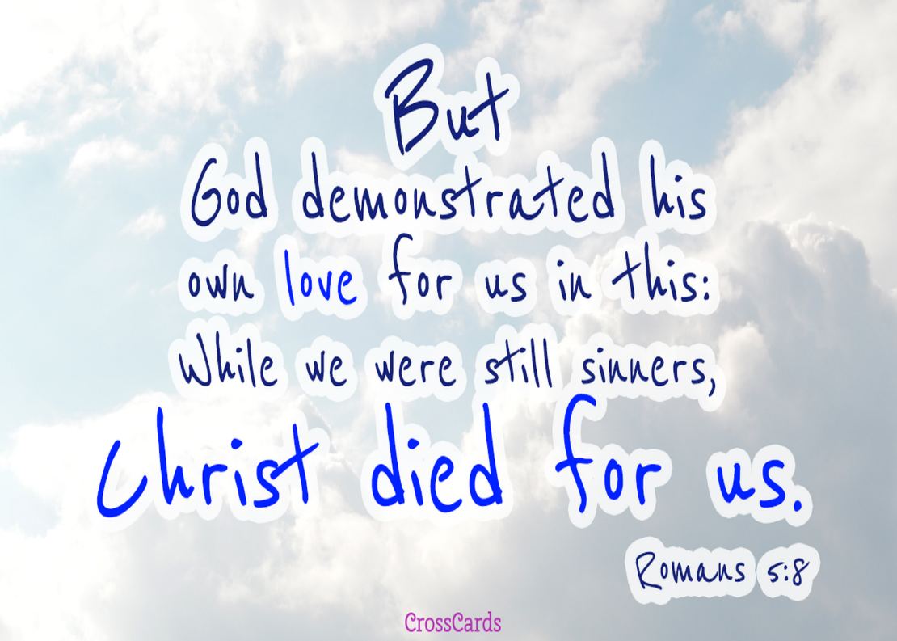

DAILY PRAYER TIME: 1:11 P.M. Stop and say a few prayers for ourselves, our families, friends, neighbors and our prayer list.

Based on Matthew 4:1-11, these prayers focus on seeking strength to overcome temptation through Scripture, relying on the Holy Spirit rather than personal desire, and trusting in God’s provision. They ask for deliverance from satanic influence, wisdom to resist shortcuts to success, and grace to prioritize God's word over worldly comfort.

Prayers for Ourselves:

For Strength in Temptation: "Lord, when I am tempted to satisfy my own desires apart from Your will, help me to remember that I live by every word that comes from Your mouth. Strengthen my inner man to resist the urge to choose comfort over obedience."

For Reliance on the Word: "Father, thank You for the example of Jesus. Help me to use Scripture as my defense against deception. Let Your Word be sharper than any temptation I face today."

For Submission to the Spirit: "Lord, I surrender my ways to You. Just as the Spirit led Jesus, lead me away from the traps of the enemy and guide me into paths of righteousness and truth."

Prayers for Others

For Those Facing Trials: "Lord, I pray for those who are currently in their own 'wilderness'—facing intense trials, hunger, or loneliness. Strengthen them to endure and remind them that You are with them, sending Your angels to comfort and sustain them."

For Deliverance from Deception: "Father, I pray for those being deceived by false promises of power or wealth. Open their eyes to recognize the enemy's traps and give them the wisdom to seek first Your kingdom, rejecting quick, unholy fixes."

For Spiritual Renewal: "Lord, I lift up those whose spirits are weak and exhausted. Renew their strength and help them to rely on Your grace rather than their own, that they might stand firm against temptation."

A Prayer of Thanksgiving

"Thank You, Father, that Jesus has already won the victory over Satan, sin, and the world. Because He was tempted and remained faithful, I have the assurance of His grace when I am weak. Thank You for the promise of protection and the promise that I can do all things through Christ."

Why we don’t sing Alleluia during Lent

The word "Alleluia" is omitted during Lent to honor the season's 40-day penitential, somber, and reflective tone, marking a "fast" from this joyful exclamation of praise. By removing it, the Church creates anticipation for the Resurrection, making its return on Easter Sunday feel more powerful, fresh, and jubilant.

Reasons for the Lenten "Fast" from Alleluia:

Penitential Focus: Lent is a time for repentance, self-reflection, and acknowledging sin, which contrasts with the jubilant praise of "Alleluia" (meaning "Praise the Lord").

Symbolic Fasting: Just as one might fast from food, the church "fasts" from specific joyful songs and expressions to heighten spiritual focus.

Building Anticipation: Removing the word for 40 days makes its return at the Easter Vigil a more meaningful celebration of the Resurrection.

Liturgical Tradition: While it is a tradition rather than strict doctrine for all, it is a key feature of the Roman Rite's Lenten liturgies.

Some traditions call this practice "burying the Alleluia" to mark the transition into a period of solemnity.
