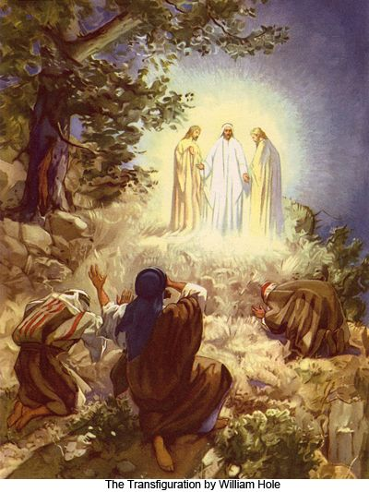

VALLEY PARK UNITED METHODIST CHURCH
436 Valley School Drive, Valley Park, MO 63088

Pastor: Jewell Brodie
Church Phone: 636-225-0057
Cell Phone: 314-401-7672
Church website: Valleypark-umc.org (BETA test version)
Church e-mail address: vpumc88@sbcglobal.net
A CELEBRATION OF THE GOSPEL
Proclamation: Every believer-Every day in God’s Word
Mission Statement: We are a Bible-believing Christian community inviting all people on a spiritual journey, forming companions in faith, and sending disciples of Jesus Christ into the world. “Which means we are called to “Carry on the Work of Christ”). Vision and Mission: We Exist to Worship; We Depart to Serve;
Connect: Christ Likeness—Inside Out

Transfiguration Sunday
Liturgical Color: Green

Our Theme: “Illumine—Be The Light, Yet Even Now”
“With God All Things Are Possible”
February 15, 2026

Praise and Worship Music 9:00—9:30 A.M.

PRELUDE

GREETING As we begin our service:
“LET US KEEP OUR EYES ON THE MASTER”

MUSIC/WORSHIP

WORDS OF REPENTANCE:
Let us repent as a people, as a church, as a community and as a nation.

PSALM 2 (NIV)

1 Why do the nations conspire and the peoples plot in vain?
2 The kings of the earth rise up and the rulers band together
against the Lord and against his anointed, saying,
3 “Let us break their chains and throw off their shackles.”

4 The One enthroned in heaven laughs; the Lord scoffs at them.
5 He rebukes them in his anger and terrifies them in his wrath, saying,
6 “I have installed my king on Zion, my holy mountain.”
7 I will proclaim the Lord’s decree:

He said to me, “You are my son; today I have become your father.
8 Ask me, and I will make the nations your inheritance,
the ends of the earth your possession.
9 You will break them with a rod of iron;
you will dash them to pieces like pottery.”
10 Therefore, you kings, be wise; be warned, you rulers of the earth.
11 Serve the Lord with fear and celebrate his rule with trembling.
12 Kiss his son, or he will be angry and your way will lead to your destruction, for his wrath can flare up in a moment.

Blessed are all who take refuge in him.

OPENING PRAYER

WORDS OF ASSURANCE

OUR FAITH DECLARATION (for the congregation):

“Lord, even when we can’t see it, we believe You are working. When what’s left looks few, less, or little, remind us that you are still with us.
We will keep building, keep believing, and keep holding on—because Your glory is coming.”

THE FIRST COMMANDMENT: Mark 12:30

The first of all the commandments is: You shall love the Lord your God with all your heart and with all your soul and with all your mind and with all your strength. And the second, like it, is this: ‘You shall love your neighbor as yourself.’

Exodus 19:8: All that you say, Lord, we will do.

*HYMN “Turn Your Eyes Upon Jesus” UMH #349
“Lord, I Want To Be A Christian” (vs. 1,4) UMH #402
“Wonderful Words of Life” (vs 1,3) UMH #600
*CALL TO WORSHIP

Leader: As God called to Moses from the mountain,

People: we are called to be God’s people.

Leader: As Jesus called the disciples to climb with him to the peak of
another mountain,

People: we are called to follow wherever he leads.

Leader: As the disciples stood in awe at the sound of God’s voice,

People: we are called to worship in wonder and praise.

*HYMN “Holy Ground” FWS #2272

*SCRIPTURE READING Matthew 17:1-9 (NIV)

The Transfiguration

17 After six days Jesus took with him Peter, James and John the brother of James, and led them up a high mountain by themselves. 2 There he was transfigured before them. His face shone like the sun, and his clothes became as white as the light. 3 Just then there appeared before them Moses and Elijah, talking with Jesus.

4 Peter said to Jesus, “Lord, it is good for us to be here. If you wish, I will put up three shelters—one for you, one for Moses and one for Elijah.”

5 While he was still speaking, a bright cloud covered them, and a voice from the cloud said, “This is my Son, whom I love; with him I am well pleased. Listen to him!”

6 When the disciples heard this, they fell facedown to the ground, terrified. 7 But Jesus came and touched them. “Get up,” he said. “Don’t be afraid.” 8 When they looked up, they saw no one except Jesus.
9 As they were coming down the mountain, Jesus instructed them, “Don’t tell anyone what you have seen, until the Son of Man has been raised from the dead.”

Leader: This is the Gospel of Jesus Christ.
People: Thanks be to God for Jesus Christ. Amen.

SPECIAL MUSIC

THE MESSAGE “Stay Awake” Pastor Jewell Brodie

DOXOLOGY UMH #95
Praise God from whom all blessings flow
Praise Him all creatures here below
Praise Him above ye heavenly host
Praise Father, Son and Holy Ghost. Amen.

“HEAR O ISRAEL”

OUR PRAYER AND TIME OF REFLECTION

PASTORAL PRAYER (including prayers for the people, silent prayers of the people.

THE LORD'S PRAYER
And now, with the confidence of children of God, let us pray:

Our Father who art in heaven, hallowed be thy name, thy kingdom come, thy will be done, on earth as it is in heaven. Give us this day our daily bread and forgive us our trespasses as we forgive those who trespass against us. And lead us not into temptation, but deliver us from evil. For thine is the kingdom, and the power, and the glory forever. Amen.

RESPONSE “Alleluia” FWS #2043
“Alleluia, Alleluia, Alleluia, Alleluia”

ANNOUNCEMENTS

TITHES AND OFFERINGS—Please leave your tithes and offerings in one of the collection boxes either on your way in or on your way out of the sanctuary.

*HYMN OF CELEBRATION “O Master, Let Me Walk With Thee”
UMH #430

SPECIAL MUSIC

*BENEDICTION

Go now, and speak of what you have seen of God’s glory.
Do not cling to the holy moments when heaven overshadows you,
but as the Lord lives, listen to Christ and follow him from the places of revelation to the places of mission.

And may God shine the light of glory into your hearts.
May Christ be with you and never leave you.
And may the Spirit renew the image of God within you.

Go in peace to love and serve the Lord . In the name of Christ. Amen.

*SHALOM

Shalom to you now, shalom, my friends. May God’s full mercies be yours my friends. In all your living and through your loving, Christ be your shalom, Christ be your shalom.

*POSTLUDE

THIS WEEK’S LECTIONARY READINGS: NEXT WEEK’S LECTIONARY READINGS:
Exodus 24:12-18 Genesis 2:15-17; 3:1-7
Psalm 2 Psalm 32
2 Peter 1:16-21 Romans 5:12-19
Matthew 17:1-9 Matthew 4:1-11

CIRCLE OF CONCERN—current needs: Dinner Helpers; Pasta Sauce; Canned Fruit; Condiments; Snacks (8-12 servings/package); Size 5 and 6 Diapers; Baby wipes
View our Amazon Wish List, Walmart List or Target List for more items to fill our pantry.

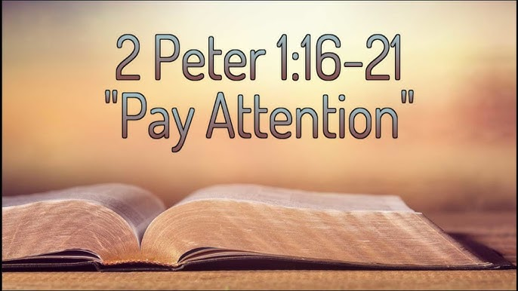

FEBRUARY, 2026

2-22 9:32 A.M. Sunday Worship on Zoom
AND IN SANCTUARY!!

Mondays, Wednesdays: 9:30-11:30 A.M. Quilting
There will be no quilting if Rockwood schools are closed

TODAY Transfiguration Sunday

2-16 Presidents’ Day

2-18 7:15 p.m.--Ash Wednesday Service

2-22 First Sunday In Lent

MARCH, 2026

3-1, 8, 15, 22,29 9:32 A.M. Sunday Worship on Zoom
AND IN SANCTUARY!!

Mondays, Wednesdays: 9:30-11:30 A.M. Quilting
There will be no quilting if Rockwood schools are closed

3-1 Communion Sunday (Love Feast) with
crackers and juice if you do not have the
communion elements.

3-6 World Day Of Prayer

3-8 Ad Board/Finance/Trustees meeting after Worship
Scouting Sunday

3-8 Daylight Savings Time Begins



3-15 UMCOR Sunday

3-17 St. Patrick’s Day

3-20 First Day of Spring

3-29 Palm/Passion Sunday

3-29—4-5 Holy Week

Monday: Matthew 21:12-19 (Jesus cleanses the temple)

Tuesday: Matthew 21:23-46 (Jesus rebukes the Pharisees)

Wednesday: Matthew 24:1-36 (Signs of things to come)

Thursday: Matthew 26:20-75 (The Significance of the Last
Supper)

Friday: Matthew 27:1-61 (Jesus’ crucifixion)

Saturday: Matthew 27:57-61 (Responding to the Cross)

Sunday: Matthew 28:1-20 (Startling Implications of the
Resurrection)

The 30-Day Church Challenge

Whether in the Sanctuary or on Zoom:
Family, we want to hear from you!

What would make you want to come to church—
or Zoom in—more often?
If you already join us from time to time, what would help you stay more connected and consistent in worship and fellowship?
Would it be a special project that excites your heart?
A mission that reaches others in need?
A ministry that helps you grow deeper in faith or serve in new ways?
This invitation is for everyone—our in-person family and our Zoom family alike.
We believe God can use your ideas—big or small, simple or bold—to strengthen our community and renew our dedication to Him.

Here’s How It Works:
1. Pray for 30 days – Ask God to reveal His vision for our church.
2. Write down your ideas – No idea is too small, too large, or too “trivial.”
3. Submit your thoughts – We’ll collect and compile them for prayerful review.
4. On Trinity Sunday, May 31, 2026, we’ll begin to implement what God reveals through this time of reflection and renewal.

“Unless the Lord builds the house, those who build it labor in vain.” — Psalm 127:1
• Let’s dream together.
• Let’s pray together.
• Let’s grow together.

And let’s watch what God will do when His people are faithful in the meantime and united in purpose.

PRAYER REQUESTS

Your prayer concerns are important to us. If you have a prayer need, joy or concern, if you need someone to just pray with you during this week, or if you are looking to connect with a church that loves people and you are interested in doing ministry and mission is this new way, please call Pastor Jewell at (314) 401-7672 or the church (636) 225-0057. We will walk with you no matter where you are on your journey. Check on someone you’ve not heard from this week.

MEMBERS, FRIENDS AND RELATIVES

Janet and Pasquale Parenti Jim Sieberg
June Bouck and her children Randy Statler
Glenda Hamilton and family Nancy and David Limback
Brinda Armstead Ashford
Alex, Alexis, Aubrey and Aden Mitchell Robison (Todd and Penny)
Captain Irma Hamilton and Dorothy Hamilton
Lilly Mulligan (Kolander) Mark Rudoff (Carol Hamilton)
Nick and Erin Rasch (Limback) Cynthia and Kenny Gooch
Doris “Bonnie” Watson; Sandy Nathan
Sara Laun (Nancy Limback’s mother)
Cathy Becker, Chris Ewalt, Abigail Ewalt (Welsh)
Michael Schmidt (Haubrich) Sybil Young (Grant’s wife)
Mary Ellen Pagliughi (Dodson) Michelle Morton
Joe and Penny Moskus Frances “Cookie” Whitfield
Yvonne McClain Letha and Jim Buckley Michelle Parker
Laurie and Jeff Knight Chris Sides Kimmy Limback
Betty Slunaker (Welsh) Gary Laun (Limback)
Stean Pack (Brodie) Freddie Freeman
Mary Cosmo (Rev. Jespersen’s daughter-in-law)
Susan Jespersen
Kathy Wuestling, Wayne Chinn, Brandon Williams (G. Hamilton)
Theresa Hamilton, Walker Friedmeyer, Jen Kurowski (G. Hamilton)
Jean Hopper (Dodson) Becky Halker
Mike Hendrickson (Dodson) Mary Crawford
Joan Ranson

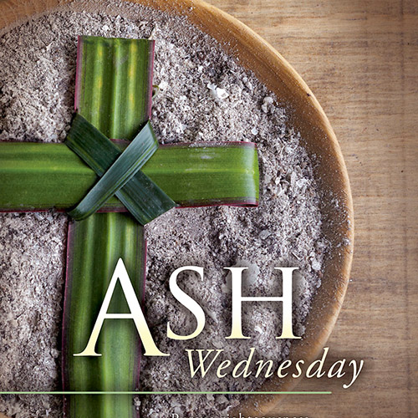

DAILY PRAYER TIME: 1:11 P.M. Stop and say a few prayers for ourselves, our families, friends, neighbors and our prayer list.

Prayers based on the Transfiguration (Matthew 17:1-9) focus on seeking a deeper vision of Christ's glory, listening to the Father's voice, and gaining strength for daily life after mountaintop experiences. These prayers ask for inner transformation to reflect Christ's light, overcome fear, and focus on Jesus alone.

Prayers for Ourselves

For Spiritual Vision: Lord Jesus, transfigure my heart to see Your radiant glory above my daily, worldly worries.

For Transformation: May I, with an unveiled face, reflect Your light, love, and hope, transformed into Your image by Your mercy.

For Listening to the Son: Father, help me to "listen to Him" (Matt 17:5), ignoring distractions and obeying Jesus as the Beloved Son.

For Courage in Fear: When I am overwhelmed by life, I hear You say, "Get up and do not be afraid." Thank You for Your calming presence.

Prayers for Others

For Church Leaders: Lord, ignite the spirits of all church leaders to reveal Your will and guide us to follow Your way.

For the Suffering: Comfort the sick, anxious, and weary, and remind them that the Transfigured Christ holds their souls in glory.

For Those in Injustice: We pray for the oppressed and marginalized; teach us to stand with them, acting with justice and mercy.

For Families and Community: May your presence in our midst protect our families, fostering hope and unity.

A Prayer for Daily Life (The "Coming Down" Prayer)

Lord God, thank You for moments of deep connection with You. As I come down from the mountain and return to the demands of life, help me to walk by faith, carrying the light of Your glory into the world and focusing only on Jesus. Amen.

Transfiguration Sunday is a key liturgical day in the United Methodist Church tradition, serving as the hinge between Epiphany and Lent. It celebrates the moment Jesus' divinity was revealed on a mountain, with his clothes shining brightly. It is a time for reflection on the glory of God and preparing for the path of suffering.

Key Aspects of Transfiguration Sunday in the UMC:

Theological Significance: It is considered a "foretaste of the resurrection" and an affirmation of Jesus as the Messiah.

Symbolism: It bridges the gap between Jesus's ministry and his upcoming Passion.

Scripture Focus: The story is found in the synoptic gospels (Matthew, Mark, and Luke), where Jesus appears with Moses and Elijah.

Worship Themes: Services often focus on the "mountaintop" experience, listening to Jesus ("Listen to him!"), and the transition from celebration to the introspective season of Lent.

Various United Methodist resources, such as Discipleship Ministries, provide liturgies, prayers, and sermons for this day.


