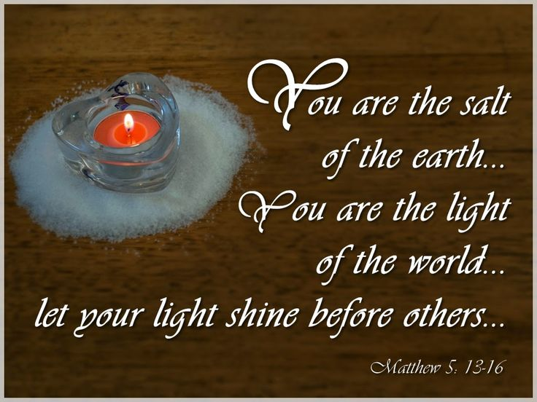

VALLEY PARK UNITED METHODIST CHURCH
436 Valley School Drive, Valley Park, MO 63088

Pastor: Jewell Brodie
Church Phone: 636-225-0057
Cell Phone: 314-401-7672
Church website: Valleypark-umc.org (BETA test version)
Church e-mail address: vpumc88@sbcglobal.net
A CELEBRATION OF THE GOSPEL
Proclamation: Every believer-Every day in God’s Word
Mission Statement: We are a Bible-believing Christian community inviting all people on a spiritual journey, forming companions in faith, and sending disciples of Jesus Christ into the world. “Which means we are called to “Carry on the Work of Christ”). Vision and Mission: We Exist to Worship; We Depart to Serve;
Connect: Christ Likeness—Inside Out

Fifth Sunday After The Epiphany
Liturgical Color: Green

Our Theme: “Illumine—Be The Light, Yet Even Now”
“With God All Things Are Possible”
February 8, 2026

Praise and Worship Music 9:00—9:30 A.M.

PRELUDE

GREETING As we begin our service:
“LET US KEEP OUR EYES ON THE MASTER”

MUSIC/WORSHIP

WORDS OF REPENTANCE:
Let us repent as a people, as a church, as a community and as a nation.

PSALM 112:1-10 (NIV)

1 Praise the Lord.
Blessed are those who fear the Lord,
who find great delight in his commands.

2 Their children will be mighty in the land;
the generation of the upright will be blessed.
3 Wealth and riches are in their houses,
and their righteousness endures forever.
4 Even in darkness light dawns for the upright,
for those who are gracious and compassionate and righteous.
5 Good will come to those who are generous and lend freely,
who conduct their affairs with justice.

6 Surely the righteous will never be shaken;
they will be remembered forever.
7 They will have no fear of bad news;
their hearts are steadfast, trusting in the Lord.
8 Their hearts are secure, they will have no fear;
in the end they will look in triumph on their foes.
9 They have freely scattered their gifts to the poor,
their righteousness endures forever;
their horn will be lifted high in honor.

10 The wicked will see and be vexed,
they will gnash their teeth and waste away;
the longings of the wicked will come to nothing.

OPENING PRAYER

WORDS OF ASSURANCE

OUR FAITH DECLARATION (for the congregation):

“Lord, even when we can’t see it, we believe You are working. When what’s left looks few, less, or little, remind us that you are still with us.
We will keep building, keep believing, and keep holding on—because Your glory is coming.”

THE FIRST COMMANDMENT: Mark 12:30

The first of all the commandments is: You shall love the Lord your God with all your heart and with all your soul and with all your mind and with all your strength. And the second, like it, is this: ‘You shall love your neighbor as yourself.’

Exodus 19:8: All that you say, Lord, we will do.

*HYMN “Pass It On” (vs 1, 3) UMH #569
“His Name Is Wonderful” UMH #174
“Go, Make Of All Disciples” (vs 1,4) UMH #361

*CALL TO WORSHIP

Leader: God said, "Let there be light."

People: And there was light.

Leader: Jesus said, "I am the light of the world."

People: And the light shone in the darkness.

Leader: Jesus said, "You are the light of the world."

People: And the light shall not be quenched.

*HYMN “Open Our Eyes” FWS #2086

*SCRIPTURE READING Matthew 5:13-20 (NIV)

Salt and Light

13 “You are the salt of the earth. But if the salt loses its saltiness, how can it be made salty again? It is no longer good for anything, except to be thrown out and trampled underfoot.

14 “You are the light of the world. A town built on a hill cannot be hidden. 15 Neither do people light a lamp and put it under a bowl. Instead they put it on its stand, and it gives light to everyone in the house. 16 In the same way, let your light shine before others, that they may see your good deeds and glorify your Father in heaven.

The Fulfillment of the Law

17 “Do not think that I have come to abolish the Law or the Prophets; I have not come to abolish them but to fulfill them. 18 For truly I tell you, until heaven and earth disappear, not the smallest letter, not the least stroke of a pen, will by any means disappear from the Law until everything is accomplished. 19 Therefore anyone who sets aside one of the least of these commands and teaches others accordingly will be called least in the kingdom of heaven, but whoever practices and teaches these commands will be called great in the kingdom of heaven. 20 For I tell you that unless your righteousness surpasses that of the Pharisees and the teachers of the law, you will certainly not enter the kingdom of heaven.

Leader: This is the Gospel of Jesus Christ.
People: Thanks be to God for Jesus Christ. Amen.

SPECIAL MUSIC

THE MESSAGE “Living The Light” Pastor Jewell Brodie

DOXOLOGY UMH #95
Praise God from whom all blessings flow
Praise Him all creatures here below
Praise Him above ye heavenly host
Praise Father, Son and Holy Ghost. Amen.

“HEAR O ISRAEL”

OUR PRAYER AND TIME OF REFLECTION

PASTORAL PRAYER (including prayers for the people, silent prayers of the people.

THE LORD'S PRAYER
And now, with the confidence of children of God, let us pray:

Our Father who art in heaven, hallowed be thy name, thy kingdom come, thy will be done, on earth as it is in heaven. Give us this day our daily bread and forgive us our trespasses as we forgive those who trespass against us. And lead us not into temptation, but deliver us from evil. For thine is the kingdom, and the power, and the glory forever. Amen.

RESPONSE “Alleluia” FWS #2043
“Alleluia, Alleluia, Alleluia, Alleluia”

ANNOUNCEMENTS

TITHES AND OFFERINGS—Please leave your tithes and offerings in one of the collection boxes either on your way in or on your way out of the sanctuary.

*HYMN OF CELEBRATION “Lord, Dismiss Us” UMH 671

SPECIAL MUSIC

*BENEDICTION

May our love be like salt that makes life tasty and worthwhile.

May our Christian living be a light to those who live in darkness.

May our Christian communities be cities of light to be seen from afar
as signs that God lives and works in his people.

And may God bless you all for this mission: the Father, and the Son, and the Holy Spirit.

Go now, and let the light of Christ shine
on all those who live around you. Thanks be to God!

*SHALOM

Shalom to you now, shalom, my friends. May God’s full mercies be yours my friends. In all your living and through your loving, Christ be your shalom, Christ be your shalom.

*POSTLUDE

THIS WEEK’S LECTIONARY READINGS: NEXT WEEK’S LECTIONARY READINGS:
Isaiah 58:1-12 Exodus 24:12-18
Psalm 112:1-10 Psalm 2
1 Corinthians 2:1-16 2 Peter 1:16-21
Matthew 5:13-20 Matthew 17:1-9

CIRCLE OF CONCERN—current needs: Dinner Helpers; Pasta Sauce; Canned Fruit; Condiments; Snacks (8-12 servings/package); Size 5 and 6 Diapers; Baby wipes
View our Amazon Wish List, Walmart List or Target List for more items to fill our pantry.

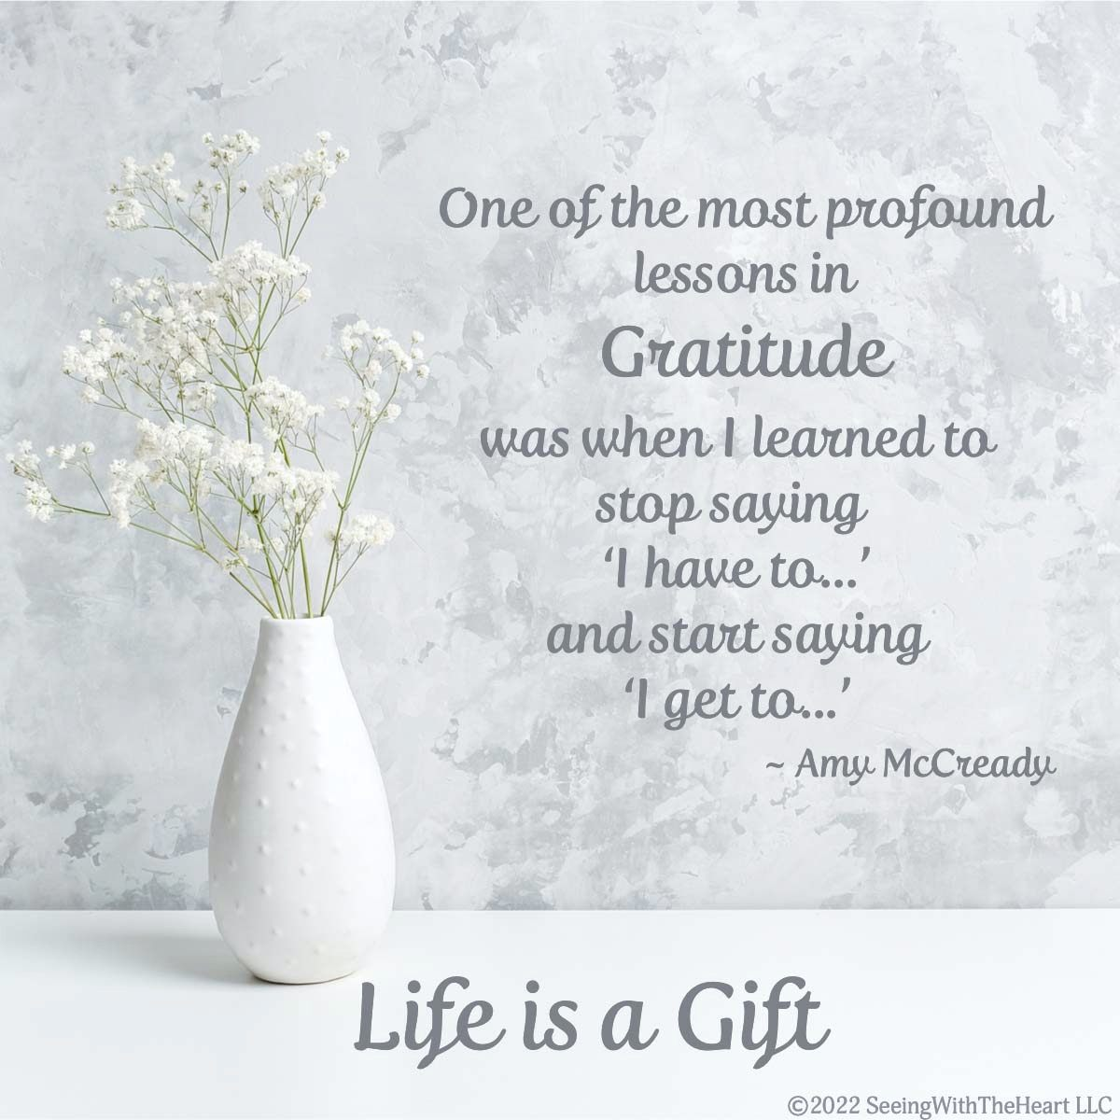
FEBRUARY, 2026

2-15,22 9:32 A.M. Sunday Worship on Zoom
AND IN SANCTUARY!!

Mondays, Wednesdays: 9:30-11:30 A.M. Quilting
There will be no quilting if Rockwood schools are closed

TODAY Ad Board/Finance/Trustees meeting after Worship

2-12 Lincoln’s Birthday

2-14 Valentine’s Day
2-15 Transfiguration Sunday
2-16 Presidents’ Day

2-18 7:15 p.m.--Ash Wednesday Service

2-22 First Sunday In Lent

MARCH, 2026

3-1, 8, 15, 22,29 9:32 A.M. Sunday Worship on Zoom
AND IN SANCTUARY!!

Mondays, Wednesdays: 9:30-11:30 A.M. Quilting
There will be no quilting if Rockwood schools are closed

3-1 Communion Sunday (Love Feast) with
crackers and juice if you do not have the
communion elements.

3-6 World Day Of Prayer
3-8 Ad Board/Finance/Trustees meeting after Worship
Scouting Sunday

3-8 Daylight Savings Time Begins



3-15 UMCOR Sunday

3-17 St. Patrick’s Day

3-20 First Day of Spring

3-29 Palm/Passion Sunday

3-29—4-5 Holy Week

Monday: Matthew 21:12-19 (Jesus cleanses the temple)

Tuesday: Matthew 21:23-46 (Jesus rebukes the Pharisees)

Wednesday: Matthew 24:1-36 (Signs of things to come)

Thursday: Matthew 26:20-75 (The Significance of the Last
Supper)

Friday: Matthew 27:1-61 (Jesus’ crucifixion)

Saturday: Matthew 27:57-61 (Responding to the Cross)

Sunday: Matthew 28:1-20 (Startling Implications of the
Resurrection)
The 30-Day Church Challenge

Whether in the Sanctuary or on Zoom:
Family, we want to hear from you!

What would make you want to come to church—
or Zoom in—more often?
If you already join us from time to time, what would help you stay more connected and consistent in worship and fellowship?
Would it be a special project that excites your heart?
A mission that reaches others in need?
A ministry that helps you grow deeper in faith or serve in new ways?
This invitation is for everyone—our in-person family and our Zoom family alike.
We believe God can use your ideas—big or small, simple or bold—to strengthen our community and renew our dedication to Him.

Here’s How It Works:
1. Pray for 30 days – Ask God to reveal His vision for our church.
2. Write down your ideas – No idea is too small, too large, or too “trivial.”
3. Submit your thoughts – We’ll collect and compile them for prayerful review.
4. On Trinity Sunday, May 31, 2026, we’ll begin to implement what God reveals through this time of reflection and renewal.

“Unless the Lord builds the house, those who build it labor in vain.” — Psalm 127:1
• Let’s dream together.
• Let’s pray together.
• Let’s grow together.

And let’s watch what God will do when His people are faithful in the meantime and united in purpose.

PRAYER REQUESTS

Your prayer concerns are important to us. If you have a prayer need, joy or concern, if you need someone to just pray with you during this week, or if you are looking to connect with a church that loves people and you are interested in doing ministry and mission is this new way, please call Pastor Jewell at (314) 401-7672 or the church (636) 225-0057. We will walk with you no matter where you are on your journey. Check on someone you’ve not heard from this week.

MEMBERS, FRIENDS AND RELATIVES

Janet and Pasquale Parenti Jim Sieberg
June Bouck and her children Randy Statler
Glenda Hamilton and family Nancy and David Limback
Brinda Armstead Ashford
Alex, Alexis, Aubrey and Aden Mitchell Robison (Todd and Penny)
Captain Irma Hamilton and Dorothy Hamilton
Lilly Mulligan (Kolander) Mark Rudoff (Carol Hamilton)
Nick and Erin Rasch (Limback) Cynthia and Kenny Gooch
Doris “Bonnie” Watson; Sandy Nathan
Sara Laun (Nancy Limback’s mother)
Cathy Becker, Chris Ewalt, Abigail Ewalt (Welsh)
Michael Schmidt (Haubrich) Sybil Young (Grant’s wife)
Mary Ellen Pagliughi (Dodson) Michelle Morton
Joe and Penny Moskus Frances “Cookie” Whitfield
Yvonne McClain Letha and Jim Buckley Michelle Parker
Laurie and Jeff Knight Chris Sides Kimmy Limback
Betty Slunaker (Welsh) Gary Laun (Limback)
Stean Pack (Brodie) Freddie Freeman
Mary Cosmo (Rev. Jespersen’s daughter-in-law)
Susan Jespersen
Kathy Wuestling, Wayne Chinn, Brandon Williams (G. Hamilton)
Theresa Hamilton, Walker Friedmeyer, Jen Kurowski (G. Hamilton)
Jean Hopper (Dodson) Becky Halker
Mike Hendrickson (Dodson) Mary Crawford
Joan Ranson

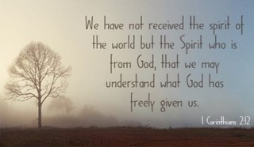

DAILY PRAYER TIME: 1:11 P.M. Stop and say a few prayers for ourselves, our families, friends, neighbors and our prayer list.

Based on Matthew 5:13-20, these prayers focus on being active "salt" and "light" in the world, asking for the strength to live out Christ’s righteousness, shine His truth, and avoid becoming ineffective. They encourage using our lives to glorify God rather than seeking self-glory, serving as a preservative and beacon of hope.

Prayers for Ourselves

To Be Light: "Lord, cleanse me anew that I may be a bright witness for You. Help me to pierce the darkness of this world with Your light shining through my words, actions, and daily life in my work, home, and community".

To Be Salt: "Father, help me not to lose my saltiness. Give me the boldness to speak Your truth, preserve goodness, and bring the seasoning of grace to those around me".

For True Righteousness: "Lord, grant me a righteousness that goes deeper than superficial actions. Let my heart be aligned with Your commandments, and help me to follow You wholeheartedly, not just in appearance".

Prayers for Others

For Boldness in Others: "Lord, I pray for my brothers and sisters in faith, that we may not hide our light. Give us courage to stand out and shine in a way that leads others to glorify You".

For the Lost and Hopeless: "Father, I bring before You those in my community who are in darkness or feel abandoned. May they see the light of Your love through our service and find hope in You".

For Impactful Living: "God, I pray that our lives together, as a church, would act as a preserving influence in this culture, combating greed and selfishness with compassion and healing".

A Closing Prayer for Daily Living

"Lord Jesus, you called us to be the salt of the earth and the light of the world. As I navigate this day, fill me with Your Spirit to make a difference. Let my life be a reflection of Your love, adding flavor and hope to the lives I touch, so that in all I do, Your name is honored. Amen".

