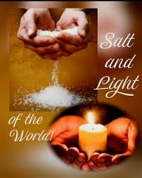

VALLEY PARK UNITED METHODIST CHURCH
436 Valley School Drive, Valley Park, MO 63088

Pastor: Jewell Brodie
Church Phone: 636-225-0057
Cell Phone: 314-401-7672
Church website: Valleypark-umc.org (BETA test version)
Church e-mail address: vpumc88@sbcglobal.net
A CELEBRATION OF THE GOSPEL
Proclamation: Every believer-Every day in God’s Word
Mission Statement: We are a Bible-believing Christian community inviting all people on a spiritual journey, forming companions in faith, and sending disciples of Jesus Christ into the world. “Which means we are called to “Carry on the Work of Christ”). Vision and Mission: We Exist to Worship; We Depart to Serve;
Connect: Christ Likeness—Inside Out

Third Sunday After The Epiphany
Liturgical Color: Green

Our Theme: “Illumine—Be The Light, Yet Even Now”
“With God All Things Are Possible”
January 25, 2026

Praise and Worship Music 9:00—9:30 A.M.

PRELUDE

GREETING As we begin our service:
“LET US KEEP OUR EYES ON THE MASTER”

MUSIC/WORSHIP

WORDS OF REPENTANCE:
Let us repent as a people, as a church, as a community and as a nation.

Psalm 27:1, 4-9—A psalm of David. (NLT)

1 The Lord is my light and my salvation—so why should I be afraid?
The Lord is my fortress, protecting me from danger,
so why should I tremble?

4 The one thing I ask of the Lord—the thing I seek most—
is to live in the house of the Lord all the days of my life,
delighting in the Lord’s perfections and meditating in his Temple.

5 For he will conceal me there when troubles come;
he will hide me in his sanctuary.
He will place me out of reach on a high rock.
6 Then I will hold my head high
above my enemies who surround me.
At his sanctuary I will offer sacrifices with shouts of joy,
singing and praising the Lord with music.

7 Hear me as I pray, O Lord.
Be merciful and answer me!
8 My heart has heard you say, “Come and talk with me.”
And my heart responds, “Lord, I am coming.”
9 Do not turn your back on me.
Do not reject your servant in anger.
You have always been my helper.
Don’t leave me now; don’t abandon me,
O God of my salvation!

OPENING PRAYER

WORDS OF ASSURANCE

OUR FAITH DECLARATION (for the congregation):

“Lord, even when we can’t see it, we believe You are working. When what’s left looks few, less, or little, remind us that you are still with us.
We will keep building, keep believing, and keep holding on—because Your glory is coming.”

THE FIRST COMMANDMENT: Mark 12:30

The first of all the commandments is: You shall love the Lord your God with all your heart and with all your soul and with all your mind and with all your strength. And the second, like it, is this: ‘You shall love your neighbor as yourself.’

Exodus 19:8: All that you say, Lord, we will do.
*HYMN “We’ve A Story To Tell” (vs 1, 4) UMH #569
“Be Thou My Vision” (vs 1,3) UMH #451
“Rock Of Ages, Cleft For Me” (vs 1,4) UMH #361

*CALL TO WORSHIP

Leader: If the human body, body of blood and muscle, is to live, it needs
salt.

People: If the body of Christ, body of peace and justice, is to live, it
needs us!

Leader: If the earthly creation, bustling and blooming, is to flourish, it
needs the sun’s light.

People: If the new creation we are in Christ is to flourish, it needs
the Spirit’s light!

Leader: Jesus says we are salt of the earth, light of the world.

People: Our faith, our love, our hope —essential as salt and light.

Leader: But if salt isn’t salty?

People: It isn’t what it’s meant to be.

Leader: And if a light doesn’t shine?

People: It isn’t what it’s meant to be.

Leader: Jesus says we are salt of the earth, light of the world. Briny and
bright, we are God’s faithful people.

People: We shall be who we are meant to be in Christ: a welcoming
oasis, a compassionate community, a justice-making
people, giving glory to God!

*HYMN “O How He Loves You And Me” FWS #2108

*SCRIPTURE READING Matthew 5:13-20 (NLT)

Teaching about Salt and Light

13 “You are the salt of the earth. But what good is salt if it has lost its flavor? Can you make it salty again? It will be thrown out and trampled underfoot as worthless.

14 “You are the light of the world—like a city on a hilltop that cannot be hidden. 15 No one lights a lamp and then puts it under a basket. Instead, a lamp is placed on a stand, where it gives light to everyone in the house. 16 In the same way, let your good deeds shine out for all to see, so that everyone will praise your heavenly Father.

Teaching about the Law

17 “Don’t misunderstand why I have come. I did not come to abolish the law of Moses or the writings of the prophets. No, I came to accomplish their purpose. 18 I tell you the truth, until heaven and earth disappear, not even the smallest detail of God’s law will disappear until its purpose is achieved. 19 So if you ignore the least commandment and teach others to do the same, you will be called the least in the Kingdom of Heaven. But anyone who obeys God’s laws and teaches them will be called great in the Kingdom of Heaven.

20 “But I warn you—unless your righteousness is better than the righteousness of the teachers of religious law and the Pharisees, you will never enter the Kingdom of Heaven!

Leader: This is the Gospel of Jesus Christ.
People: Thanks be to God for Jesus Christ. Amen.

SPECIAL MUSIC

THE MESSAGE “Come And See: Called, Known And Sent”
Pastor Jewell Brodie

DOXOLOGY UMH #95
Praise God from whom all blessings flow
Praise Him all creatures here below
Praise Him above ye heavenly host
Praise Father, Son and Holy Ghost. Amen.

“HEAR O ISRAEL”

OUR PRAYER AND TIME OF REFLECTION

PASTORAL PRAYER (including prayers for the people, silent prayers of the people.

THE LORD'S PRAYER
And now, with the confidence of children of God, let us pray:

Our Father who art in heaven, hallowed be thy name, thy kingdom come, thy will be done, on earth as it is in heaven. Give us this day our daily bread and forgive us our trespasses as we forgive those who trespass against us. And lead us not into temptation, but deliver us from evil. For thine is the kingdom, and the power, and the glory forever. Amen.

RESPONSE “Alleluia” FWS #2043
“Alleluia, Alleluia, Alleluia, Alleluia”

ANNOUNCEMENTS

TITHES AND OFFERINGS—Please leave your tithes and offerings in one of the collection boxes either on your way in or on your way out of the sanctuary.

*HYMN OF CELEBRATION “To God Be The Glory” UMH #98

SPECIAL MUSIC

*BENEDICTION

May our love be like salt that makes life tasty and worthwhile. May our Christian living be a light to those who live in darkness. May our Christian communities be cities of light to be seen from afar as signs that God lives and works in his people. And may God bless you all for this mission: the Father, and the Son, and the Holy Spirit.

Go now, and let the light of Christ shine on all those who live around you. Thanks be to God!

*SHALOM

Shalom to you now, shalom, my friends. May God’s full mercies be yours my friends. In all your living and through your loving, Christ be your shalom, Christ be your shalom.

*POSTLUDE

THIS WEEK’S LECTIONARY READINGS: NEXT WEEK’S LECTIONARY READINGS:
Isaiah 9:1-4 Micah 6:1-8
Psalm 27:1, 4-9 Psalm 15
1 Corinthians 1:18-31 1 Corinthians 1:18-31
Matthew 5:13-20 Matthew 5:1-12

CIRCLE OF CONCERN—current needs: Dinner Helpers; Pasta Sauce; Canned Fruit; Condiments; Snacks (8-12 servings/package); Size 5 and 6 Diapers; Baby wipes
View our Amazon Wish List, Walmart List or Target List for more items to fill our pantry.

New Church website: Valleypark-umc.org
(BETA test version)

JOIN US TO ENJOY A CONCERT GIVEN BY OUR OWN DEVIN ADAMS.
THERE MIGHT BE A CHANGE IN DATE OF THE CONCERT. WATCH HERE FOR CHANGES COMING SOON.

JANUARY, 2026

TODAY 9:32 A.M. Sunday Worship on Zoom
AND IN SANCTUARY!!
Ecumenical Sunday

Mondays, Wednesdays: 9:30-11:30 A.M. Quilting
There will be no quilting if Rockwood schools are closed

FEBRUARY, 2026

2-1,8,15,22 9:32 A.M. Sunday Worship on Zoom
AND IN SANCTUARY!!

Mondays, Wednesdays: 9:30-11:30 A.M. Quilting
There will be no quilting if Rockwood schools are closed

2-1 Communion Sunday (Love Feast) with
crackers and juice if you do not have the
communion elements.
National Freedom Day
2-2 Groundhog Day
2-8 Ad Board/Finance/Trustees meeting after Worship
2-12 Lincoln’s Birthday
2-14 Valentine’s Day
2-15 Transfiguration Sunday
2-16 Presidents’ Day
2-18 Ash Wednesday
2-22 First Sunday In Lent

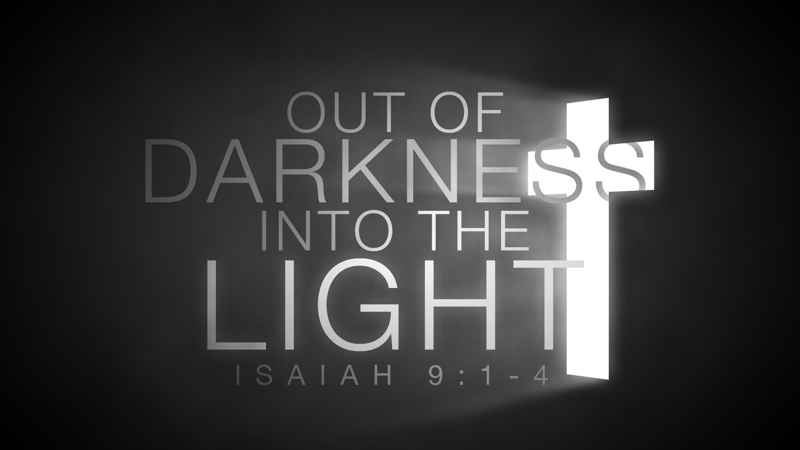

The 30-Day Church Challenge

Whether in the Sanctuary or on Zoom:
Family, we want to hear from you!

What would make you want to come to church—
or Zoom in—more often?
If you already join us from time to time, what would help you stay more connected and consistent in worship and fellowship?
Would it be a special project that excites your heart?
A mission that reaches others in need?
A ministry that helps you grow deeper in faith or serve in new ways?
This invitation is for everyone—our in-person family and our Zoom family alike.
We believe God can use your ideas—big or small, simple or bold—to strengthen our community and renew our dedication to Him.

Here’s How It Works:
1. Pray for 30 days – Ask God to reveal His vision for our church.
2. Write down your ideas – No idea is too small, too large, or too “trivial.”
3. Submit your thoughts – We’ll collect and compile them for prayerful review.
4. On Trinity Sunday, May 31, 2026, we’ll begin to implement what God reveals through this time of reflection and renewal.

“Unless the Lord builds the house, those who build it labor in vain.” — Psalm 127:1
• Let’s dream together.
• Let’s pray together.
• Let’s grow together.

And let’s watch what God will do when His people are faithful in the meantime and united in purpose.

PRAYER REQUESTS

Your prayer concerns are important to us. If you have a prayer need, joy or concern, if you need someone to just pray with you during this week, or if you are looking to connect with a church that loves people and you are interested in doing ministry and mission is this new way, please call Pastor Jewell at (314) 401-7672 or the church (636) 225-0057. We will walk with you no matter where you are on your journey. Check on someone you’ve not heard from this week.

MEMBERS, FRIENDS AND RELATIVES

Janet and Pasquale Parenti Jim Sieberg
June Bouck and her sons Randy Statler
Glenda Hamilton and family Nancy and David Limback
Brinda Armstead Ashford
Alex, Alexis, Aubrey and Aden Mitchell Robison (Todd and Penny)
Captain Irma Hamilton and Dorothy Hamilton
Lilly Mulligan (Kolander) Mark Rudoff (Carol Hamilton)
Nick and Erin Rasch (Limback) Cynthia and Kenny Gooch
Doris “Bonnie” Watson; Sandy Nathan
Sara Laun (Nancy Limback’s mother)
Cathy Becker, Chris Ewalt, Abigail Ewalt (Welsh)
Michael Schmidt (Haubrich) Sybil Young (Grant’s wife)
Mary Ellen Pagliughi (Dodson) Michelle Morton
Joe and Penny Moskus Frances “Cookie” Whitfield
Yvonne McClain Letha and Jim Buckley Michelle Parker
Laurie and Jeff Knight Chris Sides Kimmy Limback
Betty Slunaker (Welsh) Gary Laun (Limback)
Stean Pack (Brodie) Freddie Freeman
Mary Cosmo (Rev. Jespersen’s daughter-in-law)
Susan Jespersen
Kathy Wuestling, Wayne Chinn, Brandon Williams (G. Hamilton)
Theresa Hamilton, Walker Friedmeyer, Jen Kurowski (G. Hamilton)
Jean Hopper (Dodson) Becky Halker
Mike Hendrickson (Dodson) Mary Crawford
Joan Ranson

DAILY PRAYER TIME: 1:11 P.M. Stop and say a few prayers for ourselves, our families, friends, neighbors and our prayer list.

Prayers based on Matthew 5:13-20 focus on being salt of the earth (preserving, flavoring, purifying) and light of the world (guiding, illuminating, revealing God's goodness), asking God to help us live distinct, impactful lives, share His love, and shine for His glory, not our own, so others see Christ in our words and actions and glorify the Father. We pray for strength to be bold in kindness, humble in service, and connected to Jesus (our power source) to avoid becoming bland or hiding our faith, bringing hope and truth to our communities and world.

Prayers for Ourselves (Salt & Light)

For Flavor & Preservation: "Heavenly Father, help me be salt in my everyday life, adding flavor, preserving truth, and preventing corruption. Don't let me become bland or useless; infuse me with Your Spirit to bring goodness and healing where I am.

For Illumination: "Lord Jesus, I am your light. Help me not to hide it under a basket but to put it on a stand, shining brightly in my home, work, and community. Let my good deeds point others to You, so they see Your love and glorify God.

For Courage & Connection: "Father, I need Your strength to be a bold witness. Keep me connected to You, my source of light, so I can reflect Your presence. Give me courage to be visible in kindness and humble in service, sharing Your grace in a darkened world.

Prayers for Others (Salt & Light)

For a Nation/Community: "Lord, for our nation/community, we pray for a return to Your truth. Be our salt to preserve righteousness and our light to guide us. Break our hearts for those lost in darkness and empower Your people to shine Your love, so all may see and glorify You.

For People in Darkness: "Holy Spirit, reach those who are lost and in darkness. Let your light break through their struggles. Be the salt of Your grace to heal their pain and preserve them from evil. Use us, Your people, as Your hands and feet to bring Your hope to them.

For those who Hide: "Father, for those hiding their faith or their struggles, remove the fear and apathy. Help them see their identity as Your light. Give them the courage to let their good works shine, reflecting Your glory and drawing others to find You.

A Combined Prayer (Matthew 5:13-20)

"Lord, we confess we often forget we are the salt of the earth and the light of the world, meant to season and illuminate. Help us to be salty with Your truth and light with Your love, not for our glory, but so that others may see our good works and give glory to You, our Father in heaven. May we never hide our light or lose our savor. Fill us with Your Spirit to be a visible, powerful, and consistent witness in a world that desperately needs You, in Jesus' name, Amen.

