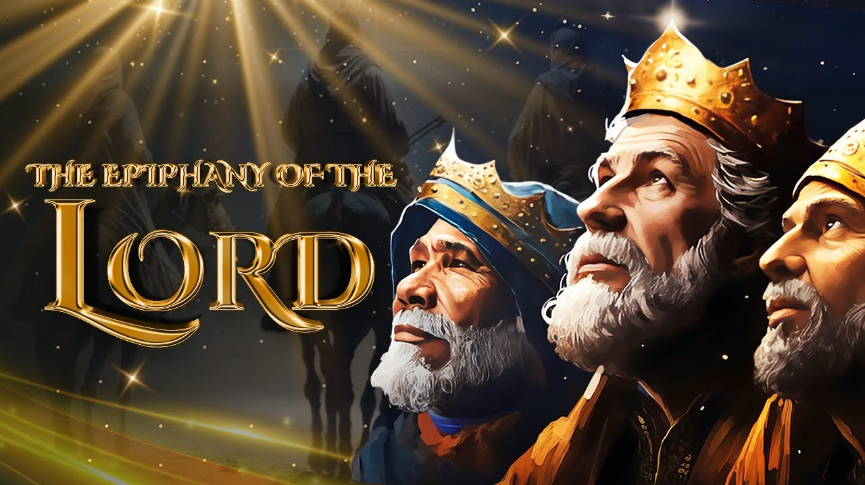

VALLEY PARK UNITED METHODIST CHURCH
436 Valley School Drive, Valley Park, MO 63088

Pastor: Jewell Brodie
Church Phone: 636-225-0057
Cell Phone: 314-401-7672
Church website: Valleypark-umc.org (under construction)
Church e-mail address: vpumc88@sbcglobal.net
A CELEBRATION OF THE GOSPEL
Proclamation: Every believer-Every day in God’s Word
Mission Statement: We are a Bible-believing Christian community inviting all people on a spiritual journey, forming companions in faith, and sending disciples of Jesus Christ into the world. “Which means we are called to “Carry on the Work of Christ”).
Holy Communion—Our Love Feast With Jesus
Epiphany Of The Lord
Liturgical Color: White

Vision and Mission: We Exist to Worship; We Depart to Serve;
Connect: Christ Likeness—Inside Out

Our Theme: “Illumine—Be The Light, Yet Even Now”
“With God All Things Are Possible”
January 4, 2026

Praise and Worship Music 9:00—9:30 A.M.

PRELUDE

GREETING As we begin our service:
“LET US KEEP OUR EYES ON THE MASTER”

MUSIC/WORSHIP

WORDS OF REPENTANCE:
Let us repent as a people, as a church, as a community and as a nation.

PSALM 113-- (Good News Translation)

1 Praise the Lord! Yes, give praise, O servants of the Lord.
Praise the name of the Lord!
2 Blessed be the name of the Lord now and forever.
3 Everywhere—from east to west—praise the name of the Lord.
4 For the Lord is high above the nations;
his glory is higher than the heavens.

5 Who can be compared with the Lord our God,
who is enthroned on high?
6 He stoops to look down on heaven and on earth.
7 He lifts the poor from the dust
and the needy from the garbage dump.
8 He sets them among princes, even the princes of his own people!
9 He gives the childless woman a family, making her a happy mother.

WORDS OF ASSURANCE

OUR FAITH DECLARATION (for the congregation):

“Lord, even when we can’t see it, we believe You are working. When what’s left looks few, less, or little, remind us that you are still with us.
We will keep building, keep believing, and keep holding on—because Your glory is coming.”

OPENING PRAYER

THE FIRST COMMANDMENT: Mark 12:30

The first of all the commandments is: You shall love the Lord your God with all your heart and with all your soul and with all your mind and with all your strength. And the second, like it, is this: ‘You shall love your neighbor as yourself.’

Exodus 19:8: All that you say, Lord, we will do.

*HYMN “There’s A Song In The Air” (vs 1, 4) UMH #249
“Love Came Down At Christmas” UMH #242
“We Three Kings” (1, 5) UMH #254

*CALL TO WORSHIP

Leader: Let us sing....

People: Praise be to God!
Leader: Who dared to take on human flesh and dwell among us.

People: Praise be to God!

Leader: Who did not turn back in the face of evil and death.

People: Praise be to God!

Leader: Who continues to dance through our lives even now.

People: Let all that have breath sing praise to God.

*HYMN “I’m So Glad Jesus Lifted Me” FWS #2151

SCRIPTURE READING John 1:1-18 (NIV)

The Word Became Flesh

1 In the beginning was the Word, and the Word was with God, and the Word was God. 2 He was with God in the beginning. 3 Through him all things were made; without him nothing was made that has been made. 4 In him was life, and that life was the light of all mankind. 5 The light shines in the darkness, and the darkness has not overcome it.

6 There was a man sent from God whose name was John. 7 He came as a witness to testify concerning that light, so that through him all might believe. 8 He himself was not the light; he came only as a witness to the light.

9 The true light that gives light to everyone was coming into the world. 10 He was in the world, and though the world was made through him, the world did not recognize him. 11 He came to that which was his own, but his own did not receive him. 12 Yet to all who did receive him, to those who believed in his name, he gave the right to become children of God— 13 children born not of natural descent, nor of human decision or a husband’s will, but born of God.

14 The Word became flesh and made his dwelling among us. We have seen his glory, the glory of the one and only Son, who came from the Father, full of grace and truth.

15 (John testified concerning him. He cried out, saying, “This is the one I spoke about when I said, ‘He who comes after me has surpassed me because he was before me.’”) 16 Out of his fullness we have all received grace in place of grace already given. 17 For the law was given through Moses; grace and truth came through Jesus Christ. 18 No one has ever seen God, but the one and only Son, who is himself God and is in closest relationship with the Father, has made him known.

Liturgist: This is the Gospel of Jesus Christ.
People: Thanks be to God for Jesus Christ. Amen.

SPECIAL MUSIC

THE MESSAGE “Blessed, Gathered, And Made Known”
Pastor Jewell Brodie

DOXOLOGY UMH #95
Praise God from whom all blessings flow;
Praise Him all creatures here below;
Praise Him above ye heavenly host;
Praise Father, Son and Holy Ghost. Amen.

“HEAR O ISRAEL”

OUR PRAYER AND TIME OF REFLECTION

PASTORAL PRAYER (including prayers for the people, silent prayers of the people.

RESPONSE “Alleluia” FWS #2043
“Alleluia, Alleluia, Alleluia, Alleluia”

*FINAL HYMN “Fill My Cup, Lord” UMH #641

SERVICE OF HOLY COMMUNION

Great Thanksgiving

Leader: The Lord be with you.
Congregation: And also with you.

Leader: Lift up your hearts.
Congregation: We lift them up to the Lord.

Leader: Let us give thanks to the Lord our God.
Congregation: It is right to give our thanks and praise.

It is right, and a good and joyful thing, always and everywhere to give thanks to you Father Almighty, creator of heaven and earth. You formed us in your image and breathed into us the breath of life.

When we turned away, and our love failed, your love remained steadfast. You delivered us from captivity, made a covenant to be our sovereign God, and spoke to us through the prophets. And so, with your people on earth and all the company of heaven we praise your name and join their unending hymn.

Holy, holy, holy Lord, God of power and might, heaven and earth are full of your glory. Hosanna in the highest. Blessed is he who comes in the name of the Lord. Hosanna in the highest.

Holy are you, and blessed is your son Jesus Christ. By the baptism of his suffering, death, and resurrection you gave birth to your church, delivered us from slavery to sin and death, and made with us a new covenant by water and the Spirit.

On the night in which he gave himself up for us he took bread, gave thanks to you, broke the bread, gave it to his disciples and said:

“Take, eat: this is my body which is given for you. Do this in remembrance of me.” When the supper was over, he took the cup, gave thanks to you, gave it to his disciples, and said:
“Drink from this, all of you: this is my blood of the new covenant, poured out for you and for many for the forgiveness of sins. Do this, as often as you drink it, in remembrance of me.

And so, in remembrance of these your mighty acts in Jesus Christ, we offer ourselves in praise and thanksgiving as a holy and living sacrifice, in union with Christ’s offering for us, as we proclaim the mystery of faith.

Christ has died; Christ is risen; Christ will come again.

Pour out your Holy Spirit on us gathered here, and on these gifts of bread and wine. Make them be for us the body and blood of, Christ that we may be for the world the body of Christ, redeemed by his blood.

By your spirit make us one with Christ, one with each other, and one in ministry to all the world, until Christ comes in final victory, and we feast at his heavenly banquet.

Through your son Jesus Christ, with the Holy Spirit in your holy Church, all honor and glory is yours, almighty Father, now and forever. Amen.

And now, with the confidence of children of God, let us pray:

Our Father who art in heaven, hallowed be thy name, thy kingdom come, thy will be done, on earth as it is in heaven. Give us this day our daily bread and forgive us our trespasses as we forgive those who trespass against us. And lead us not into temptation, but deliver us from evil. For thine is the kingdom, and the power, and the glory forever. Amen

GIVING THE BREAD AND CUP

*GIVE THANKS FWS #2036
SPECIAL MUSIC

*BENEDICTION

Go now as a light to the nations. Honor the Lord; preach what you know of the risen Christ, and fulfil all righteousness.

And may God strengthen you and bless you with peace; May Christ Jesus bring forth justice for you and among you; And may the Holy Spirit alight on you and affirm you as God’s beloved ones.

We go in peace to love and serve the Lord, In the name of Christ. Amen.

*SANCTUARY (sing through twice) FWS #2164

Lord, prepare me to be a sanctuary, pure and holy, tried and true. With thanksgiving, I’ll be a living sanctuary for you.

*POSTLUDE

THIS WEEK’S LECTIONARY READINGS: NEXT WEEK’S LECTIONARY READINGS:
Jeremiah 31:7-14 Isaiah 42:1-9
Psalm 147:12-20 Psalm 29
Ephesians 1:3-14 Acts 10:34-43
John 1:1-18 Matthew 3:13-17

CIRCLE OF CONCERN—current needs: Dinner Helpers; Pasta Sauce; Canned Fruit; Condiments; Snacks (8-12 servings/package); Size 5 and 6 Diapers; Baby wipes
View our Amazon Wish List, Walmart List or Target List for more items to fill our pantry.

New Church website: Valleypark-umc.org
(BETA test version)

JOIN US TO ENJOY A CONCERT GIVEN BY OUR OWN DEVIN ADAMS.
THERE MIGHT BE A CHANGE IN DATE OF THE CONCERT. WATCH HERE FOR CHANGES COMING SOON.

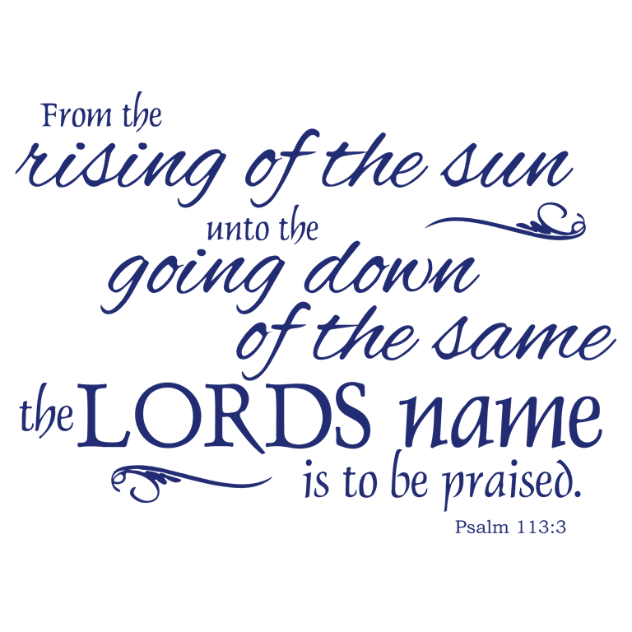

JANUARY, 2026

1-4,11,18,25 9:32 A.M. Sunday Worship on Zoom
AND IN SANCTUARY!!

Mondays, Wednesdays: 9:30-11:30 A.M. Quilting
There will be no quilting if Rockwood schools are closed

1-1 New Year’s Day

1-4 Communion Sunday (Love Feast) with
crackers and juice if you do not have the
communion elements.
Epiphany Sunday
1-6 Epiphany

1-11 Ad Board/Finance/Trustees meeting after Worship
Baptism of the Lord

1-18 Human Relations Day

1-19 Martin Luther King, Jr. Day

1-25 Ecumenical Sunday

FEBRUARY, 2026

2-1,8,15,22 9:32 A.M. Sunday Worship on Zoom
AND IN SANCTUARY!!

Mondays, Wednesdays: 9:30-11:30 A.M. Quilting
There will be no quilting if Rockwood schools are closed

2-1 Communion Sunday (Love Feast) with
crackers and juice if you do not have the
communion elements.
National Freedom Day

2-2 Groundhog Day
2-8 Ad Board/Finance/Trustees meeting after Worship

2-12 Lincoln’s Birthday
2-14 Valentine’s Day
2-15 Transfiguration Sunday
2-16 Presidents’ Day
2-18 Ash Wednesday
2-22 First Sunday In Lent

The 30-Day Church Challenge

Whether in the Sanctuary or on Zoom:
Family, we want to hear from you!

What would make you want to come to church—
or Zoom in—more often?
If you already join us from time to time, what would help you stay more connected and consistent in worship and fellowship?
Would it be a special project that excites your heart?
A mission that reaches others in need?
A ministry that helps you grow deeper in faith or serve in new ways?
This invitation is for everyone—our in-person family and our Zoom family alike.
We believe God can use your ideas—big or small, simple or bold—to strengthen our community and renew our dedication to Him.

Here’s How It Works:
1. Pray for 30 days – Ask God to reveal His vision for our church.
2. Write down your ideas – No idea is too small, too large, or too “trivial.”
3. Submit your thoughts – We’ll collect and compile them for prayerful review.
4. On Trinity Sunday, May 31, 2026, we’ll begin to implement what God reveals through this time of reflection and renewal.

“Unless the Lord builds the house, those who build it labor in vain.” — Psalm 127:1
• Let’s dream together.
• Let’s pray together.
• Let’s grow together.

And let’s watch what God will do when His people are faithful in the meantime and united in purpose.

PRAYER REQUESTS

Your prayer concerns are important to us. If you have a prayer need, joy or concern, if you need someone to just pray with you during this week, or if you are looking to connect with a church that loves people and you are interested in doing ministry and mission is this new way, please call Pastor Jewell at (314) 401-7672 or the church (636) 225-0057. We will walk with you no matter where you are on your journey. Check on someone you’ve not heard from this week.

MEMBERS, FRIENDS AND RELATIVES

Janet and Pasquale Parenti Jim Sieberg
June Bouck and her sons Randy Statler
Glenda Hamilton and family Betty Wideman
Nancy and David Limback Brinda Armstead Ashford
Alex, Alexis, Aubrey and Aden Mitchell Robison (Todd and Penny)
Captain Irma Hamilton and Dorothy Hamilton
Lilly Mulligan (Kolander) Mark Rudoff (Carol Hamilton)
Nick and Erin Rasch (Limback) Cynthia and Kenny Gooch
Doris “Bonnie” Watson; Sandy Nathan
Sara Laun (Nancy Limback’s mother)
Cathy Becker, Chris Ewalt, Abigail Ewalt (Welsh)
Michael Schmidt (Haubrich) Sybil Young (Grant’s wife)
Mary Ellen Pagliughi (Dodson) Michelle Morton
Joe and Penny Moskus Frances “Cookie” Whitfield
Yvonne McClain Letha and Jim Buckley Michelle Parker
Laurie and Jeff Knight Chris Sides Kimmy Limback
Betty Slunaker (Welsh) Gary Laun (Limback)
Stean Pack (Brodie) Freddie Freeman
Mary Cosmo (Rev. Jespersen’s daughter-in-law)
Susan Jespersen
Kathy Wuestling, Wayne Chinn, Brandon Williams (G. Hamilton)
Theresa Hamilton, Walker Friedmeyer, Jen Kurowski (G. Hamilton)
Jean Hopper (Dodson) Becky Halker
Mike Hendrickson (Dodson) Mary Crawford
Joan Ranson

Family and friends of Michael Bouck (son of Gene and June Bouck); Betty Wideman
DAILY PRAYER TIME: 1:11 P.M. Stop and say a few prayers for ourselves, our families, friends, neighbors and our prayer list.

Prayers based on John 1:1-18 focus on acknowledging Jesus as the eternal Word, Light, and Life, asking Him to reveal God, empower us to walk in His light (truth/holiness), and help us share His saving grace as witnesses, overcoming darkness and sin for ourselves and the world. We pray for spiritual awakening, deeper knowledge of God through Christ, and strength to reflect His glory.

Prayers for Ourselves

For Knowing Jesus: "Heavenly Father, thank You for revealing Yourself through Your Son, Jesus. Open my eyes to see You, my ears to hear Your voice, and my heart to understand Your desires for my life. Help me know You more fully as I follow Christ".

For Walking in Light: "Lord Jesus, You are the true Light. Shine in my darkness, dispel my ignorance, and grant me the grace to live in Your truth, reflecting Your glory and holiness in all I do".

For Receiving Grace: "God, thank You for coming as the Word made flesh, full of grace and truth. I confess my sin and weakness; apply the blood of Jesus to my life and help me grow in Your Spirit, receiving the life You offer".

For Worship: "Eternal Word, Word of God, I worship You, the Creator and Sustainer of all. Fill me with Your presence and direct my thoughts and feelings towards Your glory, so I may praise You fully".

Prayers for Others:

For Awakening & Belief: "Lord, send Your light into the darkness of people's lives. Grant them spiritual awakening, that they may see Jesus, believe in Him, and receive the life and grace You offer through Him".

For Sharing the Light: "Help us, Your people, to be faithful witnesses, like John the Baptist, pointing others to Jesus, the true Light. Give us courage to speak Your truth in love and share the glory we've seen".

For Overcoming Darkness: "We pray for those lost in spiritual darkness, that Your light would overpower it. May they turn from sin and walk in the life and freedom found only in You, Jesus, the Way, the Truth, and the Life".

For Seeing God: "We pray that through Jesus, Your Son, people will finally see and know You, God, who has been revealed. May they experience Your saving love and grace in powerful ways, bringing glory to Your name".

