

VALLEY PARK UNITED METHODIST CHURCH
436 Valley School Drive, Valley Park, MO 63088

Pastor: Jewell Brodie
Church Phone: 636-225-0057
Cell Phone: 314-401-7672
Church website: Valleypark-umc.org (BETA test version)
Church e-mail address: vpumc88@sbcglobal.net
A CELEBRATION OF THE GOSPEL
Proclamation: Every believer-Every day in God’s Word
Mission Statement: We are a Bible-believing Christian community inviting all people on a spiritual journey, forming companions in faith, and sending disciples of Jesus Christ into the world. “Which means we are called to “Carry on the Work of Christ”). Vision and Mission: We Exist to Worship; We Depart to Serve;
Connect: Christ Likeness—Inside Out

First Sunday After Christmas, Year A
Liturgical Color: White or Gold

Our Theme: “Illumine—Be The Light, Yet Even Now”
“With God All Things Are Possible”
December 28, 2025

Praise and Worship Music 9:00—9:30 A.M.

PRELUDE

GREETING As we begin our service:
“LET US KEEP OUR EYES ON THE MASTER”

MUSIC/WORSHIP

WORDS OF REPENTANCE:
Let us repent as a people, as a church, as a community and as a nation.

Psalm 148 (NLT)

1 Praise the Lord!

Praise the Lord from the heavens! Praise him from the skies!
2 Praise him, all his angels! Praise him, all the armies of heaven!
3 Praise him, sun and moon! Praise him, all you twinkling stars!
4 Praise him, skies above! Praise him, vapors high above the clouds!
5 Let every created thing give praise to the Lord,
for he issued his command, and they came into being.
6 He set them in place forever and ever. His decree will never be revoked.

7 Praise the Lord from the earth, you creatures of the ocean depths,
8 fire and hail, snow and clouds, wind and weather that obey him,
9 mountains and all hills, fruit trees and all cedars,
10 wild animals and all livestock, small scurrying animals and birds,
11 kings of the earth and all people, rulers and judges of the earth,
12 young men and young women, old men and children.

13 Let them all praise the name of the Lord.
For his name is very great;
his glory towers over the earth and heaven!
14 He has made his people strong, honoring his faithful ones—
the people of Israel who are close to him.

Praise the Lord!

OPENING PRAYER

WORDS OF ASSURANCE

OUR FAITH DECLARATION (for the congregation):

“Lord, even when we can’t see it, we believe You are working. When what’s left looks few, less, or little, remind us that you are still with us.
We will keep building, keep believing, and keep holding on—because Your glory is coming.”

THE FIRST COMMANDMENT: Mark 12:30

The first of all the commandments is: You shall love the Lord your God with all your heart and with all your soul and with all your mind and with all your strength. And the second, like it, is this: ‘You shall love your neighbor as yourself.’

Exodus 19:8: All that you say, Lord, we will do.
*HYMN “Hark! The Herald Angels Sing” (vs 1,3) UMH #240
“The First Noel” (vs 1,5) UMH #245
“Joy To The World” (vs 1,4) UMH #246

*CALL TO WORSHIP

Leader: Beloved, we have waited, watched, and witnessed the coming of
the Christ child. As we gather today on the other side of Christmas,
we might be tempted to ask, “What now?”

People: We continue to wait and watch for the day that all the
earth awaits.

Leader: In this season of Christmas, we remember that though Christ has
come among us, the good news of freedom for captives, flourishing
for the poor, and power returned to the disempowered does not
reign in so many places.

People: We continue to wait and watch for the day that all the
earth awaits.

Leader: With Mary and Joseph, we listen for God to show us how to protect
and advocate for the vulnerable among us.

People: We continue to wait and watch for the day that all the
earth awaits.

Leader: As we gather to worship today, may God bind us together in love,
empowering us to live as followers of the Christ child who declare
good news wherever we go.

People: We gather today as people who wait, watch, and work for
the day that all the earth awaits. Thanks be to God! Amen.

*HYMN “We Will Glorify The King Of Kings” FWS #2087

*SCRIPTURE READING Matthew 2:13-23 (NIV)

The Escape to Egypt

13 When they had gone, an angel of the Lord appeared to Joseph in a dream. “Get up,” he said, “take the child and his mother and escape to Egypt. Stay there until I tell you, for Herod is going to search for the child to kill him.”

14 So he got up, took the child and his mother during the night and left for Egypt, 15 where he stayed until the death of Herod. And so was fulfilled what the Lord had said through the prophet: “Out of Egypt I called my son.”

16 When Herod realized that he had been outwitted by the Magi, he was furious, and he gave orders to kill all the boys in Bethlehem and its vicinity who were two years old and under, in accordance with the time he had learned from the Magi. 17 Then what was said through the prophet Jeremiah was fulfilled:

18 “A voice is heard in Ramah, weeping and great mourning, Rachel weeping for her children and refusing to be comforted, because they are no more.”

The Return to Nazareth

19 After Herod died, an angel of the Lord appeared in a dream to Joseph in Egypt 20 and said, “Get up, take the child and his mother and go to the land of Israel, for those who were trying to take the child’s life are dead.”

21 So he got up, took the child and his mother and went to the land of Israel. 22 But when he heard that Archelaus was reigning in Judea in place of his father Herod, he was afraid to go there. Having been warned in a dream, he withdrew to the district of Galilee, 23 and he went and lived in a town called Nazareth. So was fulfilled what was said through the prophets, that he would be called a Nazarene.
Leader: This is the Gospel of Jesus Christ.
People: Thanks be to God for Jesus Christ. Amen.

SPECIAL MUSIC

THE MESSAGE “When The Word Comes Near, Jesus Is The Word”
Pastor Jewell Brodie

DOXOLOGY UMH #95
Praise God from whom all blessings flow
Praise Him all creatures here below
Praise Him above ye heavenly host
Praise Father, Son and Holy Ghost. Amen.

“HEAR O ISRAEL”

OUR PRAYER AND TIME OF REFLECTION

PASTORAL PRAYER (including prayers for the people, silent prayers of the people.

THE LORD'S PRAYER
And now, with the confidence of children of God, let us pray:

Our Father who art in heaven, hallowed be thy name, thy kingdom come, thy will be done, on earth as it is in heaven. Give us this day our daily bread and forgive us our trespasses as we forgive those who trespass against us. And lead us not into temptation, but deliver us from evil. For thine is the kingdom, and the power, and the glory forever. Amen.

RESPONSE “Alleluia” FWS #2043
“Alleluia, Alleluia, Alleluia, Alleluia”

ANNOUNCEMENTS

TITHES AND OFFERINGS—Please leave your tithes and offerings in one of the collection boxes either on your way in or on your way out of the sanctuary.

*HYMN OF CELEBRATION “Love Came Down At Christmas” UMH #242

SPECIAL MUSIC

*BENEDICTION

Family of Christ, go now into the world in the blessing and power of the Triune God to resist the misuse of power in our world, to point to the signs of good news all around us, and to work for the empowerment and flourishing of all people, especially the vulnerable among us. Amen.

*SHALOM

Shalom to you now, shalom, my friends. May God’s full mercies be yours my friends. In all your living and through your loving, Christ be your shalom, Christ be your shalom.

*POSTLUDE

THIS WEEK’S LECTIONARY READINGS: NEXT WEEK’S LECTIONARY READINGS:
Isaiah 63:7-9 Jeremiah 31:7-14
Psalm 148 Psalm 147:12-20
Hebrews 2:10-18 Ephesians 1:3-14
Matthew 2:13-23 John 1:1-18

CIRCLE OF CONCERN—current needs: Dinner Helpers; Pasta Sauce; Canned Fruit; Condiments; Snacks (8-12 servings/package); Size 5 and 6 Diapers; Baby wipes
View our Amazon Wish List, Walmart List or Target List for more items to fill our pantry.

DON’T FORGET OUR LAST FALL COLLECTION:
“Sock”-ortunity: Now through the end of December.

New Church website: Valleypark-umc.org
(BETA test version)

JOIN US TO ENJOY A CONCERT GIVEN BY OUR OWN DEVIN ADAMS.
THERE MIGHT BE A CHANGE IN DATE OF THE CONCERT. WATCH HERE FOR CHANGES COMING SOON.

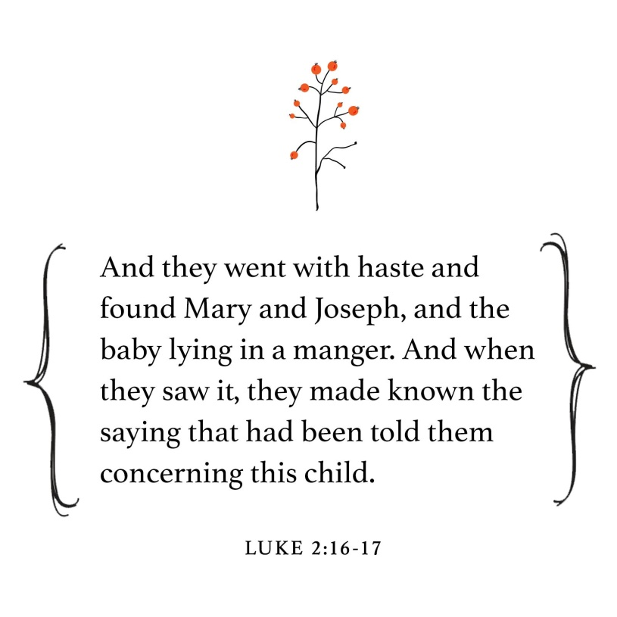

DECEMBER, 2025

12-26 Boxing Day/Kwanzaa begins

12-31 Watchnight/New Year’s Eve

JANUARY, 2026

1-4,11,18,25 9:32 A.M. Sunday Worship on Zoom
AND IN SANCTUARY!!

Mondays, Wednesdays: 9:30-11:30 A.M. Quilting
There will be no quilting if Rockwood schools are closed

1-1 New Year’s Day

1-4 Communion Sunday (Love Feast) with
crackers and juice if you do not have the
communion elements.
Epiphany Sunday

1-6 Epiphany

1-11 Ad Board/Finance/Trustees meeting after Worship
Baptism of the Lord

1-18 Human Relations Day

1-19 Martin Luther King, Jr. Day

1-25 Ecumenical Sunday

The 30-Day Church Challenge

Whether in the Sanctuary or on Zoom:
Family, we want to hear from you!

What would make you want to come to church—
or Zoom in—more often?
If you already join us from time to time, what would help you stay more connected and consistent in worship and fellowship?
Would it be a special project that excites your heart?
A mission that reaches others in need?
A ministry that helps you grow deeper in faith or serve in new ways?
This invitation is for everyone—our in-person family and our Zoom family alike.
We believe God can use your ideas—big or small, simple or bold—to strengthen our community and renew our dedication to Him.

Here’s How It Works:
1. Pray for 30 days – Ask God to reveal His vision for our church.
2. Write down your ideas – No idea is too small, too large, or too “trivial.”
3. Submit your thoughts – We’ll collect and compile them for prayerful review.
4. On Trinity Sunday, May 31, 2026, we’ll begin to implement what God reveals through this time of reflection and renewal.

“Unless the Lord builds the house, those who build it labor in vain.” — Psalm 127:1
• Let’s dream together.
• Let’s pray together.
• Let’s grow together.

And let’s watch what God will do when His people are faithful in the meantime and united in purpose.

PRAYER REQUESTS

Your prayer concerns are important to us. If you have a prayer need, joy or concern, if you need someone to just pray with you during this week, or if you are looking to connect with a church that loves people and you are interested in doing ministry and mission is this new way, please call Pastor Jewell at (314) 401-7672 or the church (636) 225-0057. We will walk with you no matter where you are on your journey. Check on someone you’ve not heard from this week.

MEMBERS, FRIENDS AND RELATIVES

Janet and Pasquale Parenti Jim Sieberg
June Bouck and her sons Randy Statler
Glenda Hamilton and family Betty Wideman
Nancy and David Limback Brinda Armstead Ashford
Alex, Alexis, Aubrey and Aden Mitchell Robison (Todd and Penny)
Captain Irma Hamilton and Dorothy Hamilton
Lilly Mulligan (Kolander) Mark Rudoff (Carol Hamilton)
Nick and Erin Rasch (Limback) Cynthia and Kenny Gooch
Doris “Bonnie” Watson; Sandy Nathan
Sara Laun (Nancy Limback’s mother)
Cathy Becker, Chris Ewalt, Abigail Ewalt (Welsh)
Michael Schmidt (Haubrich) Sybil Young (Grant’s wife)
Mary Ellen Pagliughi (Dodson) Michelle Morton
Joe and Penny Moskus Frances “Cookie” Whitfield
Yvonne McClain Letha and Jim Buckley Michelle Parker
Laurie and Jeff Knight Chris Sides Kimmy Limback
Betty Slunaker (Welsh) Gary Laun (Limback)
Stean Pack (Brodie) Freddie Freeman
Mary Cosmo (Rev. Jespersen’s daughter-in-law)
Susan Jespersen
Kathy Wuestling, Wayne Chinn, Brandon Williams (G. Hamilton)
Theresa Hamilton, Walker Friedmeyer, Jen Kurowski (G. Hamilton)
Jean Hopper (Dodson) Becky Halker
Mike Hendrickson (Dodson) Mary Crawford
Joan Ranson

Family and friends of Michael Bouck (son of Gene and June Bouck); Betty Wideman
DAILY PRAYER TIME: 1:11 P.M. Stop and say a few prayers for ourselves, our families, friends, neighbors and our prayer list.

Prayers based on Matthew 2:13-23 focus on God's protective love, obedience to His leading, overcoming fear with faith, and seeking refuge in Him, as seen in the Flight to Egypt, asking for guidance through life's challenges, protection for the vulnerable (like innocents), and the courage to follow God's call, even when it means leaving the familiar.

Prayers for Ourselves (Drawing from Joseph's Example)

For Guidance & Obedience: "Lord, like Joseph, help me to listen intently to Your voice, even in dreams or quiet moments, and to follow Your leading without question, no matter how disruptive or unfamiliar the path."

For Courage Over Fear: "Father, deliver me from the Herod-like fears that grip my heart and diminish life. Grant me courage to face my anxieties and trust Your protection over my plans and dreams."

For Trust in God's Plan: "Help me surrender my daily labors, home, and work to You, seeing them as part of my walk with You. Give me perseverance to continue Your calling despite obstacles, knowing You are with me."

Prayers for Others (Drawing from God's Care & Herod's Actions)

For Protection of the Vulnerable: "God, we pray for all innocent children and those defenseless against evil, like those Herod sought to harm. Protect them from danger, injustice, and fear, and bring them to safety."

For Refugees & Exiles: "Lord, remember all who, like Jesus' family, are forced to flee their homes and live in exile. Provide for them, offer them refuge, and bring them to a place of peace and belonging."

For Those Seeking Truth: "Guide those who are searching for You, O God, as You guided the wise men. Reveal Jesus to them and grant them the wisdom to worship Him, bringing them to salvation."

A Combined Prayer

"Heavenly Father, we thank You for Your fierce, protective love for Your Son and for us. Help us to obey Your call to follow Jesus, even when it means leaving comfort and facing the unknown. Protect the vulnerable in our world from fear and violence, and guide all who seek You to find safe refuge in Your presence. May Your kingdom come in our hearts and in our world”.



