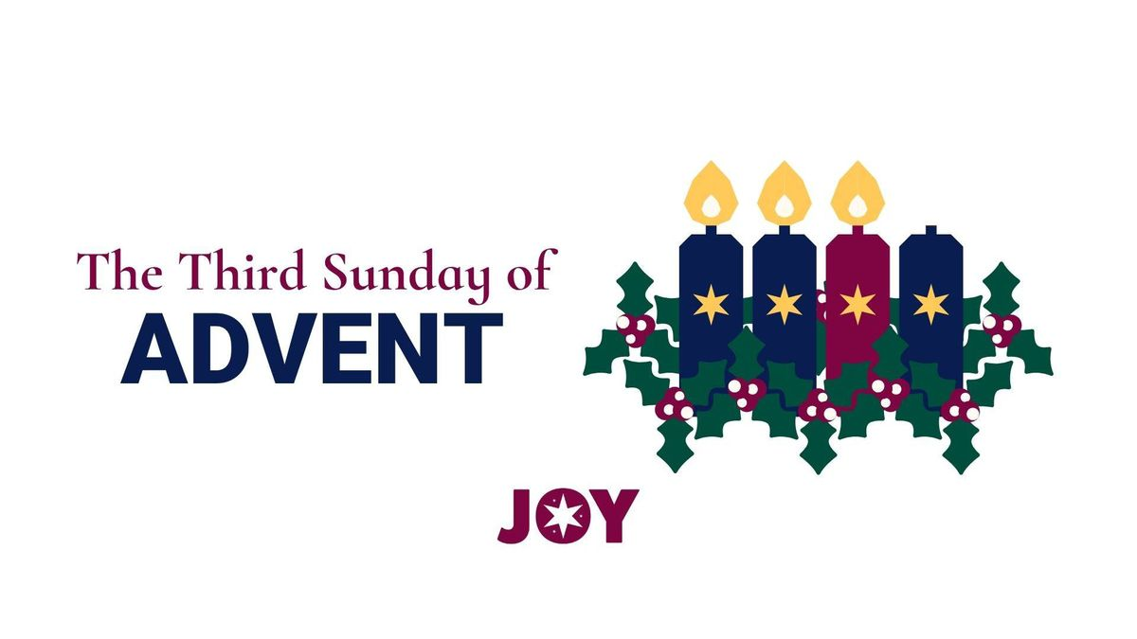

VALLEY PARK UNITED METHODIST CHURCH
436 Valley School Drive, Valley Park, MO 63088

Pastor: Jewell Brodie
Church Phone: 636-225-0057
Cell Phone: 314-401-7672
Church website: Valleypark-umc.org (BETA test version)
Church e-mail address: vpumc88@sbcglobal.net
A CELEBRATION OF THE GOSPEL
Proclamation: Every believer-Every day in God’s Word
Mission Statement: We are a Bible-believing Christian community inviting all people on a spiritual journey, forming companions in faith, and sending disciples of Jesus Christ into the world. “Which means we are called to “Carry on the Work of Christ”). Vision and Mission: We Exist to Worship; We Depart to Serve;
Connect: Christ Likeness—Inside Out

Third Sunday Of Advent, Year A
Liturgical Color: Purple or Blue

Our Theme: “Illumine—Be The Light, Yet Even Now”
“With God All Things Are Possible”
December 14, 2025

Praise and Worship Music 9:00—9:30 A.M.

PRELUDE

GREETING As we begin our service:
“LET US KEEP OUR EYES ON THE MASTER”

MUSIC/WORSHIP

WORDS OF REPENTANCE:
Let us repent as a people, as a church, as a community and as a nation.

Psalm 146:5-10 (GNT)

5 Happy are those who have the God of Jacob to help them
and who depend on the Lord their God,
6 the Creator of heaven, earth, and sea, and all that is in them.
He always keeps his promises;
7 he judges in favor of the oppressed and gives food to the hungry.
The Lord sets prisoners free 8 and gives sight to the blind.
He lifts those who have fallen; he loves his righteous people.

9 He protects the strangers who live in our land;
he helps widows and orphans,
but takes the wicked to their ruin.
10 The Lord is king forever.
Your God, O Zion, will reign for all time.
Praise the Lord!

OPENING PRAYER

WORDS OF ASSURANCE

OUR FAITH DECLARATION (for the congregation):

“Lord, even when we can’t see it, we believe You are working. When what’s left looks few, less, or little, remind us that you are still with us.
We will keep building, keep believing, and keep holding on—because Your glory is coming.”

THE FIRST COMMANDMENT: Mark 12:30

The first of all the commandments is: You shall love the Lord your God with all your heart and with all your soul and with all your mind and with all your strength. And the second, like it, is this: ‘You shall love your neighbor as yourself.’

Exodus 19:8: All that you say, Lord, we will do.

*HYMN “Emmanuel, Emmanuel” UMH #204
“O Come, O Come, Emmanuel” (vs 1,4) UMH #211
“Away In A Manger” UMH #217

*CALL TO WORSHIP

Leader: Today there is good news for us to behold!

People: Those who feared that they were worth little to God have
found blessing in God’s sight.
Leader: For in the mercy and love of God, the blind shall see, the lame shall
walk without pain, those who could not hear shall be blessed with
hearing, and there shall be peace.

People: God’s mercy and love is poured out for our parched souls.

Leader: Behold! The Lord’s compassion is with God’s people.

People: Believe in the power of God in all things. AMEN.

READING FOR THIRD SUNDAY IN ADVENT:

Sometimes on our journey, our feet get heavy, our shoulders feel burdened, and our hearts seem slow. Sometimes in the preparation, the busyness overwhelms us, and we get lost in the doing and the planning and the running. And what we lose is a sense of why. Why do we do all of this? Why is this journey necessary? And the answer is simple: for the joy of it. We forget the joy when we get caught up in the to-do lists. We forget the joy when we worry more about how things look than connecting with others.

Matthew tells us that when John asked if Jesus was the one to come, Jesus responded by saying look around you. Our call in this Advent journey is to look around us to see the one who comes already at work among us and to celebrate that presence with joy.

We light the candles of peace and hope and joy to light our way as we journey.

(Light three candles on the wreath.)

*HYMN “Light The Advent Candle” (verse 3) FWS #2090

*SCRIPTURE READING Matthew 11:2-11 (NIV)

2 John the Baptist, who was in prison, heard about all the things the Messiah was doing. So he sent his disciples to ask Jesus, 3 “Are you the Messiah we’ve been expecting, or should we keep looking for someone else?”

4 Jesus told them, “Go back to John and tell him what you have heard and seen— 5 the blind see, the lame walk, those with leprosy are cured, the deaf hear, the dead are raised to life, and the Good News is being preached to the poor.” 6 And he added, “God blesses those who do not fall away because of me.”

7 As John’s disciples were leaving, Jesus began talking about him to the crowds. “What kind of man did you go into the wilderness to see? Was he a weak reed, swayed by every breath of wind? 8 Or were you expecting to see a man dressed in expensive clothes? No, people with expensive clothes live in palaces. 9 Were you looking for a prophet? Yes, and he is more than a prophet. 10 John is the man to whom the Scriptures refer when they say,

‘Look, I am sending my messenger ahead of you,
and he will prepare your way before you.’

11 “I tell you the truth, of all who have ever lived, none is greater than John the Baptist. Yet even the least person in the Kingdom of Heaven is greater than he is!

Leader: This is the Gospel of Jesus Christ.
People: Thanks be to God for Jesus Christ. Amen.

SPECIAL MUSIC

THE MESSAGE “Joy On The Holy Highway” Pastor Jewell Brodie

DOXOLOGY UMH #95
Praise God from whom all blessings flow
Praise Him all creatures here below
Praise Him above ye heavenly host
Praise Father, Son and Holy Ghost. Amen.

“HEAR O ISRAEL”

OUR PRAYER AND TIME OF REFLECTION

PASTORAL PRAYER (including prayers for the people, silent prayers of the people.

THE LORD'S PRAYER
And now, with the confidence of children of God, let us pray:

Our Father who art in heaven, hallowed be thy name, thy kingdom come, thy will be done, on earth as it is in heaven. Give us this day our daily bread and forgive us our trespasses as we forgive those who trespass against us. And lead us not into temptation, but deliver us from evil. For thine is the kingdom, and the power, and the glory forever. Amen.

RESPONSE “Alleluia” FWS #2043
“Alleluia, Alleluia, Alleluia, Alleluia”

ANNOUNCEMENTS

TITHES AND OFFERINGS—Please leave your tithes and offerings in one of the collection boxes either on your way in or on your way out of the sanctuary.

*HYMN OF CELEBRATION “What Child Is This” UMH #219

SPECIAL MUSIC

*BENEDICTION
People of God, we wait with hope; we wait with courage; we wait with joy unspeakable, full of glory; we wait with the assurance that The Liberator will come in power, in justice, and in peace. Go now, trusting and believing that it is so . . . in the name of Jesus, the Christ!

*SHALOM

Shalom to you now, shalom, my friends. May God’s full mercies be yours my friends. In all your living and through your loving, Christ be your shalom, Christ be your shalom.

*POSTLUDE

THIS WEEK’S LECTIONARY READINGS: NEXT WEEK’S LECTIONARY READINGS:
Isaiah 35:1-10 Isaiah 7:10-16
Psalm 146:5-10 Psalm 80:1-7, 17-19
James 5:7-10 Romans 1:1-7
Matthew 11:2-11 Matthew 1:18-25

CIRCLE OF CONCERN—current needs: Dinner Helpers; Pasta Sauce; Canned Fruit; Condiments; Snacks (8-12 servings/package); Size 5 and 6 Diapers; Baby wipes
View our Amazon Wish List, Walmart List or Target List for more items to fill our pantry.

DON’T FORGET OUR LAST FALL COLLECTION:

“Sock”-ortunity Last two weeks of November, first two weeks
of December

New Church website: Valleypark-umc.org
(BETA test version)

MARK JANUARY 11, 2026, 3:00 P.M. ON YOUR CALENDARS.
JOIN US TO ENJOY A CONCERT GIVEN BY OUR OWN DEVIN ADAMS.

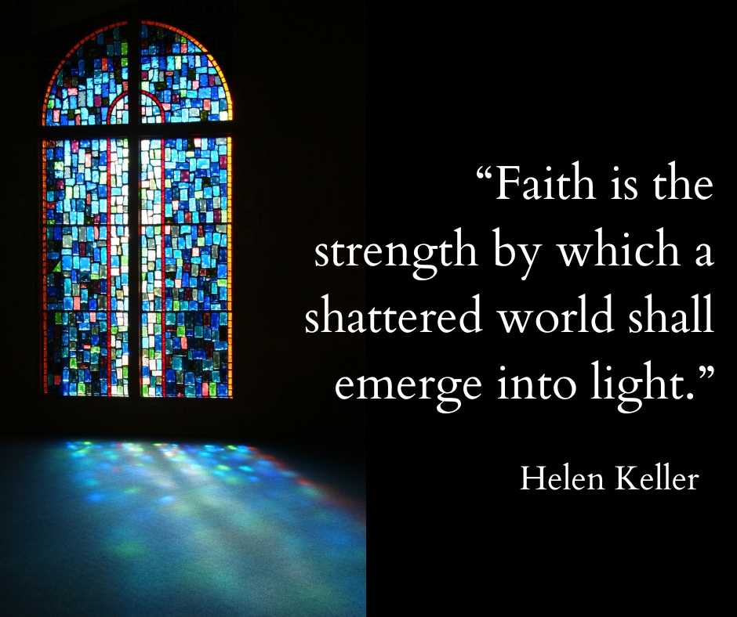

DECEMBER, 2025

12-21,28 9:32 A.M. Sunday Worship on Zoom
AND IN SANCTUARY!!

Mondays, Wednesdays: 9:30-11:30 A.M. Quilting
There will be no quilting if Rockwood schools are closed

TODAY Ad Board/Finance/Trustees meeting after Worship
Hanukkah begins
12-18 Charles Wesley’s birthday (1707)
12-21 Winter Solstice/First Day of Winter
12-24 9:00 p.m. Christmas Eve Service on Zoom
12-25 Christmas Day
12-26 Boxing Day/Kwanzaa begins
12-31 Watchnight/New Year’s Eve

JANUARY, 2026

1-4,11,18,25 9:32 A.M. Sunday Worship on Zoom
AND IN SANCTUARY!!

Mondays, Wednesdays: 9:30-11:30 A.M. Quilting
There will be no quilting if Rockwood schools are closed

1-1 New Year’s Day
1-4 Communion Sunday (Love Feast) with
crackers and juice if you do not have the
communion elements.
Epiphany Sunday
1-6 Epiphany
1-11 Ad Board/Finance/Trustees meeting after Worship
Baptism of the Lord
3:00 P.M. Devin’s concert
1-18 Human Relations Day
1-19 Martin Luther King, Jr. Day
1-25 Ecumenical Sunday
The 30-Day Church Challenge

Whether in the Sanctuary or on Zoom:
Family, we want to hear from you!

What would make you want to come to church—
or Zoom in—more often?
If you already join us from time to time, what would help you stay more connected and consistent in worship and fellowship?
Would it be a special project that excites your heart?
A mission that reaches others in need?
A ministry that helps you grow deeper in faith or serve in new ways?
This invitation is for everyone—our in-person family and our Zoom family alike.
We believe God can use your ideas—big or small, simple or bold—to strengthen our community and renew our dedication to Him.

Here’s How It Works:
1. Pray for 30 days – Ask God to reveal His vision for our church.
2. Write down your ideas – No idea is too small, too large, or too “trivial.”
3. Submit your thoughts – We’ll collect and compile them for prayerful review.
4. On Trinity Sunday, May 31, 2026, we’ll begin to implement what God reveals through this time of reflection and renewal.

“Unless the Lord builds the house, those who build it labor in vain.” — Psalm 127:1
• Let’s dream together.
• Let’s pray together.
• Let’s grow together.

And let’s watch what God will do when His people are faithful in the meantime and united in purpose.

PRAYER REQUESTS

Your prayer concerns are important to us. If you have a prayer need, joy or concern, if you need someone to just pray with you during this week, or if you are looking to connect with a church that loves people and you are interested in doing ministry and mission is this new way, please call Pastor Jewell at (314) 401-7672 or the church (636) 225-0057. We will walk with you no matter where you are on your journey. Check on someone you’ve not heard from this week.

MEMBERS, FRIENDS AND RELATIVES

Janet and Pasquale Parenti Jim Sieberg
June Bouck and her sons Randy Statler
Glenda Hamilton and family Betty Wideman
Nancy and David Limback Brinda Armstead Ashford
Alex, Alexis, Aubrey and Aden Mitchell Robison (Todd and Penny)
Captain Irma Hamilton and Dorothy Hamilton
Lilly Mulligan (Kolander) Mark Rudoff (Carol Hamilton)
Nick and Erin Rasch (Limback) Cynthia and Kenny Gooch
Doris “Bonnie” Watson; Sandy Nathan
Sara Laun (Nancy Limback’s mother)
Cathy Becker, Chris Ewalt, Abigail Ewalt (Welsh)
Michael Schmidt (Haubrich) Sybil Young (Grant’s wife)
Mary Ellen Pagliughi (Dodson) Michelle Morton
Joe and Penny Moskus Frances “Cookie” Whitfield
Yvonne McClain Letha and Jim Buckley Michelle Parker
Laurie and Jeff Knight Chris Sides Kimmy Limback
Betty Slunaker (Welsh) Gary Laun (Limback)
Stean Pack (Brodie) Freddie Freeman
Mary Cosmo (Rev. Jespersen’s daughter-in-law)
Susan Jespersen
Kathy Wuestling, Wayne Chinn, Brandon Williams (G. Hamilton)
Theresa Hamilton, Walker Friedmeyer, Jen Kurowski (G. Hamilton)
Jean Hopper (Dodson) Becky Halker
Mike Hendrickson (Dodson) Mary Crawford
Joan Ranson

DAILY PRAYER TIME: 1:11 P.M. Stop and say a few prayers for ourselves, our families, friends, neighbors and our prayer list.

For the Third Sunday of Advent (Gaudete Sunday, celebrating joy), prayers focus on rejoicing, hope, purification, and action, asking God to stir up His power, help us overcome sins and anxieties, forgive us and others, and empower us to be joyful witnesses, sharing the good news, especially with the oppressed, while preparing for Jesus' coming.

Prayers for Ourselves & Others

Joy & Rejoicing: "Rejoice in the Lord always; again I say, rejoice!" (Philippians 4:4). Pray for deep, lasting joy, not just fleeting happiness, and for the strength to be joyful even amidst difficulties.

Hope & Waiting: Pray for patient, hopeful waiting for Christ's arrival, finding hope in God's promises rather than worldly distractions, and trusting that God is with us in our struggles.

Purification & Strength: Ask God to stir His power within to overcome sins, anxieties, and worldly conformity, making us pure and ready to receive Him.

Action & Witness: Pray for the courage to be like John the Baptist, proclaiming good news, bringing liberty to the captive, and comforting the brokenhearted, extending God's favor to all.
Forgiveness & Generosity: Ask for forgiveness for ourselves and the grace to forgive others, reflecting the love we anticipate. Pray for generosity, sharing what we have with those in need.

Sample Prayers:

From the Tradition: "Stir up your power, O Lord, and with great might come among us; and, because we are sorely hindered by our sins, let your bountiful grace and mercy speedily help and deliver us; through Jesus Christ our Lord, to whom, with you and the Holy Spirit, be honor and glory, now and for ever. Amen."
For Joyful Witness: "Lord, as we journey closer to Christmas, center our joyful anticipation on Jesus' coming. Fill us with Your Holy Spirit to be witnesses of Your joy, sharing the good news with those who mourn and are oppressed. Help us to be awake and present to the love and possibilities around us. Come, Lord Jesus, fill us with Your joy!".

Gaudete Sunday:

Gaudete Sunday is the third Sunday of Advent, a mid-point break in the penitential season, signaling joy because Christmas, the celebration of Jesus' birth, and His Second Coming are drawing near, marked by priests wearing rose-colored vestments and using pink candles in Advent wreaths instead of purple. The name comes from the Latin "Gaudete," meaning "rejoice," reflecting the readings that call for gladness as the Lord's arrival is imminent.

Key Aspects of Gaudete Sunday:

Timing: Occurs on the third Sunday of Advent.

Meaning: A call to rejoice and be glad, as the wait for Christ's coming (both at Christmas and His Second Coming) is nearly over.

Colors: Instead of the usual purple for Advent, rose (pink) vestments and candles are used to symbolize joy.

Readings: The readings often focus on joy, hope, and the nearness of salvation, with the entrance antiphon beginning with "Rejoice in the Lord always; again I say, rejoice" (Philippians 4:4-5).

Tradition: It serves as a joyful pause, similar to Laetare Sunday in Lent, breaking the solemnity of the season.

Why it's celebrated:

It reminds believers that while Advent is a time of reflection, it's also a preparation for great joy, not just sorrow or penance. It highlights the coming of Jesus as a cause for celebration, encouraging spiritual readiness and hope.



