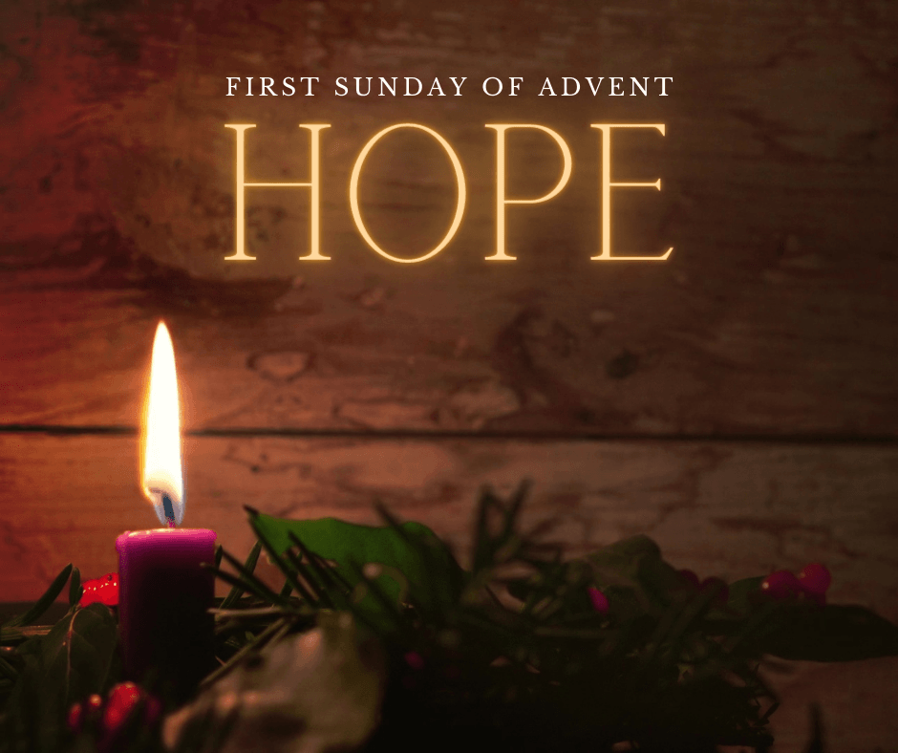

VALLEY PARK UNITED METHODIST CHURCH
436 Valley School Drive, Valley Park, MO 63088

Pastor: Jewell Brodie
Church Phone: 636-225-0057
Cell Phone: 314-401-7672
Church website: Valleypark-umc.org (BETA test version)
Church e-mail address: vpumc88@sbcglobal.net
A CELEBRATION OF THE GOSPEL
Proclamation: Every believer-Every day in God’s Word
Mission Statement: We are a Bible-believing Christian community inviting all people on a spiritual journey, forming companions in faith, and sending disciples of Jesus Christ into the world. “Which means we are called to “Carry on the Work of Christ”). Vision and Mission: We Exist to Worship; We Depart to Serve;
Connect: Christ Likeness—Inside Out

First Sunday Of Advent, Year A
Liturgical Color: Purple or Blue

Our Theme: “Illumine—Be The Light, Yet Even Now”
“With God All Things Are Possible”
November 30, 2025

Praise and Worship Music 9:00—9:30 A.M.

PRELUDE

GREETING As we begin our service:
“LET US KEEP OUR EYES ON THE MASTER”

MUSIC/WORSHIP

WORDS OF REPENTANCE:
Let us repent as a people, as a church, as a community and as a nation.

Psalm 122—In Praise of Jerusalem (GNT)

1 I was glad when they said to me, “Let us go to the Lord's house.”
2 And now we are here, standing inside the gates of Jerusalem!
3 Jerusalem is a city restored in beautiful order and harmony.
4 This is where the tribes come, the tribes of Israel,
to give thanks to the Lord according to his command.
5 Here the kings of Israel sat to judge their people.
6 Pray for the peace of Jerusalem: “May those who love you prosper.

7 May there be peace inside your walls and safety in your palaces.”
8 For the sake of my relatives and friends I say to Jerusalem, “Peace be with you!”
9 For the sake of the house of the Lord our God I pray for your prosperity.

OPENING PRAYER

WORDS OF ASSURANCE

OUR FAITH DECLARATION (for the congregation):

“Lord, even when we can’t see it, we believe You are working. When what’s left looks few, less, or little, remind us that you are still with us.
We will keep building, keep believing, and keep holding on—because Your glory is coming.”

THE FIRST COMMANDMENT: Mark 12:30

The first of all the commandments is: You shall love the Lord your God with all your heart and with all your soul and with all your mind and with all your strength. And the second, like it, is this: ‘You shall love your neighbor as yourself.’

Exodus 19:8: All that you say, Lord, we will do.

*HYMN “Come, Thou Long-Expected Jesus” UMH #196
“Hail To The Lord’s Anointed” (vs 1,4) UMH #203
“Lift Up Your Heads, Ye Mighty Gates” (vs 1, 3) UMH #213

*CALL TO WORSHIP

Leader: I was glad when they said to me, “Let us go to the house of the
Lord.”

People: For in God’s house we shall find hope and healing.

Leader: In God’s house we shall find forgiveness and friendship.

People: May peace be within the walls of this house of God.

Leader: Come, let us go to the house of the Lord.

People: Come, let us sing our praises to God who loves and
redeems us. AMEN.

READING FOR FIRST SUNDAY IN ADVENT:

Lighting a candle in the darkness helps us find our way. In darkness we lose direction. We cannot see where we have been or where we are going. A single candle, flickering brightly, helps us find our way again.

The first candle is lit.

Light one candle; see it glow; Brightly, so that all may know; How one candle shows the way; Making our darkness bright as God’s day.

Restore us, O God; let your face shine, that we may be saved.

Dear God, on this first Sunday in Advent, let this light shine brightly as the days grow shorter, so that we will be ready for your face to shine upon us at Christmas. In the Savior’s name we pray. Amen.

*HYMN “Light The Advent Candle” (verse 1) FWS #2090

*SCRIPTURE READING Matthew 24:36-44 (NIV)

The Day and Hour Unknown

36 “But about that day or hour no one knows, not even the angels in heaven, nor the Son, but only the Father. 37 As it was in the days of Noah, so it will be at the coming of the Son of Man. 38 For in the days before the flood, people were eating and drinking, marrying and giving in marriage, up to the day Noah entered the ark; 39 and they knew nothing about what would happen until the flood came and took them all away. That is how it will be at the coming of the Son of Man. 40 Two men will be in the field; one will be taken and the other left. 41 Two women will be grinding with a hand mill; one will be taken and the other left.

42 “Therefore keep watch, because you do not know on what day your Lord will come. 43 But understand this: If the owner of the house had known at what time of night the thief was coming, he would have kept watch and would not have let his house be broken into. 44 So you also must be ready, because the Son of Man will come at an hour when you do not expect him.

Leader: This is the Gospel of Jesus Christ.
People: Thanks be to God for Jesus Christ. Amen.

SPECIAL MUSIC

THE MESSAGE “No One Knows” Pastor Jewell Brodie

DOXOLOGY UMH #95
Praise God from whom all blessings flow
Praise Him all creatures here below
Praise Him above ye heavenly host
Praise Father, Son and Holy Ghost. Amen.

“HEAR O ISRAEL”

OUR PRAYER AND TIME OF REFLECTION

PASTORAL PRAYER (including prayers for the people, silent prayers of the people.

THE LORD'S PRAYER
And now, with the confidence of children of God, let us pray:

Our Father who art in heaven, hallowed be thy name, thy kingdom come, thy will be done, on earth as it is in heaven. Give us this day our daily bread and forgive us our trespasses as we forgive those who trespass against us. And lead us not into temptation, but deliver us from evil. For thine is the kingdom, and the power, and the glory forever. Amen.

RESPONSE “Alleluia” FWS #2043
“Alleluia, Alleluia, Alleluia, Alleluia”

ANNOUNCEMENTS

TITHES AND OFFERINGS—Please leave your tithes and offerings in one of the collection boxes either on your way in or on your way out of the sanctuary.

*HYMN OF CELEBRATION “Away In A Manger” UMH #217

SPECIAL MUSIC

*BENEDICTION

To all the corners of the world, God is bringing God’s blessing. Be ready! Watch! For the time is near; Salvation is at hand. Be at peace in the arms and love of God. AMEN.

*SHALOM

Shalom to you now, shalom, my friends. May God’s full mercies be yours my friends. In all your living and through your loving, Christ be your shalom, Christ be your shalom.

*POSTLUDE

THIS WEEK’S LECTIONARY READINGS: NEXT WEEK’S LECTIONARY READINGS:
Isaiah 2:1-5 Isaiah 11:1-10
Psalm 122 Psalm 72:1-7, 18-19
Romans 13:11-14 Romans 15:4-13
Matthew 24:36-44 Matthew 3:1-12

CIRCLE OF CONCERN—current needs: Dinner Helpers; Pasta Sauce; Canned Fruit; Condiments; Snacks (8-12 servings/package); Size 5 and 6 Diapers; Baby wipes
View our Amazon Wish List, Walmart List or Target List for more items to fill our pantry.

DON’T FORGET OUR LAST FALL COLLECTION:

“Sock”-ortunity Last two weeks of November, first two weeks
of December

New Church website: Valleypark-umc.org
(BETA test version)

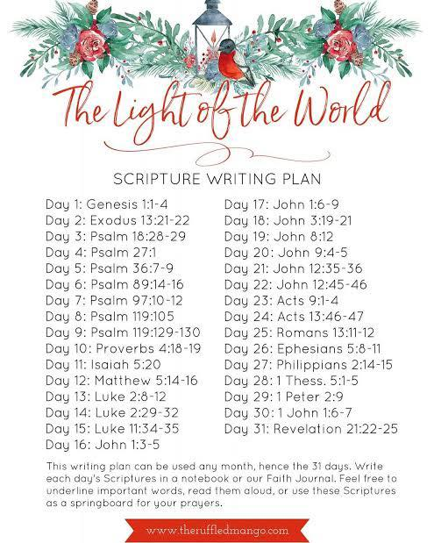

NOVEMBER, 2025

TODAY 9:32 A.M. Sunday Worship on Zoom
AND IN SANCTUARY!!

First Sunday of Advent

Mondays, Wednesdays: 9:30-11:30 A.M. Quilting
There will be no quilting if Rockwood schools are closed

DECEMBER, 2025

12-7,14,21,28 9:32 A.M. Sunday Worship on Zoom
AND IN SANCTUARY!!

Mondays, Wednesdays: 9:30-11:30 A.M. Quilting
There will be no quilting if Rockwood schools are closed

12-7 Communion Sunday (Love Feast) with
crackers and juice if you do not have the
communion elements.

12-14 Ad Board/Finance/Trustees meeting after Worship
Hanukkah begins

12-18 Charles Wesley’s birthday (1707)
12-21 Winter Solstice/First Day of Winter
12-24 Christmas Eve
12-25 Christmas Day
12-26 Boxing Day/Kwanzaa begins
12-31 Watchnight/New Year’s Eve

MARK JANUARY 11, 3:00 P.M. ON YOUR CALENDARS.
JOIN US TO ENJOY A CONCERT GIVEN BY OUR OWN DEVIN ADAMS.

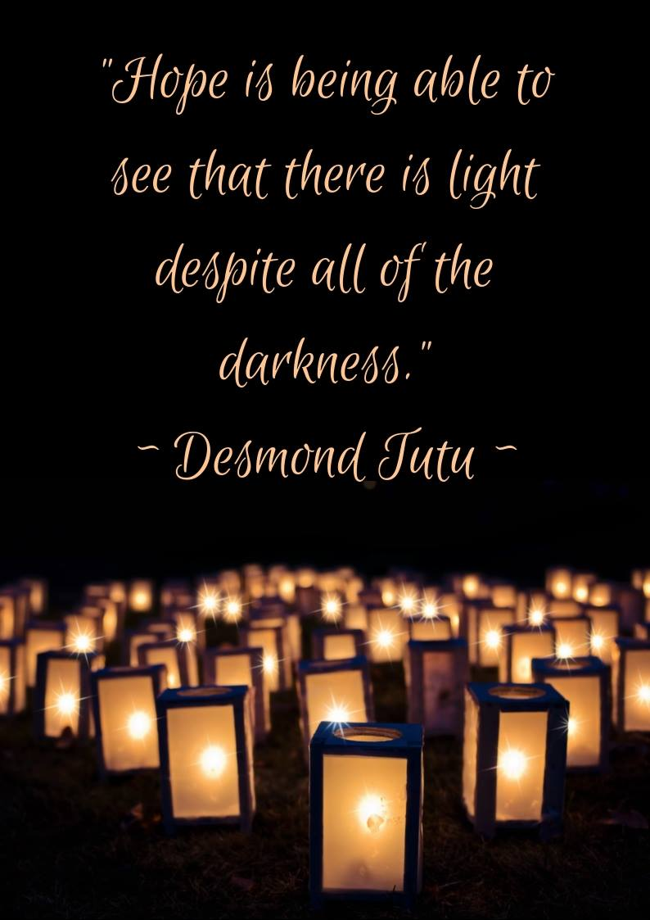

The 30-Day Church Challenge

Whether in the Sanctuary or on Zoom:
Family, we want to hear from you!

What would make you want to come to church—
or Zoom in—more often?
If you already join us from time to time, what would help you stay more connected and consistent in worship and fellowship?
Would it be a special project that excites your heart?
A mission that reaches others in need?
A ministry that helps you grow deeper in faith or serve in new ways?
This invitation is for everyone—our in-person family and our Zoom family alike.
We believe God can use your ideas—big or small, simple or bold—to strengthen our community and renew our dedication to Him.

Here’s How It Works:
1. Pray for 30 days – Ask God to reveal His vision for our church.
2. Write down your ideas – No idea is too small, too large, or too “trivial.”
3. Submit your thoughts – We’ll collect and compile them for prayerful review.
4. On Trinity Sunday, May 31, 2026, we’ll begin to implement what God reveals through this time of reflection and renewal.

“Unless the Lord builds the house, those who build it labor in vain.” — Psalm 127:1
• Let’s dream together.
• Let’s pray together.
• Let’s grow together.

And let’s watch what God will do when His people are faithful in the meantime and united in purpose.

PRAYER REQUESTS

Your prayer concerns are important to us. If you have a prayer need, joy or concern, if you need someone to just pray with you during this week, or if you are looking to connect with a church that loves people and you are interested in doing ministry and mission is this new way, please call Pastor Jewell at (314) 401-7672 or the church (636) 225-0057. We will walk with you no matter where you are on your journey. Check on someone you’ve not heard from this week.

MEMBERS, FRIENDS AND RELATIVES

Janet and Pasquale Parenti Jim Sieberg
June Bouck and her sons Randy Statler
Glenda Hamilton and family Betty Wideman
Nancy and David Limback Brinda Armstead Ashford
Alex, Alexis, Aubrey and Aden Mitchell Robison (Todd and Penny)
Captain Irma Hamilton and Dorothy Hamilton
Lilly Mulligan (Kolander) Mark Rudoff (Carol Hamilton)
Nick and Erin Rasch (Limback) Cynthia and Kenny Gooch
Doris “Bonnie” Watson; Sandy Nathan
Sara Laun (Nancy Limback’s mother)
Cathy Becker, Chris Ewalt, Abigail Ewalt (Welsh)
Michael Schmidt (Haubrich) Sybil Young (Grant’s wife)
Mary Ellen Pagliughi (Dodson) Michelle Morton
Joe and Penny Moskus Frances “Cookie” Whitfield
Yvonne McClain Letha and Jim Buckley Michelle Parker
Laurie and Jeff Knight Chris Sides Kimmy Limback
Betty Slunaker (Welsh) Gary Laun (Limback)
Stean Pack (Brodie) Freddie Freeman
Mary Cosmo (Rev. Jespersen’s daughter-in-law)
Susan Jespersen
Kathy Wuestling, Wayne Chinn, Brandon Williams (G. Hamilton)
Theresa Hamilton, Walker Friedmeyer, Jen Kurowski (G. Hamilton)
Jean Hopper (Dodson) Becky Halker
Mike Hendrickson (Dodson) Mary Crawford
Joan Ranson

The family and friends of: Joe Hendrickson

DAILY PRAYER TIME: 1:11 P.M. Stop and say a few prayers for ourselves, our families, friends, neighbors and our prayer list.

For the first Sunday of Advent, prayers should focus on themes of hope, anticipation, and waiting, asking God to help us prepare our hearts and minds for Christ's coming. Prayers often include asking for grace to overcome darkness and prepare for Christ's return, seeking to grow in love for one another, and interceding for those who are struggling, such as the sick, the poor, and those experiencing loss.

Prayers for ourselves:

For hope and anticipation: "O Lord, as we enter this season of Advent, this time of waiting and anticipation, fill us with the hope of Christ. Help us to wait in expectation for your light to shine in this world..."

To cast away darkness: "Almighty God, give us grace to cast away the works of darkness, and put on the armor of light, now in the time of this mortal life..."

For a renewed heart: "May we pause to remember that we have hope in you... Renew our sense of holy anticipation! Let us be those who are waiting eagerly for Jesus to come again."

To be prepared: "Help me not to go a day without being thankful. For that Lord I confess areas in my life where I feel hopeless or doubtful for you to work, would you please remind me that just as you have worked in the past throughout the Bible that you are still working. Today remind me that the hope that comes from you does not disappoint."

Prayers for others:

For those who are suffering: "God of mercy, hear our prayer in this Advent season for ourselves, and for our families and friends who live with the struggles of illness and the pain of loss."

For those in need: "We pray for the homeless, the refugees the expelled and forgotten people everywhere... Comfort and heal all who suffer, give them courage and hope in their troubles..."

For all of humanity: "God of companionship and community, we give you thanks for the saints who journeyed with us and now abide in you... In this Advent season, we pray for those who are awaiting births, deaths, divorces, new unions, new jobs, retirements, healing, and life transitions of every kind."

For guidance: "We pray for those who have lost their way... help us all to use our gifts and our talents to the greater good of all, challenge us to drive away complacency and apathy..."

