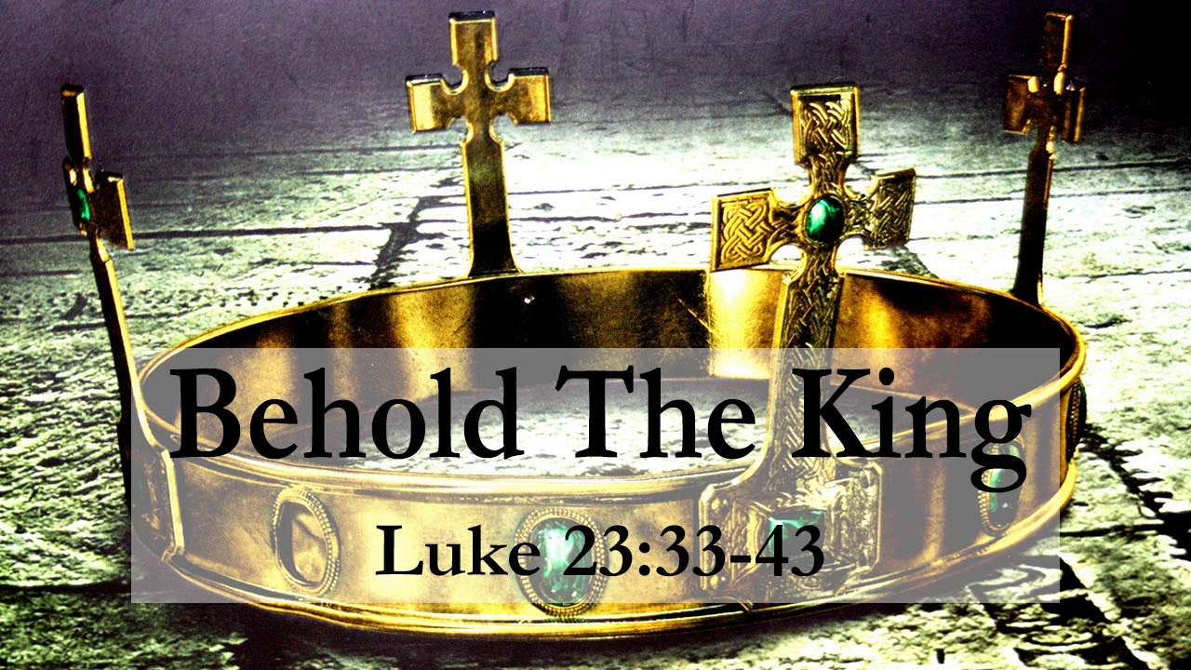

VALLEY PARK UNITED METHODIST CHURCH
436 Valley School Drive, Valley Park, MO 63088

Pastor: Jewell Brodie
Church Phone: 636-225-0057
Cell Phone: 314-401-7672
Church website: Valleypark-umc.org (BETA test version)
Church e-mail address: vpumc88@sbcglobal.net
A CELEBRATION OF THE GOSPEL
Proclamation: Every believer-Every day in God’s Word
Mission Statement: We are a Bible-believing Christian community inviting all people on a spiritual journey, forming companions in faith, and sending disciples of Jesus Christ into the world. “Which means we are called to “Carry on the Work of Christ”). Vision and Mission: We Exist to Worship; We Depart to Serve;
Connect: Christ Likeness—Inside Out

Christ The King/Reign Of Christ Sunday
Liturgical Color: White

Our Theme: “Illumine—Be The Light, Yet Even Now”
November 23, 2025

Praise and Worship Music 9:00—9:30 A.M.

PRELUDE

GREETING As we begin our service:
“LET US KEEP OUR EYES ON THE MASTER”

MUSIC/WORSHIP

WORDS OF REPENTANCE:
Let us repent as a people, as a church, as a community and as a nation.

Psalm 46—God Is With Us (GNT)

1 God is our shelter and strength,
always ready to help in times of trouble.
2 So we will not be afraid, even if the earth is shaken
and mountains fall into the ocean depths;
3 even if the seas roar and rage,
and the hills are shaken by the violence.

4 There is a river that brings joy to the city of God,
to the sacred house of the Most High.
5 God is in that city, and it will never be destroyed;
at early dawn he will come to its aid.
6 Nations are terrified, kingdoms are shaken;
God thunders, and the earth dissolves.

7 The Lord Almighty is with us;
the God of Jacob is our refuge.

8 Come and see what the Lord has done.
See what amazing things he has done on earth.
9 He stops wars all over the world;
he breaks bows, destroys spears,
and sets shields on fire.
10 “Stop fighting,” he says, “and know that I am God,
supreme among the nations,
supreme over the world.”

11 The Lord Almighty is with us;
the God of Jacob is our refuge.

OPENING PRAYER

WORDS OF ASSURANCE

OUR FAITH DECLARATION (for the congregation):

“Lord, even when we can’t see it, we believe You are working. When what’s left looks few, less, or little, remind us that you are still with us.

We will keep building, keep believing, and keep holding on—because Your glory is coming.”

THE FIRST COMMANDMENT: Mark 12:30

The first of all the commandments is: You shall love the Lord your God with all your heart and with all your soul and with all your mind and with all your strength. And the second, like it, is this: ‘You shall love your neighbor as yourself.’

Exodus 19:8: All that you say, Lord, we will do.

*HYMN “What A Friend We Have In Jesus” (vs 1,3) UMH #526
“Jesus , Keep Me Near The Cross” (vs 1,4) UMH #301
“Sweet Hour Of Prayer” (vs 1, 3) UMH #496

*CALL TO WORSHIP

Leader: Even though darkness and fear threaten to overcome us and
swallow us

People: Yet we will place our hope and trust in Jesus Christ.

Leader: For he is the light of the world.

People: His love will shine on us, in us, and through us to all God’s
people.

Leader: We come to the presence of Christ with sadness and sorrow

People: And he offers his healing love, restoring us to light and joy.

*HYMN “Lamb Of God” FWS #2113

*SCRIPTURE READING Luke 23:33-43 (NIV)

33 When they came to the place called the Skull, they crucified him there, along with the criminals—one on his right, the other on his left. 34 Jesus said, “Father, forgive them, for they do not know what they are doing.” And they divided up his clothes by casting lots.

35 The people stood watching, and the rulers even sneered at him. They said, “He saved others; let him save himself if he is God’s Messiah, the Chosen One.”
36 The soldiers also came up and mocked him. They offered him wine vinegar 37 and said, “If you are the king of the Jews, save yourself.”

38 There was a written notice above him, which read: this is the king of the jews.

39 One of the criminals who hung there hurled insults at him: “Aren’t you the Messiah? Save yourself and us!”

40 But the other criminal rebuked him. “Don’t you fear God,” he said, “since you are under the same sentence? 41 We are punished justly, for we are getting what our deeds deserve. But this man has done nothing wrong.”

42 Then he said, “Jesus, remember me when you come into your kingdom.”

43 Jesus answered him, “Truly I tell you, today you will be with me in paradise.”

Leader: This is the Gospel of Jesus Christ.

People: Thanks be to God for Jesus Christ. Amen.

SPECIAL MUSIC

THE MESSAGE “Christ the King: Our Shepherd, Savior and
Sustainer” Pastor Jewell Brodie

DOXOLOGY UMH #95
Praise God from whom all blessings flow
Praise Him all creatures here below
Praise Him above ye heavenly host
Praise Father, Son and Holy Ghost. Amen.

“HEAR O ISRAEL”

OUR PRAYER AND TIME OF REFLECTION

PASTORAL PRAYER (including prayers for the people, silent prayers of the people.

THE LORD'S PRAYER
And now, with the confidence of children of God, let us pray:

Our Father who art in heaven, hallowed be thy name, thy kingdom come, thy will be done, on earth as it is in heaven. Give us this day our daily bread and forgive us our trespasses as we forgive those who trespass against us. And lead us not into temptation, but deliver us from evil. For thine is the kingdom, and the power, and the glory forever. Amen.

RESPONSE “Alleluia” FWS #2043
“Alleluia, Alleluia, Alleluia, Alleluia”

ANNOUNCEMENTS

TITHES AND OFFERINGS—Please leave your tithes and offerings in one of the collection boxes either on your way in or on your way out of the sanctuary.

*HYMN OF CELEBRATION “Beneath The Cross Of Jesus” UMH #297

SPECIAL MUSIC

*BENEDICTION

Though the days increase in their darkness, the Lord of light and love reigns supreme. May the power of God’s love be in your hearts and reflected in your lives now and always. Go in peace and may God’s peace be with you. AMEN.

*POSTLUDE

THIS WEEK’S LECTIONARY READINGS: NEXT WEEK’S LECTIONARY READINGS:
Jeremiah 23:1-6 Isaiah 2:1-5
Psalm 46 Psalm 122
Colossians 1:11-20 Romans 13:11-14
Luke 23:33-43 Matthew 24:36-44

CIRCLE OF CONCERN—current needs: Dinner Helpers; Pasta Sauce; Canned Fruit; Condiments; Snacks (8-12 servings/package); Size 5 and 6 Diapers; Baby wipes
View our Amazon Wish List, Walmart List or Target List for more items to fill our pantry.

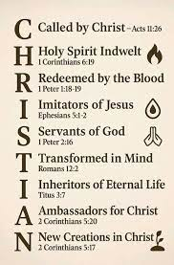

DON’T FORGET OUR LAST FALL COLLECTION:

“Sock”-ortunity Last two weeks of November, first two weeks
of December

New Church website: Valleypark-umc.org
(BETA test version)

NOVEMBER, 2025

11-23.30 9:32 A.M. Sunday Worship on Zoom
AND IN SANCTUARY!!

Mondays, Wednesdays: 9:30-11:30 A.M. Quilting
There will be no quilting if Rockwood schools are closed

TODAY Christ The King/Reign Of Christ Sunday
Thanksgiving Sunday

11-27 Thanksgiving Day

11-30 First Sunday Of Advent

DECEMBER, 2025

12-7,14,21,28 9:32 A.M. Sunday Worship on Zoom
AND IN SANCTUARY!!

Mondays, Wednesdays: 9:30-11:30 A.M. Quilting
There will be no quilting if Rockwood schools are closed

12-7 Communion Sunday (Love Feast) with
crackers and juice if you do not have the
communion elements.

12-14 Ad Board/Finance/Trustees meeting after Worship
Hanukkah begins

12-18 Charles Wesley’s birthday (1707)

12-21 Winter Solstice/First Day of Winter

12-24 Christmas Eve

12-25 Christmas Day

12-26 Boxing Day/Kwanzaa begins

12-31 Watchnight/New Year’s Eve

MARK JANUARY 11, 3:00 P.M. ON YOUR CALENDARS.
JOIN US TO ENJOY A CONCERT GIVEN BY OUR OWN DEVIN ADAMS.
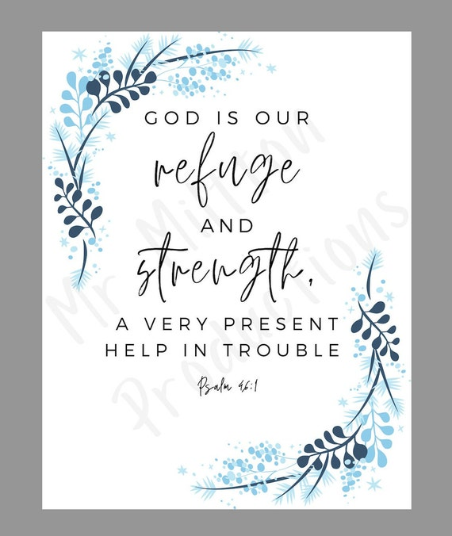

The 30-Day Church Challenge

Whether in the Sanctuary or on Zoom:
Family, we want to hear from you!

What would make you want to come to church—
or Zoom in—more often?
If you already join us from time to time, what would help you stay more connected and consistent in worship and fellowship?
Would it be a special project that excites your heart?
A mission that reaches others in need?
A ministry that helps you grow deeper in faith or serve in new ways?
This invitation is for everyone—our in-person family and our Zoom family alike.
We believe God can use your ideas—big or small, simple or bold—to strengthen our community and renew our dedication to Him.

Here’s How It Works:
1. Pray for 30 days – Ask God to reveal His vision for our church.
2. Write down your ideas – No idea is too small, too large, or too “trivial.”
3. Submit your thoughts – We’ll collect and compile them for prayerful review.
4. On Trinity Sunday, May 31, 2026, we’ll begin to implement what God reveals through this time of reflection and renewal.

“Unless the Lord builds the house, those who build it labor in vain.” — Psalm 127:1
• Let’s dream together.
• Let’s pray together.
• Let’s grow together.

And let’s watch what God will do when His people are faithful in the meantime and united in purpose.

PRAYER REQUESTS

Your prayer concerns are important to us. If you have a prayer need, joy or concern, if you need someone to just pray with you during this week, or if you are looking to connect with a church that loves people and you are interested in doing ministry and mission is this new way, please call Pastor Jewell at (314) 401-7672 or the church (636) 225-0057. We will walk with you no matter where you are on your journey. Check on someone you’ve not heard from this week.

MEMBERS, FRIENDS AND RELATIVES

Janet and Pasquale Parenti Jim Sieberg
June Bouck and her sons Randy Statler
Glenda Hamilton and family Betty Wideman
Nancy and David Limback Brinda Armstead Ashford
Chris, Zane, Kensley, Loralei and Kelly Messina McClellan
Alex, Alexis, Aubrey and Aden Mitchell Robison (Todd and Penny)
Captain Irma Hamilton and Dorothy Hamilton
Lilly Mulligan (Kolander) Mark Rudoff (Carol Hamilton)
Nick and Erin Rasch (Limback) Cynthia and Kenny Gooch
Doris “Bonnie” Watson; Sandy Nathan
Sara Laun (Nancy Limback’s mother)
Cathy Becker, Chris Ewalt, Abigail Ewalt (Welsh)
Michael Schmidt (Haubrich) Sybil Young (Grant’s wife)
Mary Ellen Pagliughi (Dodson) Michelle Morton
Joe and Penny Moskus Frances “Cookie” Whitfield
Yvonne McClain Letha Buckley Michelle Parker
Laurie and Jeff Knight Chris Sides Kimmy Limback
Betty Slunaker (Welsh) Gary Laun (Limback)
Stean Pack (Brodie) Freddie Freeman
Mary Cosmo (Rev. Jespersen’s daughter-in-law)
Susan Jespersen
Kathy Wuestling, Wayne Chinn, Brandon Williams (G. Hamilton)
Theresa Hamilton, Walker Friedmeyer, Jen Kurowski (G. Hamilton)
Jean Hopper (Dodson) Becky Halker
Mike Hendrickson (Dodson) Mary Crawford
Joan Ranson Jim Buckey

DAILY PRAYER TIME: 1:11 P.M. Stop and say a few prayers for ourselves, our families, friends, neighbors and our prayer list.

Prayers inspired by Luke 23:33-43 include: a prayer for our own forgiveness and to overcome selfishness, mirroring Jesus' plea, "Father, forgive them," and a prayer for strength to forgive others who have wronged us. We can also pray for wisdom and gratitude, like the penitent thief, asking Jesus to remember us and guide us to paradise. A prayer for humility and courage to stand up against injustice, and to show true repentance, is also relevant.

Prayers for ourselves:

Prayer for forgiveness and repentance: "Lord, like the penitent thief, I admit my sins and ask for your forgiveness. Help me to overcome selfishness and to turn away from sin".

Prayer for strength to overcome challenges: "I pray to you for the strength to embrace the crosses you send me, just as Jesus did. Teach me to trust in your truth and to do what is right".

Prayer for humility: "Help me to be wise enough to reject the scoffing of the world and humble enough to become like the penitent thief, who turned to you in his final moments".

Prayers for others:

Prayer for the forgiveness of others: "Father, forgive those who have wronged us, for they may not know what they do. Help us to let go of anger and bitterness, just as Jesus prayed for his crucifiers".

Prayer for wisdom and guidance for leaders: "We pray for all leaders, that they may govern with righteousness and justice. Help them to reject greed and to serve others with integrity and compassion".

Prayer for those who are suffering: "We pray for all who are suffering, that they may find peace and comfort in their struggles. Like the penitent thief, may they know that you are with them even in their pain".

Prayer for the world:

Prayer for justice and peace: "We pray for a world where justice and peace prevail, where everyone has access to education, healthcare, and opportunities to thrive. May we all work together to build a better world".

Prayer for an end to violence and conflict: "We pray for an end to violence and conflict, and for a world where everyone is treated with respect and dignity. May we all learn to love one another as you have loved us".

Prayer for spiritual awakening: "We pray for a spiritual awakening, that more and more people will come to know and love you, and that we all may find true fulfillment in you".

