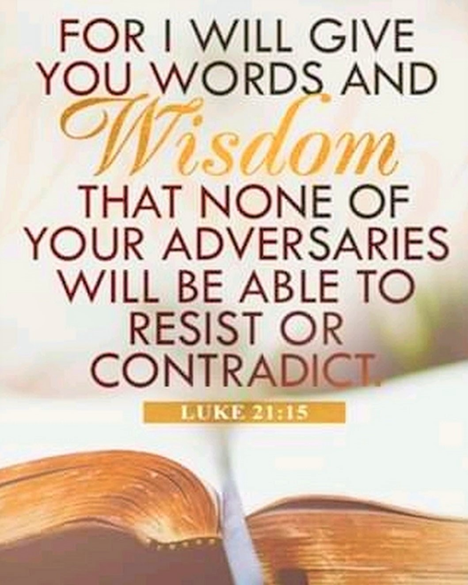

VALLEY PARK UNITED METHODIST CHURCH
436 Valley School Drive, Valley Park, MO 63088

Pastor: Jewell Brodie
Church Phone: 636-225-0057
Cell Phone: 314-401-7672
Church website: Valleypark-umc.org (under construction)
Church e-mail address: vpumc88@sbcglobal.net
A CELEBRATION OF THE GOSPEL
Proclamation: Every believer-Every day in God’s Word
Mission Statement: We are a Bible-believing Christian community inviting all people on a spiritual journey, forming companions in faith, and sending disciples of Jesus Christ into the world. “Which means we are called to “Carry on the Work of Christ”). Vision and Mission: We Exist to Worship; We Depart to Serve;
Connect: Christ Likeness—Inside Out

Twenty-Third Sunday After Pentecost
Liturgical Color: Green

New Church website: Valleypark-umc.org (under construction)

Our Theme: “Illumine—Be The Light, Yet Even Now”

November 16, 2025

Praise and Worship Music 9:00—9:30 A.M.

PRELUDE

GREETING As we begin our service:
“LET US KEEP OUR EYES ON THE MASTER”

MUSIC/WORSHIP

OUR FAITH DECLARATION (for the congregation):

“Lord, even when we can’t see it, we believe You are working. When what’s left looks few, less, or little, remind us that you are still with us.

We will keep building, keep believing, and keep holding on—because Your glory is coming.”

WORDS OF REPENTANCE:
Let us repent as a people, as a church, as a community and as a nation.

ISAIAH 12--Hymn of Thanksgiving (GNT)
(no psalm in lectionary this week)

1 A day is coming when people will sing,

“I praise you, Lord! You were angry with me,
but now you comfort me and are angry no longer.
2 God is my savior;
I will trust him and not be afraid.
The Lord gives me power and strength;
he is my savior.
3 As fresh water brings joy to the thirsty,
so God's people rejoice when he saves them.”

4 A day is coming when people will sing,

“Give thanks to the Lord! Call for him to help you!
Tell all the nations what he has done!
Tell them how great he is!
5 Sing to the Lord because of the great things he has done.
Let the whole world hear the news.
6 Let everyone who lives in Zion shout and sing!
Israel's holy God is great,
and he lives among his people.”

OPENING PRAYER

WORDS OF ASSURANCE

THE FIRST COMMANDMENT: Mark 12:30

The first of all the commandments is: You shall love the Lord your God with all your heart and with all your soul and with all your mind and with all your strength. And the second, like it, is this: ‘You shall love your neighbor as yourself.’

Exodus 19:8: All that you say, Lord, we will do.
*HYMN “Where Cross The Crowded Ways” (vs 1,6) UMH #427
“We’re Marching To Zion” (vs 1) UMH #733
“Stand By Me” (vs 1, 3) UMH #512

*CALL TO WORSHIP

Leader: God’s promises are awesome!

People: In the midst of difficulty, God gives us a word of hope.

Leader: Something new is coming!

People: We stand eagerly on tiptoes awaiting God’s new creation.

Leader: Prepare your hearts to receive God’s mighty blessings.

People: Open our spirits and our hearts, Lord, to be ready to
receive all that you have to offer. AMEN

*HYMN “He Is Exalted” FWS #2070

*SCRIPTURE READING Luke 21:5-19 (NIV)

The Destruction of the Temple and Signs of the End Times

5 Some of his disciples were remarking about how the temple was adorned with beautiful stones and with gifts dedicated to God. But Jesus said, 6 “As for what you see here, the time will come when not one stone will be left on another; every one of them will be thrown down.”

7 “Teacher,” they asked, “when will these things happen? And what will be the sign that they are about to take place?”

8 He replied: “Watch out that you are not deceived. For many will come in my name, claiming, ‘I am he,’ and, ‘The time is near.’ Do not follow them. 9 When you hear of wars and uprisings, do not be frightened. These things must happen first, but the end will not come right away.”

10 Then he said to them: “Nation will rise against nation, and kingdom against kingdom. 11 There will be great earthquakes, famines and pestilences in various places, and fearful events and great signs from heaven.

12 “But before all this, they will seize you and persecute you. They will hand you over to synagogues and put you in prison, and you will be brought before kings and governors, and all on account of my name. 13 And so you will bear testimony to me. 14 But make up your mind not to worry beforehand how you will defend yourselves.

15 For I will give you words and wisdom that none of your adversaries will be able to resist or contradict. 16 You will be betrayed even by parents, brothers and sisters, relatives and friends, and they will put some of you to death. 17 Everyone will hate you because of me. 18 But not a hair of your head will perish. 19 Stand firm, and you will win life.

Leader: This is the Gospel of Jesus Christ.

People: Thanks be to God for Jesus Christ. Amen.

SPECIAL MUSIC

THE MESSAGE “Faithful In The Meantime” Pastor Jewell Brodie

DOXOLOGY UMH #95
Praise God from whom all blessings flow
Praise Him all creatures here below
Praise Him above ye heavenly host
Praise Father, Son and Holy Ghost. Amen.

“HEAR O ISRAEL”

OUR PRAYER AND TIME OF REFLECTION
PASTORAL PRAYER (including prayers for the people, silent prayers of the people.

THE LORD'S PRAYER
And now, with the confidence of children of God, let us pray:

Our Father who art in heaven, hallowed be thy name, thy kingdom come, thy will be done, on earth as it is in heaven. Give us this day our daily bread and forgive us our trespasses as we forgive those who trespass against us. And lead us not into temptation, but deliver us from evil. For thine is the kingdom, and the power, and the glory forever. Amen.

RESPONSE “Alleluia” FWS #2043
“Alleluia, Alleluia, Alleluia, Alleluia”

ANNOUNCEMENTS

TITHES AND OFFERINGS—Please leave your tithes and offerings in one of the collection boxes either on your way in or on your way out of the sanctuary.

*HYMN OF CELEBRATION “Christ Is Alive” UMH #318

SPECIAL MUSIC

*BENEDICTION

Go forth into a world that needs new visions. Bring the message of hope and love, of justice and peace, to all you meet. Live the dream. Make it reality. Celebrate endings and new beginnings, challenges and promises. Live the new creation. Amen.

*POSTLUDE

THIS WEEK’S LECTIONARY READINGS: NEXT WEEK’S LECTIONARY READINGS:
Isaiah 65:17-25 Jeremiah 23:1-6
Isaiah 12 Psalm 46
2 Thessalonians 3:6-13 Colossians 1:11-20
Luke 21:5-19 Luke 23:33-43

CIRCLE OF CONCERN—current needs: Dinner Helpers; Pasta Sauce; Canned Fruit; Condiments; Snacks (8-12 servings/package); Size 5 and 6 Diapers; Baby wipes
View our Amazon Wish List, Walmart List or Target List for more items to fill our pantry.

DON’T FORGET SOME OF OUR FALL COLLECTIONS:

Warner’s Warm-Up End of October, first of November

“Sock”-ortunity Last two weeks of November, first two weeks
of December

New Church website: Valleypark-umc.org
(under construction)

NOVEMBER, 2025

11-16.23.30 9:32 A.M. Sunday Worship on Zoom
AND IN SANCTUARY!!

Mondays, Wednesdays: 9:30-11:30 A.M. Quilting
There will be no quilting if Rockwood schools are closed

11-23 Christ The King/Reign Of Christ Sunday
Thanksgiving Sunday

11-27 Thanksgiving Day

11-30 First Sunday Of Advent

DECEMBER, 2025

12-7,14,21,28 9:32 A.M. Sunday Worship on Zoom
AND IN SANCTUARY!!

Mondays, Wednesdays: 9:30-11:30 A.M. Quilting
There will be no quilting if Rockwood schools are closed

12-7 Communion Sunday (Love Feast) with
crackers and juice if you do not have the
communion elements.
12-14 Ad Board/Finance/Trustees meeting after Worship
Hanukkah begins
12-18 Charles Wesley’s birthday (1707)
12-21 Winter Solstice/First Day of Winter
12-24 Christmas Eve
12-25 Christmas Day
12-26 Boxing Day/Kwanzaa begins
12-31 Watchnight/New Year’s Eve


The 30-Day Church Challenge

Whether in the Sanctuary or on Zoom:
Family, we want to hear from you!

What would make you want to come to church—
or Zoom in—more often?
If you already join us from time to time, what would help you stay more connected and consistent in worship and fellowship?
Would it be a special project that excites your heart?
A mission that reaches others in need?
A ministry that helps you grow deeper in faith or serve in new ways?
This invitation is for everyone—our in-person family and our Zoom family alike.
We believe God can use your ideas—big or small, simple or bold—to strengthen our community and renew our dedication to Him.

Here’s How It Works:
1. Pray for 30 days – Ask God to reveal His vision for our church.
2. Write down your ideas – No idea is too small, too large, or too “trivial.”
3. Submit your thoughts – We’ll collect and compile them for prayerful review.
4. On Trinity Sunday, May 31, 2026, we’ll begin to implement what God reveals through this time of reflection and renewal.

“Unless the Lord builds the house, those who build it labor in vain.” — Psalm 127:1
• Let’s dream together.
• Let’s pray together.
• Let’s grow together.

And let’s watch what God will do when His people are faithful in the meantime and united in purpose.

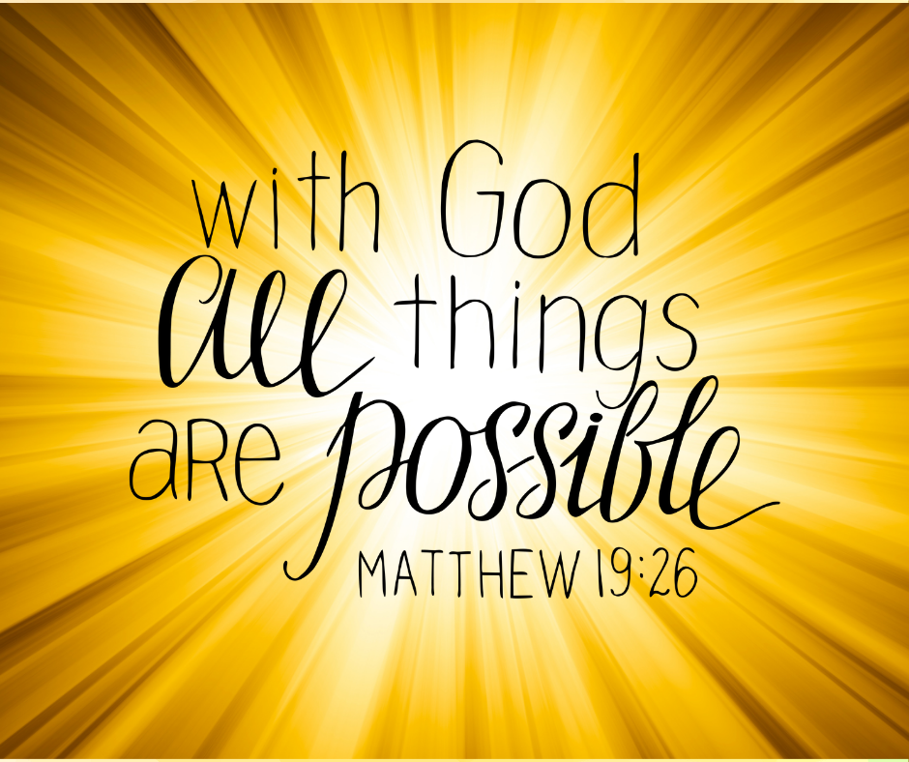

PRAYER REQUESTS

Your prayer concerns are important to us. If you have a prayer need, joy or concern, if you need someone to just pray with you during this week, or if you are looking to connect with a church that loves people and you are interested in doing ministry and mission is this new way, please call Pastor Jewell at (314) 401-7672 or the church (636) 225-0057. We will walk with you no matter where you are on your journey. Check on someone you’ve not heard from this week.

MEMBERS, FRIENDS AND RELATIVES

Janet and Pasquale Parenti Jim Sieberg
June Bouck and her sons Randy Statler
Glenda Hamilton and family Betty Wideman
Nancy and David Limback Brinda Armstead Ashford
Chris, Zane, Kensley, Loralei and Kelly Messina McClellan
Alex, Alexis, Aubrey and Aden Mitchell Robison (Todd and Penny)
Captain Irma Hamilton and Dorothy Hamilton
Lilly Mulligan (Kolander) Mark Rudoff (Carol Hamilton)
Nick and Erin Rasch (Limback) Cynthia and Kenny Gooch
Doris “Bonnie” Watson; Sandy Nathan
Sara Laun (Nancy Limback’s mother)
Cathy Becker, Chris Ewalt, Abigail Ewalt (Welsh)
Michael Schmidt (Haubrich) Sybil Young (Grant’s wife)
Mary Ellen Pagliughi (Dodson) Michelle Morton
Joe and Penny Moskus Frances “Cookie” Whitfield
Yvonne McClain Letha Buckley Michelle Parker
Laurie and Jeff Knight Chris Sides Kimmy Limback
Betty Slunaker (Welsh) Gary Laun (Limback)
Stean Pack (Brodie) Freddie Freeman
Mary Cosmo (Rev. Jespersen’s daughter-in-law)
Susan Jespersen
Kathy Wuestling, Wayne Chinn, Brandon Williams (G. Hamilton)
Theresa Hamilton, Walker Friedmeyer, Jen Kurowski (G. Hamilton)
Jean Hopper (Dodson) Becky Halker
Mike Hendrickson (Dodson) Mary Crawford
Joan Ranson

DAILY PRAYER TIME: 1:11 P.M. Stop and say a few prayers for ourselves, our families, friends, neighbors and our prayer list.

Prayers based on Luke 21:5-19 focus on having strength, wisdom, and endurance through hardship, as well as being alert and faithful. You can pray for yourself to be steadfast in your faith and to receive God's guidance, and for others to also find peace, wisdom, and resilience amid difficulties and betrayal.

Prayers for ourselves:

For strength and endurance: "Heavenly Father, grant me the strength to remain alert and to endure when I face challenges and betrayals. Help me to stand firm in my faith, just as Jesus promised that I will have the strength to escape difficult times and to stand before the Son of Man".

For wisdom and guidance:

"Lord Jesus, you promised to give your followers words and wisdom when they need them. Please fill me with Your wisdom today, and help me to listen for Your voice in the quiet moments. Guide me and help me to make wise choices, especially when I feel afraid or uncertain".

To overcome fear:

"God, when fear tries to take hold, I choose to trust in Your presence and faithfulness. Help me to resist the fear that wants to rule my life and to remember that Your love is more powerful. Give me the hope that comes from knowing you are in the midst of it all".

For a watchful spirit:

"Holy Spirit, help me to be watchful and attentive, not just to the signs of the times, but to the quiet spiritual battles in my own life. Equip me with Your Word and a faithful heart to respond with love and truth".

Prayers for others:

For those who are suffering:

"Lord, I pray for everyone who is experiencing hardship, betrayal, or fear. Please be with them, comfort them, and give them the strength they need to persevere. May they feel Your presence and know they are not alone".

For wisdom and guidance for leaders:

"Heavenly Father, we pray for those in positions of leadership. Grant them wisdom, discernment, and a heart that seeks justice and peace. Protect them from words that are not of the Spirit, and guide them toward Your path".

For those who are angry or hateful:

"God, please open the hearts of those who spew cruel or vicious words. Soften their hearts with Your love and grace, and help them to listen to the gentle voice of Jesus. Bring them into a place of peace and reconciliation".

For a new awareness and love:

"Lord, open our eyes to see the needs of those around us and to give of our time, talents, and resources to help build Your kingdom. Help us to share the love and hope of Christ with all those we meet, and not to be consumed by selfishness".

