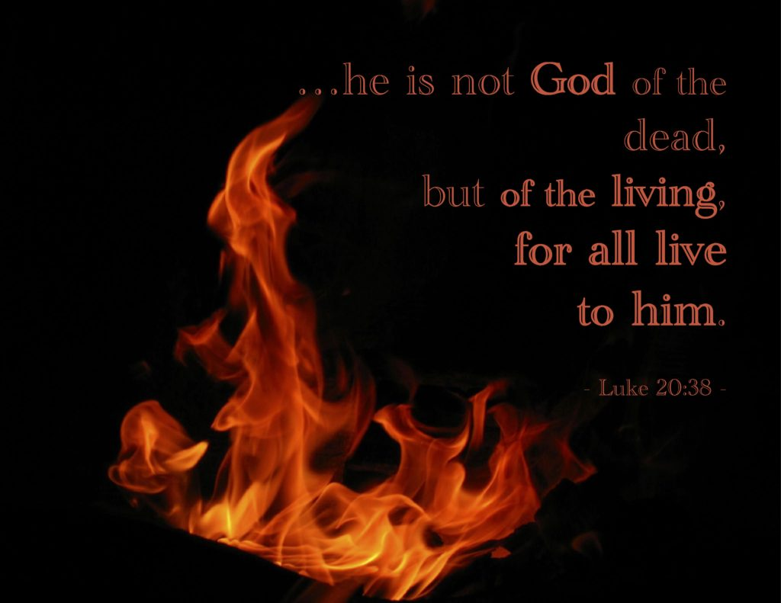

VALLEY PARK UNITED METHODIST CHURCH
436 Valley School Drive, Valley Park, MO 63088

Pastor: Jewell Brodie
Church Phone: 636-225-0057
Cell Phone: 314-401-7672
Church website: Valleypark-umc.org (under construction)
Church e-mail address: vpumc88@sbcglobal.net
A CELEBRATION OF THE GOSPEL
Proclamation: Every believer-Every day in God’s Word
Mission Statement: We are a Bible-believing Christian community inviting all people on a spiritual journey, forming companions in faith, and sending disciples of Jesus Christ into the world. “Which means we are called to “Carry on the Work of Christ”). Vision and Mission: We Exist to Worship; We Depart to Serve;
Connect: Christ Likeness—Inside Out

Twenty-Second Sunday After Pentecost
Liturgical Color: Green

Vision and Mission: We Exist to Worship; We Depart to Serve;
Connect: Christ Likeness—Inside Out
Our Theme: “Illumine—Be The Light, Yet Even Now”

November 9, 2025

Praise and Worship Music 9:00—9:30 A.M.

CALL TO COLORS

STAR SPANGLED BANNER

PLEDGE OF ALLIGANCE

PRELUDE

GREETING As we begin our service:
“LET US KEEP OUR EYES ON THE MASTER”

MUSIC/WORSHIP

WORDS OF REPENTANCE:
Let us repent as a people, as a church, as a community and as a nation.

PSALM 145:1-5, 17-21—A Hymn Of Praise (GNT)

1 I will proclaim your greatness, my God and king;
I will thank you forever and ever.
2 Every day I will thank you;
I will praise you forever and ever.
3 The Lord is great and is to be highly praised;
his greatness is beyond understanding.

4 What you have done will be praised from one generation to the next;
they will proclaim your mighty acts.
5 They will speak of your glory and majesty,
and I will meditate on your wonderful deeds.

17 The Lord is righteous in all he does, merciful in all his acts.
18 He is near to those who call to him,
who call to him with sincerity.
19 He supplies the needs of those who honor him;
he hears their cries and saves them.
20 He protects everyone who loves him,
but he will destroy the wicked.

21 I will always praise the Lord;
let all his creatures praise his holy name forever.

OPENING PRAYER

WORDS OF ASSURANCE

THE FIRST COMMANDMENT: Mark 12:30

The first of all the commandments is: You shall love the Lord your God with all your heart and with all your soul and with all your mind and with all your strength. And the second, like it, is this: ‘You shall love your neighbor as yourself.’

Exodus 19:8: All that you say, Lord, we will do.
*HYMN “It Is Well With My Soul” (vs 1,4) UMH #377
“There’s Within My Heart A Melody” (vs 1, 5) UMH #380
“Of Master, Let Me Walk With Thee” (vs 1, 4) UMH #430

*CALL TO WORSHIP

Leader: Guard me as the apple of your eye, O God.

People: You wondrously show us your steadfast peace

Leader: Hide me in the shadow of your wings, Divine Spirit.

People: You wondrously show us your steadfast strength.

Leader: I behold your face in righteousness, Christ of Hope.

People: You wondrously show us your steadfast love.

*HYMN “Lord I Lift Your Name On High” FWS #2088

*SCRIPTURE READING Luke 20:27-38 (NIV)

The Resurrection and Marriage

27 Some of the Sadducees, who say there is no resurrection, came to Jesus with a question. 28 “Teacher,” they said, “Moses wrote for us that if a man’s brother dies and leaves a wife but no children, the man must marry the widow and raise up offspring for his brother.

29 Now there were seven brothers. The first one married a woman and died childless. 30 The second 31 and then the third married her, and in the same way the seven died, leaving no children.

32 Finally, the woman died too. 33 Now then, at the resurrection whose wife will she be, since the seven were married to her?”

34 Jesus replied, “The people of this age marry and are given in marriage.

35 But those who are considered worthy of taking part in the age to come and in the resurrection from the dead will neither marry nor be given in marriage, 36 and they can no longer die; for they are like the angels. They are God’s children, since they are children of the resurrection.

37 But in the account of the burning bush, even Moses showed that the dead rise, for he calls the Lord ‘the God of Abraham, and the God of Isaac, and the God of Jacob.’ 38 He is not the God of the dead, but of the living, for to him all are alive.”

Leader: This is the Gospel of Jesus Christ.

People: Thanks be to God for Jesus Christ. Amen.

SPECIAL MUSIC

THE MESSAGE “Hold On—Glory Is Coming” Pastor Jewell Brodie

DOXOLOGY UMH #95
Praise God from whom all blessings flow
Praise Him all creatures here below
Praise Him above ye heavenly host
Praise Father, Son and Holy Ghost. Amen.

“HEAR O ISRAEL”

OUR PRAYER AND TIME OF REFLECTION

PASTORAL PRAYER (including prayers for the people, silent prayers of the people.

THE LORD'S PRAYER
And now, with the confidence of children of God, let us pray:

Our Father who art in heaven, hallowed be thy name, thy kingdom come, thy will be done, on earth as it is in heaven. Give us this day our daily bread and forgive us our trespasses as we forgive those who trespass against us. And lead us not into temptation, but deliver us from evil. For thine is the kingdom, and the power, and the glory forever. Amen.

RESPONSE “Alleluia” FWS #2043
“Alleluia, Alleluia, Alleluia, Alleluia”

ANNOUNCEMENTS

TITHES AND OFFERINGS—Please leave your tithes and offerings in one of the collection boxes either on your way in or on your way out of the sanctuary.

*HYMN OF CELEBRATION “Let There Be Peace On Earth” UMH #431

SPECIAL MUSIC

*BENEDICTION

May God's promise, that all are alive to him, fill you with hope for the resurrection life to come.

May you trust in His eternal presence, and may you be strengthened to live as children of God, ready to serve and love others.

Go in the peace of the God who is God of the living, and may He bless you all your lives.

TAPS (please leave the sanctuary in silence)

*POSTLUDE

THIS WEEK’S LECTIONARY READINGS: NEXT WEEK’S LECTIONARY READINGS:
Haggai 1:15b-2:9 Isaiah 65:17-25
Psalm 145:1-5, 17-21 Isaiah 12
2 Thessalonians 2:1-5, 13-17 2 Thessalonians 3:6-13
Luke 20:27-38 Luke 21:5-19

CIRCLE OF CONCERN—current needs: Dinner Helpers; Pasta Sauce; Canned Fruit; Condiments; Snacks (8-12 servings/package); Size 5 and 6 Diapers; Baby wipes
View our Amazon Wish List, Walmart List or Target List for more items to fill our pantry.

NOVEMBER, 2025

11-16.23.30 9:32 A.M. Sunday Worship on Zoom
AND IN SANCTUARY!!

Mondays, Wednesdays: 8:30-11:30 A.M. Quilting

TODAY Organ and Tissue Donor Sunday
Ad Board/Trustees/Finance after Worship
11-11 Veterans Day

11-23 Christ The King/Reign Of Christ Sunday
Thanksgiving Sunday

11-27 Thanksgiving Day

11-30 First Sunday Of Advent

DON’T FORGET SOME OF OUR FALL COLLECTIONS:

Warner’s Warm-Up End of October, first of November

“Sock”-ortunity Last two weeks of November, first two weeks
of December



DECEMBER, 2025

12-7,14,21,28 9:32 A.M. Sunday Worship on Zoom
AND IN SANCTUARY!!

Mondays, Wednesdays: 8:30-11:30 A.M. Quilting

12-7 Communion Sunday (Love Feast) with
crackers and juice if you do not have the
communion elements.

12-14 Ad Board/Trustees/Finance after Worship
12-21 First Day of Winter

12-25 Christmas Day

12-31 Watchnight
New Year’s Eve



PRAYER REQUESTS

Your prayer concerns are important to us. If you have a prayer need, joy or concern, if you need someone to just pray with you during this week, or if you are looking to connect with a church that loves people and you are interested in doing ministry and mission is this new way, please call Pastor Jewell at (314) 401-7672 or the church (636) 225-0057. We will walk with you no matter where you are on your journey. Check on someone you’ve not heard from this week.

MEMBERS, FRIENDS AND RELATIVES

Janet and Pasquale Parenti Jim Sieberg
June Bouck and her sons Randy Statler
Glenda Hamilton and family Betty Wideman
Nancy and David Limback Brinda Armstead Ashford
Chris, Zane, Kensley, Loralei and Kelly Messina McClellan
Alex, Alexis, Aubrey and Aden Mitchell Robison (Todd and Penny)
Captain Irma Hamilton and Dorothy Hamilton
Lilly Mulligan (Kolander) Mark Rudoff (Carol Hamilton)
Nick and Erin Rasch (Limback) Cynthia and Kenny Gooch
Doris “Bonnie” Watson; Sandy Nathan
Sara Laun (Nancy Limback’s mother)
Cathy Becker, Chris Ewalt, Abigail Ewalt (Welsh)
Michael Schmidt (Haubrich) Sybil Young (Grant’s wife)
Mary Ellen Pagliughi (Dodson) Michelle Morton
Joe and Penny Moskus Frances “Cookie” Whitfield
Yvonne McClain Letha Buckley Michelle Parker
Laurie and Jeff Knight Chris Sides Kimmy Limback
Betty Slunaker (Welsh) Gary Laun (Limback)
Stean Pack (Brodie) Freddie Freeman
Mary Cosmo (Rev. Jespersen’s daughter-in-law)
Susan Jespersen
Kathy Wuestling, Wayne Chinn, Brandon Williams (G. Hamilton)
Theresa Hamilton, Walker Friedmeyer, Jen Kurowski (G. Hamilton)
Jean Hopper (Dodson) Becky Halker
Mike Hendrickson (Dodson) Mary Crawford
Joan Ranson

DAILY PRAYER TIME: 1:11 P.M. Stop and say a few prayers for ourselves, our families, friends, neighbors and our prayer list.

Prayers based on Luke 20:27-38 focus on trusting God's wisdom regarding the mysteries of the afterlife, embracing our identity as children of the living God, and living a life motivated by resurrection hope and love rather than by the limitations and fears of this age.

Prayers for Ourselves:

For Trust in God's Plan: Merciful God, we confess that like the Sadducees, we often try to confine Your glorious future within the narrow limits of our present understanding and human logic. Help us to trust in Your wisdom regarding the life to come, and to rest in the assurance that all things will be made perfect in Your time.

For a Resurrection-Focused Life: Lord Jesus, You have shown that in the age to come, we will be like the angels, children of God, and no longer subject to death. Grant us the grace to live this present life with an eternal perspective, not driven by worldly anxieties or the fear of death, but by the sure hope of the resurrection.

For Deepening Faith: Holy Spirit, increase our faith so that we may see beyond our short-range desires and human assumptions. Open our eyes and ears to the profound truth that God is the God of the living, and that in Him, all those who have died in faith are alive.

For Love and Service: Creator God, in the resurrection, all our relationships will be perfected in love. Help us to cultivate that same quality of love and service in our lives now, using our blessings for healing and restoration rather than for selfish gain, and to serve others in need.

Prayers for Others:

For Those Grieving: Loving God, we pray for those who are grieving the loss of loved ones (mention specific names if desired). In their pain, remind them of Your resurrection promise and the joy of knowing that our Redeemer lives. Bring them Your peace that passes all understanding and comfort them with the knowledge that to You, all Your children are alive forevermore.

For the Skeptical and Doubting: Lord of Truth, we lift up those who doubt or question the reality of the afterlife. Silence their fears and their intellectual pride with the irrefutable evidence of Your power and Your Word. Reveal Yourself to them as the God of the living, and grant them the humility to believe and find salvation in Christ.

For the Church Universal: Strengthen Your church, O Lord, to boldly proclaim the message of the resurrection. Give us courage and unfailing compassion to be witnesses of Your coming kingdom in a world often focused only on the temporary. Help us to stand firm in the hope we have in Jesus Christ, our King and Messiah.

For the Oppressed: We pray for a world where justice is not compromised. May life rise out of the ashes of crushed hopes and dreams for those who suffer oppression or injustice. Hasten the day when Your kingdom comes in its fullness, where all people are valued as Your children and there is no more suffering or death.


