

VALLEY PARK UNITED METHODIST CHURCH
436 Valley School Drive, Valley Park, MO 63088

Pastor: Jewell Brodie
Church Phone: 636-225-0057
Cell Phone: 314-401-7672
Church website: Valleypark-umc.org (under construction)
Church e-mail address: vpumc88@sbcglobal.net
A CELEBRATION OF THE GOSPEL
Proclamation: Every believer-Every day in God’s Word
Mission Statement: We are a Bible-believing Christian community inviting all people on a spiritual journey, forming companions in faith, and sending disciples of Jesus Christ into the world. “Which means we are called to “Carry on the Work of Christ”). Vision and Mission: We Exist to Worship; We Depart to Serve;
Connect: Christ Likeness—Inside Out

Twentieth Sunday After Pentecost
Liturgical Color: Green

Vision and Mission: We Exist to Worship; We Depart to Serve;
Connect: Christ Likeness—Inside Out

Our Theme: “Illumine—Be The Light, Yet Even Now”
October 26, 2025

Praise and Worship Music 9:00—9:30 A.M.

PRELUDE

GREETING As we begin our service:
“LET US KEEP OUR EYES ON THE MASTER”

MUSIC/WORSHIP

WORDS OF REPENTANCE:
Let us repent as a people, as a church, as a community and as a nation.

PSALM 65-- Praise and Thanksgiving (GNT)

1 O God, it is right for us to praise you in Zion
and keep our promises to you,

2 because you answer prayers.
People everywhere will come to you

3 on account of their sins.
Our faults defeat us,
but you forgive them.

4 Happy are those whom you choose,
whom you bring to live in your sanctuary.
We shall be satisfied with the good things of your house,
the blessings of your sacred Temple.

5 You answer us by giving us victory,
and you do wonderful things to save us.
People all over the world
and across the distant seas trust in you.

6 You set the mountains in place by your strength,
showing your mighty power.

7 You calm the roar of the seas
and the noise of the waves;
you calm the uproar of the peoples.

8 The whole world stands in awe
of the great things that you have done.
Your deeds bring shouts of joy
from one end of the earth to the other.

9 You show your care for the land by sending rain;
you make it rich and fertile.
You fill the streams with water;
you provide the earth with crops.
This is how you do it:

10 you send abundant rain on the plowed fields
and soak them with water;
you soften the soil with showers
and cause the young plants to grow.

11 What a rich harvest your goodness provides!
Wherever you go there is plenty.

12 The pastures are filled with flocks;
the hillsides are full of joy.

13 The fields are covered with sheep;
the valleys are full of wheat.
Everything shouts and sings for joy.

OPENING PRAYER

WORDS OF ASSURANCE

THE FIRST COMMANDMENT: Mark 12:30

The first of all the commandments is: You shall love the Lord your God with all your heart and with all your soul and with all your mind and with all your strength. And the second, like it, is this: ‘You shall love your neighbor as yourself.’

Exodus 19:8: All that you say, Lord, we will do.

*HYMN “Depth Of Mercy” (vs 1,5) UMH #355
“Abide With Me” (verses 1, 3) UMH #700
“Spirit Of God” (Verses 1, 5) UMH #500

*CALL TO WORSHIP

Leader: Praise is due to you, O God, O you who answer prayer.

People: Happy are those who live in your courts—those who are
satisfied with the goodness of your house and your holy
temple.

Leader: You are the hope of all things, Holy One, from the ends of the
earth to the farthest seas.
People: You make the gateways of the evening and the morning
shout for joy.

Leader: Rejoice in God, O people, and be glad.

People: Let us shout and sing together for joy.

*HYMN “Humble Thyself In The Sight Of The Lord” FWS #2131

*SCRIPTURE READING Luke 18:9-14 (NIV)

The Parable of the Pharisee and the Tax Collector

9 To some who were confident of their own righteousness and looked down on everyone else, Jesus told this parable: 10 “Two men went up to the temple to pray, one a Pharisee and the other a tax collector. 11 The Pharisee stood by himself and prayed: ‘God, I thank you that I am not like other people—robbers, evildoers, adulterers—or even like this tax collector. 12 I fast twice a week and give a tenth of all I get.’

13 “But the tax collector stood at a distance. He would not even look up to heaven, but beat his breast and said, ‘God, have mercy on me, a sinner.’

14 “I tell you that this man, rather than the other, went home justified before God. For all those who exalt themselves will be humbled, and those who humble themselves will be exalted.”

Leader: This is the Gospel of Jesus Christ.
People: Thanks be to God for Jesus Christ. Amen.

SPECIAL MUSIC

THE MESSAGE “Humble Yourself In The Sight Of The Lord”
Robert Haubrich

DOXOLOGY UMH #95
Praise God from whom all blessings flow
Praise Him all creatures here below
Praise Him above ye heavenly host
Praise Father, Son and Holy Ghost. Amen.

“HEAR O ISRAEL”

OUR PRAYER AND TIME OF REFLECTION

PASTORAL PRAYER (including prayers for the people, silent prayers of the people.

THE LORD'S PRAYER
And now, with the confidence of children of God, let us pray:

Our Father who art in heaven, hallowed be thy name, thy kingdom come, thy will be done, on earth as it is in heaven. Give us this day our daily bread and forgive us our trespasses as we forgive those who trespass against us. And lead us not into temptation, but deliver us from evil. For thine is the kingdom, and the power, and the glory forever. Amen.

RESPONSE “Alleluia” FWS #2043
“Alleluia, Alleluia, Alleluia, Alleluia”

ANNOUNCEMENTS

TITHES AND OFFERINGS—Please leave your tithes and offerings in one of the collection boxes either on your way in or on your way out of the sanctuary.

*HYMN OF CELEBRATION “Lord, Dismiss Us With Thy Blessing”
UMH #671

SPECIAL MUSIC

*BENEDICTION

Our gathered worship has ended, but our race goes on. The faith we celebrate in here continues to be the faith we keep out there.

As you have poured yourself out in worship – in song and in prayer, in fellowship and in unity – now may we go to pour ourselves out in service to the world God so loves.

Let the church be the witness that God is at work in the world. Go with God. Amen.

*SHALOM

Shalom to you now, shalom, my friends. May God’s full mercies be yours my friends. In all your living and through your loving, Christ be your shalom, Christ be your shalom.

*POSTLUDE

THIS WEEK’S LECTIONARY READINGS: NEXT WEEK’S LECTIONARY READINGS:
Joel 2:23-32 Habakkuk 1:1-4; 2:1-4
Psalm 65 Psalm 119:137-144
2 Timothy 4:6-8, 16-18 2 Thessalonians 1:1-4, 11-12
Luke 18:9-14 Luke 19:1-10

CIRCLE OF CONCERN—current needs: Dinner Helpers; Pasta Sauce; Canned Fruit; Condiments; Snacks (8-12 servings/package); Size 5 and 6 Diapers; Baby wipes
View our Amazon Wish List, Walmart List or Target List for more items to fill our pantry.

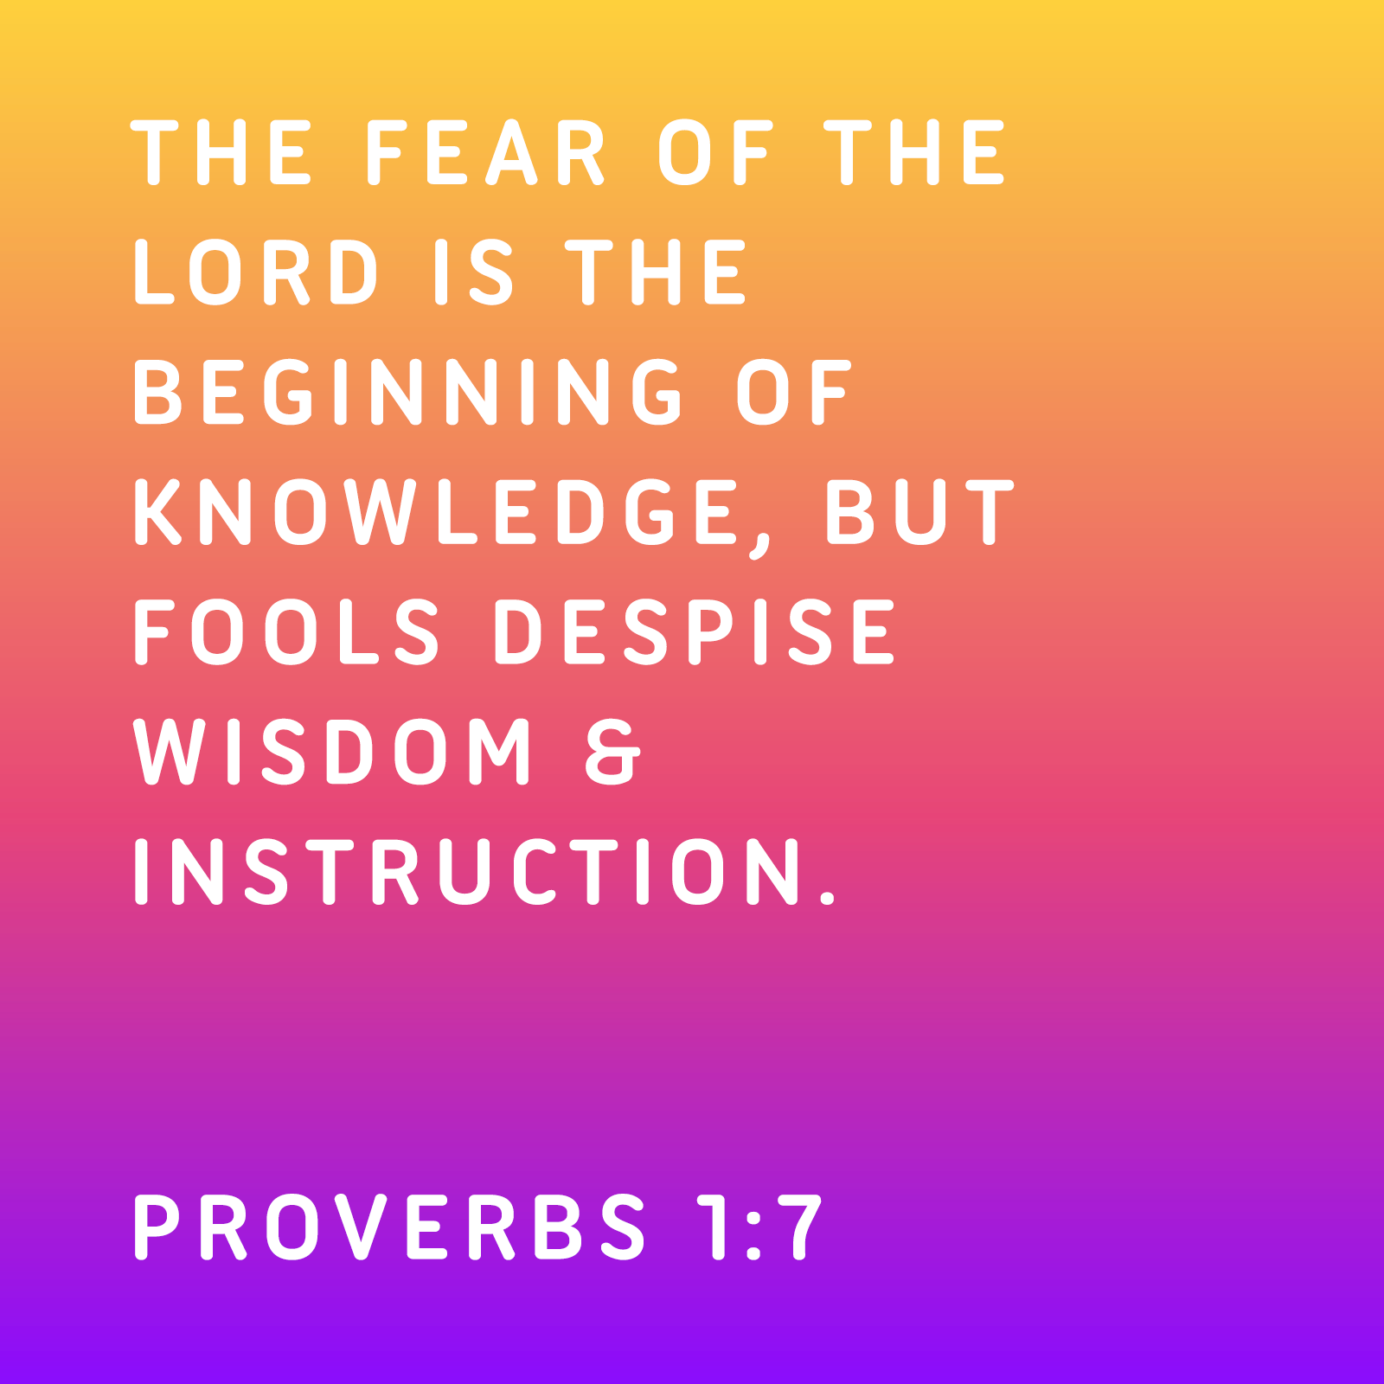

OCTOBER, 2025

10-26 9:32 A.M. Sunday Worship on Zoom
AND IN SANCTUARY!!
Reformation Sunday

Mondays, Wednesdays: 8:30-11:30 A.M. Quilting

10-31 Halloween

CLOCKS “FALL” BACK SATURDAY NIGHT,
NOVEMBER 1, 2025

NOVEMBER, 2025

11-2.9.16.23.30 9:32 A.M. Sunday Worship on Zoom
AND IN SANCTUARY!!

Mondays, Wednesdays: 8:30-11:30 A.M. Quilting

11-1 All Saints Day/Day of the Dead

11-2 Communion Sunday (Love Feast) with
crackers and juice if you do not have the
communion elements.

All Saints Sunday

Ad Board/Trustees/Finance after Worship

11-9 Organ and Tissue Donor Sunday

11-11 Veterans Day

11-23 Christ The King/Reign Of Christ Sunday
Thanksgiving Sunday

11-27 Thanksgiving Day

11-30 First Sunday Of Advent

DON’T FORGET SOME OF OUR FALL COLLECTIONS:

Warner’s Warm-Up End of October, first of November

“Sock”-ortunity Last two weeks of November, first two weeks
of December

Samaritan’s Purse Collection Dates: Now to October 15th.
Packing date is November 8, 11:00 to 1:00

What Goes in My Shoebox? Make Your Gift Fun, Full, and Personalized.
For children around the world, a shoebox is often their very first gift. Given together with the Good News of Jesus Christ, it communicates God’s love to a boy or girl in need. So, it is important to make sure your gift is …

FUN—includes a “wow” item and other quality toys

FULL—packed to the brim with additional school supplies and personal care items

PERSONALIZED—prayed over and contains a note and photo, which are

DO NOT INCLUDE • Soap • Food, candy, or gum • Toothpaste • Used or damaged items • Scary or war-related items • Wearable traditional camouflage • Seeds or organic matter • Liquids • Medication • Money • Breakable items • Matches, fire starters, or aerosols • Knives, saws, or razor blades

PRAYER REQUESTS

Your prayer concerns are important to us. If you have a prayer need, joy or concern, if you need someone to just pray with you during this week, or if you are looking to connect with a church that loves people and you are interested in doing ministry and mission is this new way, please call Pastor Jewell at (314) 401-7672 or the church (636) 225-0057. We will walk with you no matter where you are on your journey. Check on someone you’ve not heard from this week.

MEMBERS, FRIENDS AND RELATIVES

Janet and Pasquale Parenti Jim Sieberg
June Bouck and her sons Randy Statler
Glenda Hamilton and family Betty Wideman
Nancy and David Limback Brinda Armstead Ashford
Chris, Zane, Kensley, Loralei and Kelly Messina McClellan
Alex, Alexis, Aubrey and Aden Mitchell Robison (Todd and Penny)
Captain Irma Hamilton and Dorothy Hamilton
Lilly Mulligan (Kolander) Mark Rudoff (Carol Hamilton)
Nick and Erin Rasch (Limback) Cynthia and Kenny Gooch
Doris “Bonnie” Watson; Sandy Nathan
Sara Laun (Nancy Limback’s mother)
Cathy Becker, Chris Ewalt, Abigail Ewalt (Welsh)
Michael Schmidt (Haubrich) Sybil Young (Grant’s wife)
Mary Ellen Pagliughi (Dodson) Michelle Morton
Joe and Penny Moskus Frances “Cookie” Whitfield
Yvonne McClain Letha Buckley Michelle Parker
Laurie and Jeff Knight Chris Sides Kimmy Limback
Betty Slunaker (Welsh) Gary Laun (Limback)
Stean Pack (Brodie) Freddie Freeman
Mary Cosmo (Rev. Jespersen’s daughter-in-law)
Susan Jespersen
Kathy Wuestling, Wayne Chinn, Brandon Williams (G. Hamilton)
Theresa Hamilton, Walker Friedmeyer, Jen Kurowski (G. Hamilton)
Jean Hopper (Dodson) Becky Halker
Mike Hendrickson (Dodson) Mary Crawford
Joan Ranson

DAILY PRAYER TIME: 1:11 P.M. Stop and say a few prayers for ourselves, our families, friends, neighbors and our prayer list.

Prayers based on Luke 18:9-14 focus on humility and recognizing one's need for God's mercy, rather than self-righteousness. Prayers for ourselves should reflect the tax collector's plea, "God, be merciful to me, a sinner," acknowledging sin and asking for forgiveness and renewal. For others, we should pray with humility, asking God for mercy and compassion, and to be lifted up in their humility, rather than judging them.

Prayers for ourselves

Acknowledge your need: "God, have mercy on me, a sinner. I know that I cannot save myself and desperately need your forgiveness and love."

Surrender pride: "Help me to not compare myself to others or think I'm more righteous. Help me to humble myself, for you exalt those who humble themselves and humble those who exalt themselves."

Pray for renewal: Ask for a heart that reflects God's grace and mercy, acknowledging that true righteousness comes from Him. "Thank you, Father, for your unending love and patience. Forgive me for the times I've judged others. Give me a heart of compassion and love to everyone."

Prayers for others

Pray with humility: "Lord, show mercy to this person as well. They may be struggling, and I know that I am in no position to judge. Help me to see them through your eyes and not my own."

Ask for God's lifting action: "Help them to humble themselves before you, and you will lift them up. Please don't let them be humbled out of pride, but exalted through humility and grace."

Focus on repentance: "God, help them to see their own need for your mercy, just as I must. Protect them from the pride that blinds and keep them from exalting themselves."


