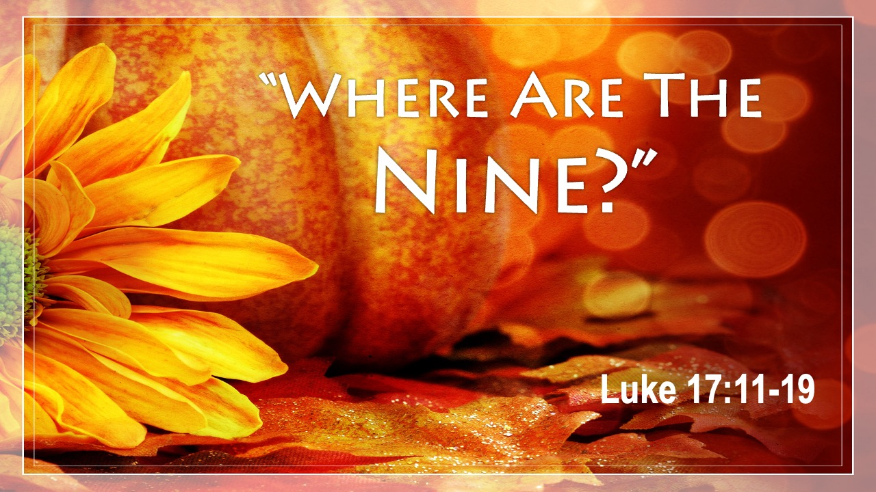

VALLEY PARK UNITED METHODIST CHURCH
436 Valley School Drive, Valley Park, MO 63088

Pastor: Jewell Brodie
Church Phone: 636-225-0057
Cell Phone: 314-401-7672
Church website: Valleypark-umc.org (under construction)
Church e-mail address: vpumc88@sbcglobal.net
A CELEBRATION OF THE GOSPEL
Proclamation: Every believer-Every day in God’s Word
Mission Statement: We are a Bible-believing Christian community inviting all people on a spiritual journey, forming companions in faith, and sending disciples of Jesus Christ into the world. “Which means we are called to “Carry on the Work of Christ”). Vision and Mission: We Exist to Worship; We Depart to Serve;
Connect: Christ Likeness—Inside Out

Eighteenth Sunday After Pentecost
Liturgical Color: Green

Vision and Mission: We Exist to Worship; We Depart to Serve;
Connect: Christ Likeness—Inside Out

Our Theme: “Illumine—Be The Light, Yet Even Now”
October 12, 2025

Praise and Worship Music 9:00—9:30 A.M.

PRELUDE

GREETING As we begin our service:
“LET US KEEP OUR EYES ON THE MASTER”

MUSIC/WORSHIP

WORDS OF REPENTANCE:
Let us repent as a people, as a church, as a community and as a nation.

PSALM 66:1-12 (GNT) -- A Song of Praise and Thanksgiving

1 Praise God with shouts of joy, all people!

2 Sing to the glory of his name;
offer him glorious praise!

3 Say to God, “How wonderful are the things you do!
Your power is so great
that your enemies bow down in fear before you.

4 Everyone on earth worships you;
they sing praises to you,
they sing praises to your name.”

5 Come and see what God has done,
his wonderful acts among people.

6 He changed the sea into dry land;
our ancestors crossed the river on foot.
There we rejoiced because of what he did.

7 He rules forever by his might
and keeps his eyes on the nations.
Let no rebels rise against him.

8 Praise our God, all nations;
let your praise be heard.

9 He has kept us alive
and has not allowed us to fall.

10 You have put us to the test, God;
as silver is purified by fire,
so you have tested us.

11 You let us fall into a trap
and placed heavy burdens on our backs.

12 You let our enemies trample us;
we went through fire and flood,
but now you have brought us to a place of safety.

OPENING PRAYER

WORDS OF ASSURANCE

THE FIRST COMMANDMENT: Mark 12:30

The first of all the commandments is: You shall love the Lord your God with all your heart and with all your soul and with all your mind and with all your strength. And the second, like it, is this: ‘You shall love your neighbor as yourself.’

Exodus 19:8: All that you say, Lord, we will do.

*HYMN “Something Beautiful” UMH #394
“To God Be The Glory” (verse 1) UMH #98
“Through It All” UMH #507

*CALL TO WORSHIP

Leader: When we are lonely and feeling lost . . .

People: Jesus calls us and brings us hope and peace.

Leader: When we are angry and frustrated . . .

People: Jesus heals our wounds and soothes our tempers.

Leader: When we are sorrowful and broken . . .

People: Jesus binds up our wounds with his healing love.

Leader: Come, let us worship the one who cares so abundantly for us.

People: AMEN

*HYMN “Lord I Lift Your Name On High” FWS #2088

*SCRIPTURE READING Luke 17:11-19 (NIV)

Jesus Heals Ten Men With Leprosy

11 Now on his way to Jerusalem, Jesus traveled along the border between Samaria and Galilee. 12 As he was going into a village, ten men who had leprosy met him. They stood at a distance 13 and called out in a loud voice, “Jesus, Master, have pity on us!”

14 When he saw them, he said, “Go, show yourselves to the priests.” And as they went, they were cleansed.
15 One of them, when he saw he was healed, came back, praising God in a loud voice. 16 He threw himself at Jesus’ feet and thanked him—and he was a Samaritan.

17 Jesus asked, “Were not all ten cleansed? Where are the other nine? 18 Has no one returned to give praise to God except this foreigner?” 19 Then he said to him, “Rise and go; your faith has made you well.”

Leader: This is the Gospel of Jesus Christ.
People: Thanks be to God for Jesus Christ. Amen.

SPECIAL MUSIC

THE MESSAGE “Thankful For Grace” Pastor Jewell Brodie

DOXOLOGY UMH #95
Praise God from whom all blessings flow
Praise Him all creatures here below
Praise Him above ye heavenly host
Praise Father, Son and Holy Ghost. Amen.

“HEAR O ISRAEL”

OUR PRAYER AND TIME OF REFLECTION

PASTORAL PRAYER (including prayers for the people, silent prayers of the people.

THE LORD'S PRAYER
And now, with the confidence of children of God, let us pray:

Our Father who art in heaven, hallowed be thy name, thy kingdom come, thy will be done, on earth as it is in heaven. Give us this day our daily bread and forgive us our trespasses as we forgive those who trespass against us. And lead us not into temptation, but deliver us from evil. For thine is the kingdom, and the power, and the glory forever. Amen.
RESPONSE “Alleluia” FWS #2043
“Alleluia, Alleluia, Alleluia, Alleluia”

ANNOUNCEMENTS

TITHES AND OFFERINGS—Please leave your tithes and offerings in one of the collection boxes either on your way in or on your way out of the sanctuary.

*HYMN OF CELEBRATION “Come, Christians, Join To Sing” UMH #158

SPECIAL MUSIC

*BENEDICTION

Having opened your hearts to God and received God’s healing love, go now into this hurting troubled world with the good news of God’s presence and compassion. AMEN

*SHALOM

Shalom to you now, shalom, my friends. May God’s full mercies be yours my friends. In all your living and through your loving, Christ be your shalom, Christ be your shalom.

*POSTLUDE

THIS WEEK’S LECTIONARY READINGS: NEXT WEEK’S LECTIONARY READINGS:
Jeremiah 29:1, 4-7 Jeremiah 31:27-34
Psalm 66:1-12 Psalm 119:97-104
2 Timothy 2:8-15 2 Timothy 3:14-4:5
Luke 17:11-19 Luke 18:1-8

CIRCLE OF CONCERN—current needs: Dinner Helpers; Pasta Sauce; Canned Fruit; Condiments; Snacks (8-12 servings/package); Size 5 and 6 Diapers; Baby wipes
View our Amazon Wish List, Walmart List or Target List for more items to fill our pantry.

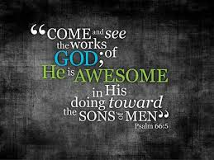

OCTOBER, 2025

10-19,26 9:32 A.M. Sunday Worship on Zoom
AND IN SANCTUARY!!

Mondays, Wednesdays: 8:30-11:30 A.M. Quilting

10-13 Columbus Day

10-16 Boss’ Day

10-19 Laity Sunday

10-26 Reformation Sunday

10-31 Halloween

CLOCKS “FALL” BACK SATURDAY NIGHT,
NOVEMBER 1, 2025

NOVEMBER, 2025

11-2.9.16.23.30 9:32 A.M. Sunday Worship on Zoom
AND IN SANCTUARY!!

Mondays, Wednesdays: 8:30-11:30 A.M. Quilting

11-1 All Saints Day/Day of the Dead

11-2 Communion Sunday (Love Feast) with
crackers and juice if you do not have the
communion elements.
All Saints Sunday

Ad Board/Trustees/Finance after Worship
11-9 Organ and Tissue Donor Sunday

11-11 Veterans Day

11-23 Christ The King/Reign Of Christ Sunday
Thanksgiving Sunday

11-27 Thanksgiving Day

11-30 First Sunday Of Advent

DON’T FORGET SOME OF OUR FALL COLLECTIONS:

Warner’s Warm-Up End of October, first of November
“Sock”-ortunity Last two weeks of November, first two weeks
of December

Samaritan’s Purse Collection Dates: Now to October 15th.
Packing date to be determined

What Goes in My Shoebox? Make Your Gift Fun, Full, and Personalized.
For children around the world, a shoebox is often their very first gift. Given together with the Good News of Jesus Christ, it communicates God’s love to a boy or girl in need. So, it is important to make sure your gift is …
FUN—includes a “wow” item and other quality toys
FULL—packed to the brim with additional school supplies and personal care items
PERSONALIZED—prayed over and contains a note and photo, which are

DO NOT INCLUDE • Soap • Food, candy, or gum • Toothpaste • Used or damaged items • Scary or war-related items • Wearable traditional camouflage • Seeds or organic matter • Liquids • Medication • Money • Breakable items • Matches, fire starters, or aerosols • Knives, saws, or razor blades

PRAYER REQUESTS

Your prayer concerns are important to us. If you have a prayer need, joy or concern, if you need someone to just pray with you during this week, or if you are looking to connect with a church that loves people and you are interested in doing ministry and mission is this new way, please call Pastor Jewell at (314) 401-7672 or the church (636) 225-0057. We will walk with you no matter where you are on your journey. Check on someone you’ve not heard from this week.

MEMBERS, FRIENDS AND RELATIVES

Janet and Pasquale Parenti Jim Sieberg
June Bouck and her sons Randy Statler
Glenda Hamilton and family Betty Wideman
Nancy and David Limback Brinda Armstead Ashford
Chris, Zane, Kensley, Loralei and Kelly Messina McClellan
Alex, Alexis, Aubrey and Aden Mitchell Robison (Todd and Penny)
Captain Irma Hamilton and Dorothy Hamilton
Lilly Mulligan (Kolander) Mark Rudoff (Carol Hamilton)
Nick and Erin Rasch (Limback) Cynthia and Kenny Gooch
Doris “Bonnie” Watson; Sandy Nathan
Sara Laun (Nancy Limback’s mother)
Cathy Becker, Chris Ewalt, Abigail Ewalt (Welsh)
Michael Schmidt (Haubrich) Sybil Young (Grant’s wife)
Mary Ellen Pagliughi (Dodson) Michelle Morton
Joe and Penny Moskus Frances “Cookie” Whitfield
Yvonne McClain Letha Buckley Michelle Parker
Laurie and Jeff Knight Chris Sides Kimmy Limback
Betty Slunaker (Welsh) Gary Laun (Limback)
Stean Pack (Brodie) Freddie Freeman
Mary Cosmo (Rev. Jespersen’s daughter-in-law)
Kathy Wuestling, Wayne Chinn, Brandon Williams (G. Hamilton)
Theresa Hamilton, Walker Friedmeyer, Jen Kurowski (G. Hamilton)
Jean Hopper (Dodson) Becky Halker
Mike Hendrickson (Dodson) Mary Crawford
Joan Ranson

The family and friends of: Bill Kvasnicka (Carol Karlow’s father)

DAILY PRAYER TIME: 1:11 P.M. Stop and say a few prayers for ourselves, our families, friends, neighbors and our prayer list.

Prayers based on Luke 17:11-19 focus on seeking and expressing mercy, confessing our spiritual shortcomings, and cultivating a heart of deep gratitude for God's blessings. Pray for healing, like the ten lepers, for both physical and spiritual maladies, and ask for the grace to be like the one leper who returned to thank Jesus, proclaiming God's goodness and spreading thankfulness to others.

Prayer for Mercy and Healing

Confess and Seek Mercy: "Jesus, have mercy on us. See us as we are, with our faults and failures, and have pity on us, for we cry out to you for mercy".

Pray for Spiritual Healing: "Heal us, not just physically, but from the things that keep us isolated and disenfranchised. Touch the hidden places in our hearts where we most need to be seen and loved".

Extend to Others: "We pray for mercy for ourselves and for others who suffer, that they might be seen and healed by Your abundant grace".

Prayer for Thanksgiving and Gratitude

Acknowledge Blessings: "Abundant God, we confess that we often take Your blessings for granted". Help us to see them and be thankful for the healing and provisions You have already provided.

Cultivate Thankfulness: "Put thankfulness into our hearts and souls, that we may speak it, sing it, and live it". May we be examples of gratitude for others to see.

Return to God: "Let us be like the one leper who returned, praising God with a loud voice and prostrating ourselves at Your feet in thanksgiving".

Prayer for a Heart of Gratitude

Express Deep Gratitude: "Lord, we thank You for all Your blessings upon us. Our glory is all Yours, our Lord".

Be a Channel of Thanks: "Help us to share the message of Your goodness and grace with others, leading a life steeped in thankfulness and gratitude".

Thank God for His Mercy: "Thank you for the mercy of Jesus poured out upon us, making us whole, and thank you for inviting us to continue in love and kindness to all people".



