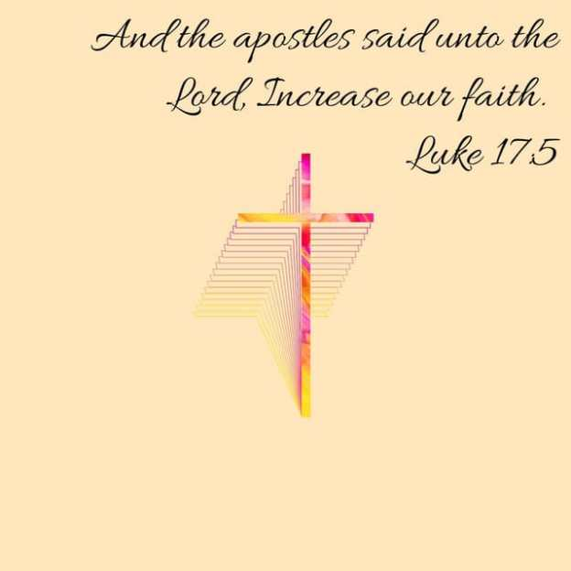

VALLEY PARK UNITED METHODIST CHURCH
436 Valley School Drive, Valley Park, MO 63088

Pastor: Jewell Brodie
Church Phone: 636-225-0057
Cell Phone: 314-401-7672
Church website: Valleypark-umc.org (under construction)
Church e-mail address: vpumc88@sbcglobal.net
A CELEBRATION OF TH GOSPEL
Proclamation: Every believer-Every day in God’s Word
Mission Statement: We are a Bible-believing Christian community inviting all people on a spiritual journey, forming companions in faith, and sending disciples of Jesus Christ into the world. “Which means we are called to “Carry on the Work of Christ”).
Holy Communion—Our Love Feast With Jesus
Seventeenth Sunday After Pentecost
Liturgical Color: Green

Vision and Mission: We Exist to Worship; We Depart to Serve;
Connect: Christ Likeness—Inside Out

Our Theme: “Illumine—Be The Light, Yet Even Now”

October 5, 2025

Praise and Worship Music 9:00—9:30 A.M.

PRELUDE

GREETING As we begin our service:
“LET US KEEP OUR EYES ON THE MASTER”

MUSIC/WORSHIP

WORDS OF REPENTANCE:
Let us repent as a people, as a church, as a community and as a nation.

PSALM 116 Someone Saved from Death Praises God
(Good News Translation)

1 I love the Lord, because he hears me; he listens to my prayers.
2 He listens to me every time I call to him.
3 The danger of death was all around me;
the horrors of the grave closed in on me;
I was filled with fear and anxiety.
4 Then I called to the Lord, “I beg you, Lord, save me!”
5 The Lord is merciful and good; our God is compassionate.
6 The Lord protects the helpless; when I was in danger, he saved me.
7 Be confident, my heart, because the Lord has been good to me.

8 The Lord saved me from death; he stopped my tears
and kept me from defeat.
9 And so I walk in the presence of the Lord in the world of the living.
10 I kept on believing, even when I said, “I am completely crushed,”
11 even when I was afraid and said, “No one can be trusted.”

12 What can I offer the Lord for all his goodness to me?
13 I will bring a wine offering to the Lord, to thank him for saving me.
14 In the assembly of all his people
I will give him what I have promised.

15 How painful it is to the Lord when one of his people dies!
16 I am your servant, Lord; I serve you just as my mother did.
You have saved me from death.
17 I will give you a sacrifice of thanksgiving
and offer my prayer to you.
18-19 In the assembly of all your people, in the sanctuary of your Temple in Jerusalem, I will give you what I have promised.

Praise the Lord!

WORDS OF ASSURANCE

OPENING PRAYER

THE FIRST COMMANDMENT: Mark 12:30

The first of all the commandments is: You shall love the Lord your God with all your heart and with all your soul and with all your mind and with all your strength. And the second, like it, is this: ‘You shall love your neighbor as yourself.’

Exodus 19:8: All that you say, Lord, we will do.
*HYMN “I Know Whom I Have Believed” (vs 1, 4) UMH #714
“God Of Love And God Of Power” (vs 1, 4) UMH #578
“Jesus’ Hands Were Kind Hands” UMH #273

*CALL TO WORSHIP

Leader: From the mustard seed a great and mighty shrub emerges.

People: Good things can come from something that seemed so
insignificant!

Leader: The spore of the yeast can leaven the whole loaf of bread.

People: We can be those people who bring hope and peace to God’s
world.

Leader: Come, let us praise the God of great and mighty wonders.

People: Let our spirits soar in gratitude for the opportunities God
gives us to serve. AMEN.

*HYMN “Here Is Bread, Here Is Wine” FWS #2266

SCRIPTURE READING Luke 17:5-10 (NIV)

5 The apostles said to the Lord, “Increase our faith!”

6 He replied, “If you have faith as small as a mustard seed, you can say to this mulberry tree, ‘Be uprooted and planted in the sea,’ and it will obey you.

7 “Suppose one of you has a servant plowing or looking after the sheep. Will he say to the servant when he comes in from the field, ‘Come along now and sit down to eat’? 8 Won’t he rather say, ‘Prepare my supper, get yourself ready and wait on me while I eat and drink; after that you may eat and drink’? 9 Will he thank the servant because he did what he was told to do? 10 So you also, when you have done everything you were told to do, should say, ‘We are unworthy servants; we have only done our duty.’”

Liturgist: This is the Gospel of Jesus Christ.
People: Thanks be to God for Jesus Christ. Amen.

SPECIAL MUSIC

THE MESSAGE “Faith To Keep Going” Pastor Jewell Brodie

DOXOLOGY UMH #95
Praise God from whom all blessings flow;
Praise Him all creatures here below;
Praise Him above ye heavenly host;
Praise Father, Son and Holy Ghost. Amen.

“HEAR O ISRAEL”

OUR PRAYER AND TIME OF REFLECTION

PASTORAL PRAYER (including prayers for the people, silent prayers of the people.

RESPONSE “Alleluia” FWS #2043
“Alleluia, Alleluia, Alleluia, Alleluia”

*FINAL HYMN “Holy Spirit, Truth Divine” UMH #465

SERVICE OF HOLY COMMUNION

Great Thanksgiving

Leader: The Lord be with you.
Congregation: And also with you.

Leader: Lift up your hearts.
Congregation: We lift them up to the Lord.

Leader: Let us give thanks to the Lord our God.
Congregation: It is right to give our thanks and praise.

It is right, and a good and joyful thing, always and everywhere to give thanks to you Father Almighty, creator of heaven and earth. You formed us in your image and breathed into us the breath of life.

When we turned away, and our love failed, your love remained steadfast. You delivered us from captivity, made a covenant to be our sovereign God, and spoke to us through the prophets. And so, with your people on earth and all the company of heaven we praise your name and join their unending hymn.

Holy, holy, holy Lord, God of power and might, heaven and earth are full of your glory. Hosanna in the highest. Blessed is he who comes in the name of the Lord. Hosanna in the highest.

Holy are you, and blessed is your son Jesus Christ. By the baptism of his suffering, death, and resurrection you gave birth to your church, delivered us from slavery to sin and death, and made with us a new covenant by water and the Spirit.

On the night in which he gave himself up for us he took bread, gave thanks to you, broke the bread, gave it to his disciples and said:

“Take, eat: this is my body which is given for you. Do this in remembrance of me.” When the supper was over, he took the cup, gave thanks to you, gave it to his disciples, and said:

“Drink from this, all of you: this is my blood of the new covenant, poured out for you and for many for the forgiveness of sins. Do this, as often as you drink it, in remembrance of me.

And so, in remembrance of these your mighty acts in Jesus Christ, we offer ourselves in praise and thanksgiving as a holy and living sacrifice, in union with Christ’s offering for us, as we proclaim the mystery of faith.

Christ has died; Christ is risen; Christ will come again.

Pour out your Holy Spirit on us gathered here, and on these gifts of bread and wine. Make them be for us the body and blood of, Christ that we may be for the world the body of Christ, redeemed by his blood.

By your spirit make us one with Christ, one with each other, and one in ministry to all the world, until Christ comes in final victory, and we feast at his heavenly banquet.

Through your son Jesus Christ, with the Holy Spirit in your holy Church, all honor and glory is yours, almighty Father, now and forever. Amen.

And now, with the confidence of children of God, let us pray:

Our Father who art in heaven, hallowed be thy name, thy kingdom come, thy will be done, on earth as it is in heaven. Give us this day our daily bread and forgive us our trespasses as we forgive those who trespass against us. And lead us not into temptation, but deliver us from evil. For thine is the kingdom, and the power, and the glory forever. Amen

GIVING THE BREAD AND CUP

*GIVE THANKS FWS #2036
SPECIAL MUSIC

*BENEDICTION

May your faith, though it may seem as small as a mustard seed, be a source of great power in your life. Let the Lord increase your faith, that you may have the strength to serve Him faithfully and forgive others, even when it is difficult.

As humble and obedient servants, may you do what you ought to do without expecting earthly reward or recognition. May you live with the knowledge that you are God's creation and have been given eternal life through His grace.

Let the Lord's presence be your comfort and your strength as you walk in obedience to His will. Amen.

*SANCTUARY (sing through twice) FWS #2164
Lord, prepare me to be a sanctuary, pure and holy, tried and true. With thanksgiving, I’ll be a living sanctuary for you.

*POSTLUDE

THIS WEEK’S LECTIONARY READINGS: NEXT WEEK’S LECTIONARY READINGS:
Lamentations 1:1-6 Jeremiah 29:1, 4-7
Psalm 137 Psalm 66:1-12
2 Timothy 1:1-14 2 Timothy 2:8-15
Luke 17:5-10 Luke 17:11-19

CIRCLE OF CONCERN—current needs: Dinner Helpers; Pasta Sauce; Canned Fruit; Condiments; Snacks (8-12 servings/package); Size 5 and 6 Diapers; Baby wipes
View our Amazon Wish List, Walmart List or Target List for more items to fill our pantry.

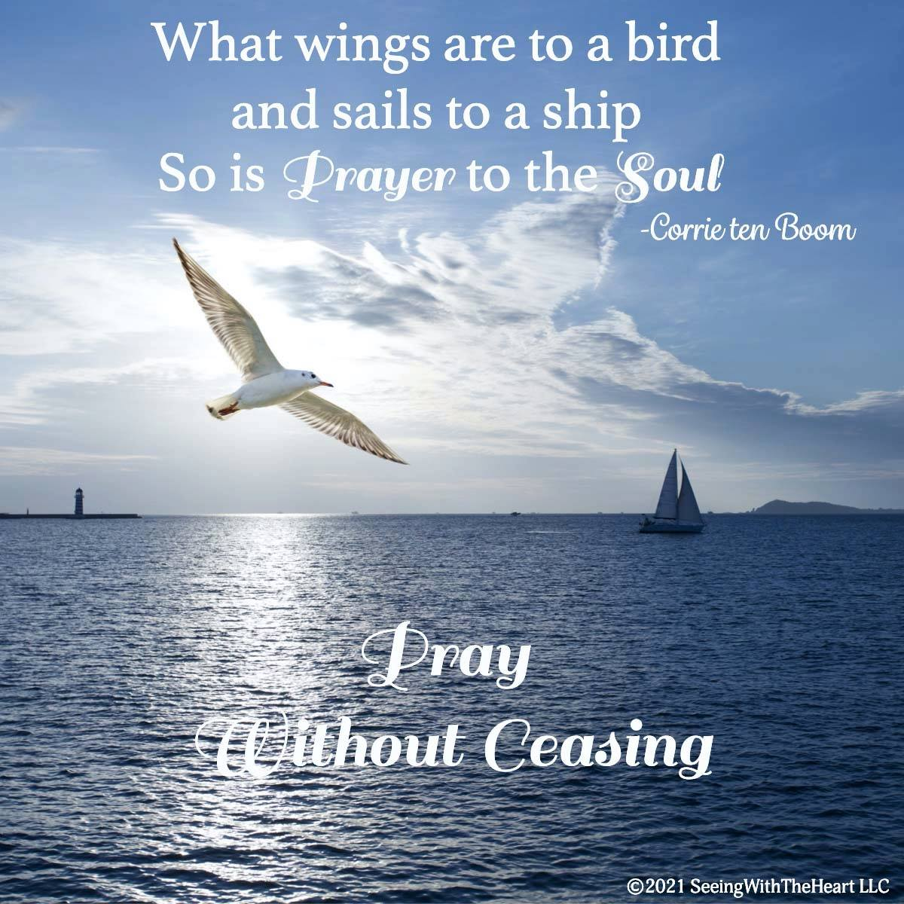

OCTOBER, 2025

10-12,19,26 9:32 A.M. Sunday Worship on Zoom
AND IN SANCTUARY!!

Mondays, Wednesdays: 8:30-11:30 A.M. Quilting

TODAY Communion Sunday (Love Feast) with
crackers and juice if you do not have the
communion elements.

Ad Board/Trustees/Finance after Worship
10-13 Columbus Day

10-16 Boss’ Day

10-19 Laity Sunday

10-26 Reformation Sunday

10-31 Halloween

CLOCKS “FALL” BACK SATURDAY NIGHT,
NOVEMBER 1, 2025

NOVEMBER, 2025

11-2.9.16.23.30 9:32 A.M. Sunday Worship on Zoom
AND IN SANCTUARY!!

Mondays, Wednesdays: 8:30-11:30 A.M. Quilting

11-1 All Saints Day/Day of the Dead

11-2 Communion Sunday (Love Feast) with
crackers and juice if you do not have the
communion elements.
All Saints Sunday

11-2 Ad Board/Trustees/Finance after Worship
11-9 Organ and Tissue Donor Sunday
11-11 Veterans Day
11-23 Christ The King/Reign Of Christ Sunday
Thanksgiving Sunday
11-27 Thanksgiving Day
11-30 First Sunday Of Advent

DON’T FORGET SOME OF OUR FALL COLLECTIONS:

Warner’s Warm-Up End of October, first of November
“Sock”-ortunity Last two weeks of November, first two weeks
of December

Samaritan’s Purse Collection Dates: Now to October 15th.
Packing date to be determined

What Goes in My Shoebox? Make Your Gift Fun, Full, and Personalized.
For children around the world, a shoebox is often their very first gift. Given together with the Good News of Jesus Christ, it communicates God’s love to a boy or girl in need. So, it is important to make sure your gift is …
FUN—includes a “wow” item and other quality toys
FULL—packed to the brim with additional school supplies and personal care items
PERSONALIZED—prayed over and contains a note and photo, which are

DO NOT INCLUDE • Soap • Food, candy, or gum • Toothpaste • Used or damaged items • Scary or war-related items • Wearable traditional camouflage • Seeds or organic matter • Liquids • Medication • Money • Breakable items • Matches, fire starters, or aerosols • Knives, saws, or razor blades

PRAYER REQUESTS

Your prayer concerns are important to us. If you have a prayer need, joy or concern, if you need someone to just pray with you during this week, or if you are looking to connect with a church that loves people and you are interested in doing ministry and mission is this new way, please call Pastor Jewell at (314) 401-7672 or the church (636) 225-0057. We will walk with you no matter where you are on your journey. Check on someone you’ve not heard from this week.

MEMBERS, FRIENDS AND RELATIVES

Janet and Pasquale Parenti Jim Sieberg
June Bouck Randy Statler
Glenda Hamilton and family Betty Wideman
Nancy and David Limback Brinda Armstead Ashford
Chris, Zane, Kensley, Loralei and Kelly Messina McClellan
Alex, Alexis, Aubrey and Aden Mitchell Robison (Todd and Penny)
Captain Irma Hamilton and Dorothy Hamilton
Lilly Mulligan (Kolander) Mark Rudoff (Carol Hamilton)
Nick and Erin Rasch (Limback) Cynthia and Kenny Gooch
Doris “Bonnie” Watson; Sandy Nathan
Sara Laun (Nancy Limback’s mother)
Cathy Becker, Chris Ewalt, Abigail Ewalt (Welsh)
Michael Schmidt (Haubrich) Sybil Young (Grant’s wife)
Mary Ellen Pagliughi (Dodson) Michelle Morton
Joe and Penny Moskus Frances “Cookie” Whitfield
Yvonne McClain Letha Buckley Michelle Parker
Laurie and Jeff Knight Chris Sides Kimmy Limback
Betty Slunaker (Welsh) Gary Laun (Limback)
Stean Pack (Brodie) Freddie Freeman
Mary Cosmo (Rev. Jespersen’s daughter-in-law)
Kathy Wuestling, Wayne Chinn, Brandon Williams (G. Hamilton)
Theresa Hamilton, Walker Friedmeyer, Jen Kurowski (G. Hamilton)
Jean Hopper (Dodson) Becky Halker
Mike Hendrickson (Dodson) Mary Crawford
Joan Ranson

The family and friends of: Bill Kvasnicka (Carol Karlow’s father)

DAILY PRAYER TIME: 1:11 P.M. Stop and say a few prayers for ourselves, our families, friends, neighbors and our prayer list.

Prayers based on Luke 17:5-10 should focus on increasing faith and approaching God with a servant's heart, recognizing that even a small amount of faith is enough when placed in Him. You can pray for yourself to have the strength to be obedient and to trust God's provision, and you can pray for others to have the same "mustard seed faith" to overcome their challenges. The core of this passage is about humble service and faithfulness, not about personal gain.

Prayer for yourself:

For an increase in faith: "Lord, increase my faith. Help me not to be satisfied with a tiny amount of faith, but give me the courage to believe and act, even when things seem overwhelming".

For the ability to be a faithful servant: "Father, help me to be a faithful and obedient servant, just as Jesus taught. May I serve you, my family, and my community with my whole heart, knowing that I am doing what is my duty".

For strength to be obedient: "Give me the strength to be obedient in every step of my journey. Help me to surrender my doubts, insecurities, and fears to you today".

Prayer for others

For their faith: "Lord, I pray for my children, grandchildren, and all those I know. I pray that they will find and exercise that mustard seed faith you spoke of. Let them trust in you and be strengthened by your power".

For them to be faithful servants: "I pray that those around me will have the faith to be faithful servants in their own lives and to others. May they be empowered to do what is right, to your glory".
For them to overcome fear: "I pray for those who are facing struggles. Give them the strength and courage to overcome their fears and doubts. Remind them that they can trust in you, even in the midst of the mess".



