

VALLEY PARK UNITED METHODIST CHURCH
436 Valley School Drive, Valley Park, MO 63088

Pastor: Jewell Brodie
Church Phone: 636-225-0057
Cell Phone: 314-401-7672
Church website: Valleypark-umc.org (under construction)
Church e-mail address: vpumc88@sbcglobal.net
A CELEBRATION OF THE GOSPEL
Proclamation: Every believer-Every day in God’s Word
Mission Statement: We are a Bible-believing Christian community inviting all people on a spiritual journey, forming companions in faith, and sending disciples of Jesus Christ into the world. “Which means we are called to “Carry on the Work of Christ”). Vision and Mission: We Exist to Worship; We Depart to Serve;
Connect: Christ Likeness—Inside Out

Sixteenth Sunday After Pentecost
Liturgical Color: Green

Vision and Mission: We Exist to Worship; We Depart to Serve;
Connect: Christ Likeness—Inside Out

Our Theme: “Illumine—Be The Light, Yet Even Now”
September 28, 2025

Praise and Worship Music 9:00—9:30 A.M.

PRELUDE

GREETING As we begin our service:
“LET US KEEP OUR EYES ON THE MASTER”

MUSIC/WORSHIP

WORDS OF REPENTANCE:
Let us repent as a people, as a church, as a community and as a nation.

PSALM 91:1-6, 14-16 (NIV)

1 Whoever dwells in the shelter of the Most High
will rest in the shadow of the Almighty.
2 I will say of the Lord, “He is my refuge and my fortress,
my God, in whom I trust.”
3 Surely he will save you from the fowler’s snare
and from the deadly pestilence.
4 He will cover you with his feathers,
and under his wings you will find refuge;
his faithfulness will be your shield and rampart.
5 You will not fear the terror of night,
nor the arrow that flies by day,
6 nor the pestilence that stalks in the darkness,
nor the plague that destroys at midday.

14 “Because he (probably the king) loves me,” says the Lord, “I will
rescue him; I will protect him, for he acknowledges my name.
15 He will call on me, and I will answer him;
I will be with him in trouble,
I will deliver him and honor him.
16 With long life I will satisfy him
and show him my salvation.”

OPENING PRAYER

WORDS OF ASSURANCE

THE FIRST COMMANDMENT: Mark 12:30

The first of all the commandments is: You shall love the Lord your God with all your heart and with all your soul and with all your mind and with all your strength. And the second, like it, is this: ‘You shall love your neighbor as yourself.’

Exodus 19:8: All that you say, Lord, we will do.

*HYMN “Take Time To Be Holy” (verses 1, 4) UMH #395
“Immortal, Invisible, God Only Wise” (verses 1, 4)
UMH #733
“Amazing Grace” (verses 1, 4) UMH #378

*CALL TO WORSHIP

Leader: Come and worship!
People: We will praise the One between, within, and over.

Leader: Trust in the One who co-creates the was, the now, and the will-be.

People: Our hope is in the One who creates expansive love calling
us to do the same.

Leader: Follow the One who never breaks covenant.

People: We follow the One whose extravagant love calls us to co-
create justice for the oppressed, feed the hungry, unlock
prisons, and welcome strangers, orphans, and widows.

Leader: Praise the One whose justice is grace-full and inclusive.

People: We praise the Spirit that spans the ages. Amen!

*HYMN “All Hail King Jesus” FWS #2069

*SCRIPTURE READING Luke 16:19-31 (NIV)

The Rich Man and Lazarus

19 “There was a rich man who was dressed in purple and fine linen and lived in luxury every day. 20 At his gate was laid a beggar named Lazarus, covered with sores 21 and longing to eat what fell from the rich man’s table. Even the dogs came and licked his sores.

22 “The time came when the beggar died and the angels carried him to Abraham’s side. The rich man also died and was buried. 23 In Hades, where he was in torment, he looked up and saw Abraham far away, with Lazarus by his side. 24 So he called to him, ‘Father Abraham, have pity on me and send Lazarus to dip the tip of his finger in water and cool my tongue, because I am in agony in this fire.’

25 “But Abraham replied, ‘Son, remember that in your lifetime you received your good things, while Lazarus received bad things, but now he is comforted here and you are in agony. 26 And besides all this, between us and you a great chasm has been set in place, so that those who want to go from here to you cannot, nor can anyone cross over from there to us.’

27 “He answered, ‘Then I beg you, father, send Lazarus to my family, 28 for I have five brothers. Let him warn them, so that they will not also come to this place of torment.’

29 “Abraham replied, ‘They have Moses and the Prophets; let them listen to them.’

30 “‘No, father Abraham,’ he said, ‘but if someone from the dead goes to them, they will repent.’

31 “He said to him, ‘If they do not listen to Moses and the Prophets, they will not be convinced even if someone rises from the dead.’”

Leader: This is the Gospel of Jesus Christ.
People: Thanks be to God for Jesus Christ. Amen.

SPECIAL MUSIC

THE MESSAGE “Faith For The Future” Pastor Jewell Brodie

DOXOLOGY UMH #95
Praise God from whom all blessings flow
Praise Him all creatures here below
Praise Him above ye heavenly host
Praise Father, Son and Holy Ghost. Amen.

“HEAR O ISRAEL”

OUR PRAYER AND TIME OF REFLECTION

PASTORAL PRAYER (including prayers for the people, silent prayers of the people.
THE LORD'S PRAYER
And now, with the confidence of children of God, let us pray:

Our Father who art in heaven, hallowed be thy name, thy kingdom come, thy will be done, on earth as it is in heaven. Give us this day our daily bread and forgive us our trespasses as we forgive those who trespass against us. And lead us not into temptation, but deliver us from evil. For thine is the kingdom, and the power, and the glory forever. Amen.

RESPONSE “Alleluia” FWS #2043
“Alleluia, Alleluia, Alleluia, Alleluia”

ANNOUNCEMENTS

TITHES AND OFFERINGS—Please leave your tithes and offerings in one of the collection boxes either on your way in or on your way out of the sanctuary.

*HYMN OF CELEBRATION “God Will Take Care Of You” UMH #130

SPECIAL MUSIC

*BENEDICTION

As we leave this place, may our eyes be opened to those who lie at our gates. With the love of Christ within us, may we see the hungry and the hurting, the abused and the forgotten. And may we seek to share the blessings we have been given. In the name of God, Creator, Redeemer and Sustainer, may we go out and live the Kin-dom. Amen.

*SHALOM

Shalom to you now, shalom, my friends. May God’s full mercies be yours my friends. In all your living and through your loving, Christ be your shalom, Christ be your shalom.

*POSTLUDE

THIS WEEK’S LECTIONARY READINGS: NEXT WEEK’S LECTIONARY READINGS:
Jeremiah 32:1-3a, 6-15 Lamentations 1:1-6
Psalm 91:1-6, 14-16 Psalm 137
1 Timothy 6:6-19 2 Timothy 1:1-14
Luke 16:19-31 Luke 17:5-10

CIRCLE OF CONCERN—current needs: Dinner Helpers; Pasta Sauce; Canned Fruit; Condiments; Snacks (8-12 servings/package); Size 5 and 6 Diapers; Baby wipes
View our Amazon Wish List, Walmart List or Target List for more items to fill our pantry.

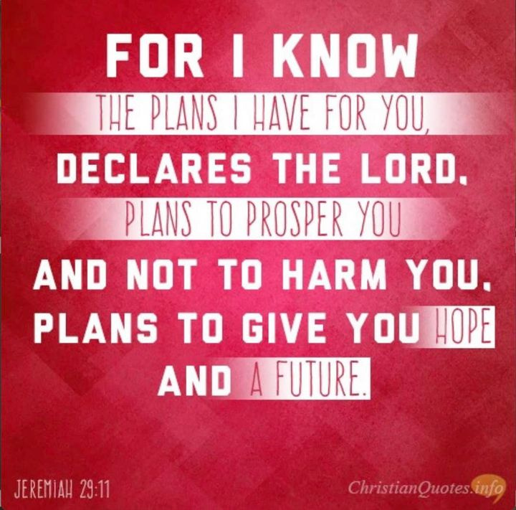

OCTOBER, 2025

10-5,12,19,26 9:32 A.M. Sunday Worship on Zoom
AND IN SANCTUARY!!

Mondays, Wednesdays: 8:30-11:30 A.M. Quilting

10-5 Communion Sunday (Love Feast) with
crackers and juice if you do not have the
communion elements.

Ad Board/Trustees/Finance after Worship

10-13 Columbus Day

10-16 Boss’ Day

10-19 Laity Sunday

10-26 Reformation Sunday

NOVEMBER, 2025

11-2.9.16.23.30 9:32 A.M. Sunday Worship on Zoom
AND IN SANCTUARY!!

Mondays, Wednesdays: 8:30-11:30 A.M. Quilting

11-1 All Saints Day

11-2 Communion Sunday (Love Feast) with
crackers and juice if you do not have the
communion elements.
All Saints Sunday

11-2 Ad Board/Trustees/Finance after Worship

11-9 Organ and Tissue Donor Sunday

11-11 Veterans Day

11-23 Christ The King/Reign Of Christ Sunday
Thanksgiving Sunday

11-27 Thanksgiving Day

11-30 First Sunday Of Advent

DON’T FORGET SOME OF OUR FALL COLLECTIONS:

Warner’s Warm-Up End of October, first of November
“Sock”-ortunity Last two weeks of November, first two weeks
of December

Samaritan’s Purse Collection Dates: Now to October 15th.
Packing date to be determined

What Goes in My Shoebox? Make Your Gift Fun, Full, and Personalized.
For children around the world, a shoebox is often their very first gift. Given together with the Good News of Jesus Christ, it communicates God’s love to a boy or girl in need. So, it is important to make sure your gift is …
FUN—includes a “wow” item and other quality toys
FULL—packed to the brim with additional school supplies and personal care items
PERSONALIZED—prayed over and contains a note and photo, which are

DO NOT INCLUDE • Soap • Food, candy, or gum • Toothpaste • Used or damaged items • Scary or war-related items • Wearable traditional camouflage • Seeds or organic matter • Liquids • Medication • Money • Breakable items • Matches, fire starters, or aerosols • Knives, saws, or razor blades


PRAYER REQUESTS

Your prayer concerns are important to us. If you have a prayer need, joy or concern, if you need someone to just pray with you during this week, or if you are looking to connect with a church that loves people and you are interested in doing ministry and mission is this new way, please call Pastor Jewell at (314) 401-7672 or the church (636) 225-0057. We will walk with you no matter where you are on your journey. Check on someone you’ve not heard from this week.

MEMBERS, FRIENDS AND RELATIVES

Janet and Pasquale Parenti Jim Sieberg
June Bouck Randy Statler
Glenda Hamilton and family Betty Wideman
Nancy and David Limback Brinda Armstead Ashford
Chris, Zane, Kensley, Loralei and Kelly Messina McClellan
Alex, Alexis, Aubrey and Aden Mitchell Robison (Todd and Penny)
Captain Irma Hamilton and Dorothy Hamilton
Bill Kvasnicka (Carol Karlow’s father)
Lilly Mulligan (Kolander) Mark Rudoff (Carol Hamilton)
Nick and Erin Rasch (Limback) Cynthia and Kenny Gooch
Doris “Bonnie” Watson; Sandy Nathan
Sara Laun (Nancy Limback’s mother)
Cathy Becker, Chris Ewalt, Abigail Ewalt (Welsh)
Michael Schmidt (Haubrich) Sybil Young (Grant’s wife)
Mary Ellen Pagliughi (Dodson) Michelle Morton
Joe and Penny Moskus Frances “Cookie” Whitfield
Yvonne McClain Letha Buckley Michelle Parker
Laurie and Jeff Knight Chris Sides Kimmy Limback
Betty Slunaker (Welsh) Gary Laun (Limback)
Stean Pack (Brodie) Freddie Freeman
Mary Cosmo (Rev. Jespersen’s daughter-in-law)
Kathy Wuestling, Wayne Chinn, Brandon Williams (G. Hamilton)
Theresa Hamilton, Walker Friedmeyer, Jen Kurowski (G. Hamilton)
Jean Hopper (Dodson) Becky Halker
Mike Hendrickson (Dodson) Mary Crawford
Joan Ranson

DAILY PRAYER TIME: 1:11 P.M. Stop and say a few prayers for ourselves, our families, friends, neighbors and our prayer list.

Prayers based on Luke 16:19-31 often focus on the spiritual dangers of self-satisfaction and materialism, asking for a heart for the poor, a willingness to hear God's Word, and the power to live generously rather than greedily, as a warning to those who neglect the suffering and God's commandments. Prayers can confess our own insensitivity and pursuit of wealth, ask for a heart that reflects God's truth, and intercede for those who haven't yet heard the Gospel to have a chance to repent.

Prayers for Ourselves

Prayer for a changed heart:

"Father, I pray for a heart that reflects the truth of Jesus, not one that is hardened by the world's desires for more. Please strip away my calluses so that I can love the poor and suffering as You do."

Prayer against spiritual complacency:

"God, forgive us for becoming smug and self-satisfied in our own comfort. Help us to be restless for You and to remain attentive to Your Word and the needs of our brothers and sisters."

Prayer for true treasure:

"My awesome God, I thank You for the beauty of heaven. Assist me in my pursuit of good and help me to be generous rather than greedy, for the treasure of a life in service to Your Name."

Prayers for Others

Prayer for the materially poor and suffering:

"Lord, give me a heart to serve the poor and suffering, for they are Your children. Let my Bible knowledge become a blessing, equipping me to be Jesus' disciple through deeds of righteousness."

Prayer for the spiritually blind:

"Father, I beg You to send Your Spirit to open the ears and hearts of those who are deaf to Your word. May they hear Moses and the Prophets and turn from their path to salvation, lest they too face torment."

Prayer for repentance and salvation:

"Heavenly Father, place Your Spirit upon those who do not yet know Jesus, giving them a deep understanding of the consequences of their actions and the beauty of Your grace. Help them to choose life and love over wealth and self-interest."

Prayer for conviction of the living word:

"Divine Word, send someone to warn the spiritually lost. But more importantly, let them hear the life-giving words of Jesus, reminding them that the Scriptures are a

